**Camellia**

**the State Flower of Alabama**

**Страноведческий кроссворд**

Для учащихся 8-11 классов, влюбленных в английский язык

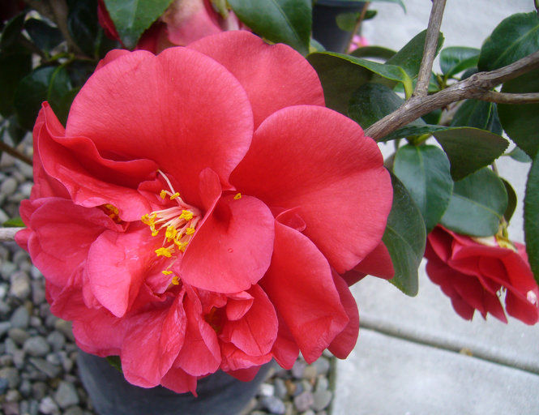

**Автор:**

**Ольга Михайловна Степанова**

**учитель английского языка**

**МБОУ «Цивильская СОШ №2»**

**города Цивильск**

**Чувашской Республики**

**2015**

Успехи в учёбе наблюдаются тогда, когда на нужном уровне поставлена внеклассная работа по предмету. Эта мысль Сухомлинского как никогда звучит актуально, когда внедряется ФГОС.

Данный материал информацию о цветке камелии, которая является флористическим символом штата Алабама, США, и поможет создать у учащихся общее впечатление о цветке. Цель кроссворда – развитие языка во всех его аспектах – чтение, правописание, произношение, обогащение лексики. Материал предназначен для старшеклассников (8-11 классы)

Прекрасный страноведческий материал для проведения лучших знатоков английского языка во время проведения дней английского языка, а также для индивидуальной и групповой работы., ибо технологии работы с кроссвордами различны. Ценность кроссворда в том, что его можно решить на онлайн, потому что он одновременно размещается в интернете по адресу <file:///C:/Users/1/Desktop/Camellia%20the%20State%20Flower%20of%20Aladama.html>

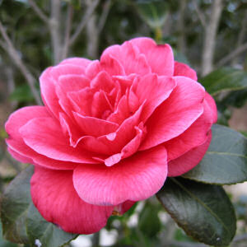

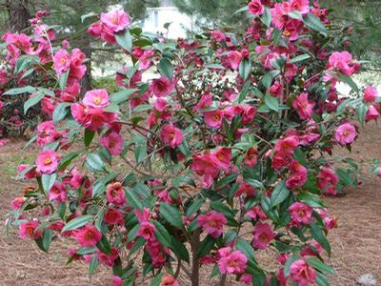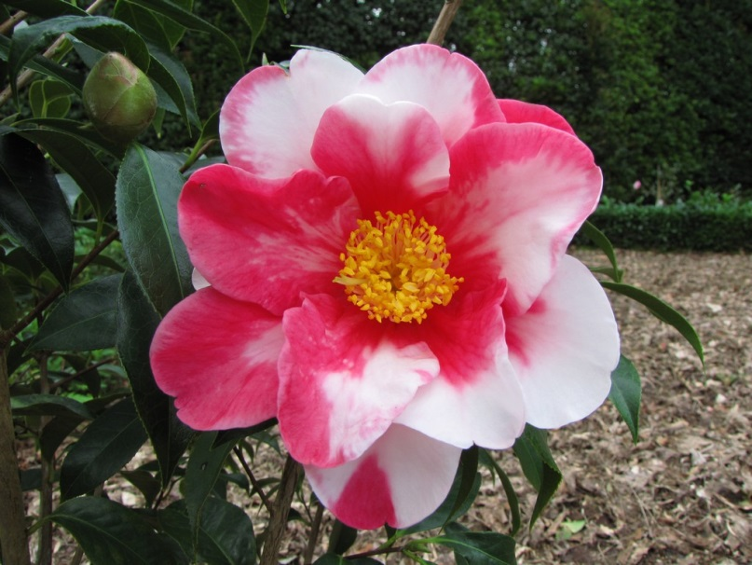

**Across**



1. Rabindranath Tagore wrote a ... entitled "Camellia" about the camellia. (4)

3. Camellia is an easy-to-grow, evergreen flowering shrub with incredible austerity and breathtaking ... . (6)

4. Camellias were even used as offerings to the ... during the Chinese New Year. (4)

6. Camellia Red: You're a flame in My ... . (The Language of fkowers) (5)

7. White camellias feature on the New Zeland ten-dollar ... . (4)

10. Centuries ago, Koreans displayed camellias at ... , signifying longevity and faithfulness. (8)

12. Camellia is sometimes called the Rose of ... . (6)

15. In the U.S.A., camellias were first sold in 1807 as ... plants, but were soon distributed to be grown outdoors in the south. (10)

16. Resembling a rose, the camellia flower bursts open, revealing a yellow ... and round, overlapping petals. (6)

17. Blooming in white and vivid shades of red, pink, orange, yellow and lavender, camellias symbolize the various stages of ... . (4)

**Down**

1. The name "camellia" honors Jesuit missionary and botanist Josef George Kamel, who journeyed throughout Asia in the 17th century and documented the medicinal ... of plants. (10)

2. The capital of California ... is nicknamed the Camellia City. (10)

5. Camellias are seen as lucky symbols for the Chinese New Year and ... . (6)

8. Camellia is a flowering shrub or a ... , usually 1.5–6 metres (4.9–19.7 ft) tall, but occasionally up to 11 metres (36 ft) tall. (4)

9. A non-native state symbol of Alabama, the camellia flower (Camellia japonica) is indigenous to ... . (5)

11. The fruit of camellia is shaped like a capsule that can contain 1 - 8 ... . (5)

13. White camellias became a symbol of New Zealand women's ... to vote. (5)

14. Camellias should be planted in the shade in organic, somewhat acidic, semi-moist but well drained ... . (4)

Ответы НИЖЕ:

**Across**

**1. POEM**—Rabindranath Tagore wrote a ... entitled "Camellia" about the camellia.

**3. BEAUTY**—Camellia is an easy-to-grow, evergreen flowering shrub with incredible austerity and breathtaking ... .

**4. GODS**—Camellias were even used as offerings to the ... during the Chinese New Year.

**6. HEART**—Camellia Red: You're a flame in My ... . (The Language of fkowers)

**7. NOTE**—White camellias feature on the New Zeland ten-dollar ... .

**10. WEDDINGS**—Centuries ago, Koreans displayed camellias at ... , signifying longevity and faithfulness.

**12. WINTER**—Camellia is sometimes called the Rose of ... .

**15. GREENHOUSE**—In the U.S.A., camellias were first sold in 1807 as ... plants, but were soon distributed to be grown outdoors in the south.

**16. CENTER**—Resembling a rose, the camellia flower bursts open, revealing a yellow ... and round, overlapping petals.

**17. LOVE**—Blooming in white and vivid shades of red, pink, orange, yellow and lavender, camellias symbolize the various stages of ... .

**Down**

**1. PROPERTIES**—The name "camellia" honors Jesuit missionary and botanist Josef George Kamel, who journeyed throughout Asia in the 17th century and documented the medicinal ... of plants.

**2. SACRAMENTO**—The capital of California ... is nicknamed the Camellia City.

**5. SPRING**—Camellias are seen as lucky symbols for the Chinese New Year and ... .

**8. TREE**—Camellia is a flowering shrub or a ... , usually 1.5–6 metres (4.9–19.7 ft) tall, but occasionally up to 11 metres (36 ft) tall.

**9. CHINA**—A non-native state symbol of Alabama, the camellia flower (Camellia japonica) is indigenous to ... .

**11. SEEDS**—The fruit of camellia is shaped like a capsule that can contain 1 - 8 ... .

**13. RIGHT**—White camellias became a symbol of New Zealand women's ... to vote.

**14. SOIL**—Camellias should be planted in the shade in organic, somewhat acidic, semi-moist but well drained ... .

Использованная литература:

<http://en.wikipedia.org/wiki/Camellia>

<http://www.proflowers.com/blog/alabama-state-flower-the-camellia>

<http://www.statesymbolsusa.org/Alabama/flower_camelia.html>

<http://www.netstate.com/states/symb/flowers/al_camellia.htm>