**Banana Story**

**Кроссворд**

**для учащихся 7-11 классов, влюбленных в английский язык**

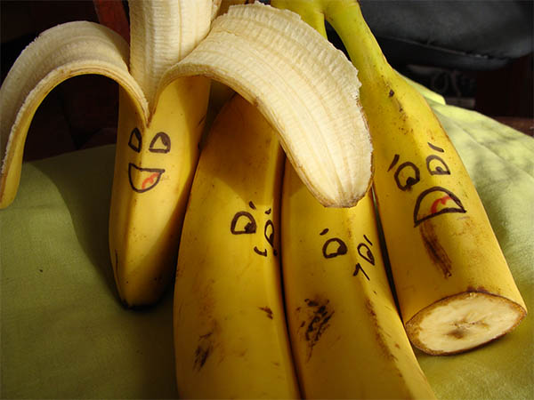

**Автор**

**Ольга Михайловна Степанова**

**учитель английского языка**

**МБОУ «Цивильская СОШ №2» Чувашской республики**

**2015**

**адрес для решения в онлайн режиме (желательно открыть в Google Chrome)** **file:///C:/Users/1/Desktop/banana/Banana%20Story.html**

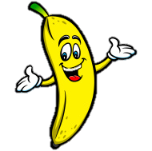 C:\Users\1\Desktop\banana 2.wmf

**Across**

2. There is a museum in Auburn, Washington dedicated to bananas. It’s called the ... Banana Museum. (10)

4. When bad luck chooses you as a companion, even a ripe banana can remove your ... . (African Proverb) (5)

6. Fibre taken from banana plants can be used to make ... . (7)

9. ananas may not be overflowing with calcium, but they are still helpful in keeping ... strong. (5)

11. The International Banana Museum was started back in 1976 by a man name Ken Bannister, who called himself the “Top Banana ... ”. (3)

12. Bananas float in ... , as do apples and watermelons. (5)

13. The banana tree is not a tree.It's just a sneaky herb posing as a tree. A huge ... .Trying to be a palm tree. (4)

15. Located southeast of Palm Springs in Mecca, CA, International Banana Museum is recognized by the Guinness Book of World ... for having the largest collection dedicated to a single fruit. (6)

16. Intellectual property has the shelf ... of a banana. Bill Gates (4)

17. The curvy yellow fruits are high in "potassium and ... , a form of fiber," said Laura Flores, a San Diego-based nutritionist. (6)

18. Bananas are good for your heart. They are packed with potassium, a mineral electrolyte that keeps electricity flowing throughout your body, which is required to keep your ..., beating. (5)

20. Bananas have high nutritional value and are a healthy ... . (5)

21. "Bananas are known to reduce swelling, protect against developing type-2 diabetes, aid in weight loss, strengthen the nervous system and help with production of white blood cells, all due to the high level of ... B6 that bananas contain," Laura Flores, a San Diego-based nutritionist told Live Science. (7)

23. "Time flies like an arrow; ... flies like a banana." ---Groucho Marx (5)

24. Bananas' high potassium and low sodium content may also help protect your cardiovascular system against high ... pressure. (5)

28. Bananas, as we know them, are a human ... from like, 5000 B.C. (9)

29. Rubbing a banana peel on your forehead can help cure a ... . (8)

31. Bananas may be helpful in preventing kidney ... because of their high levels of antioxidant phenolic compounds. (6)

**Down**

1. The inside of a banana skin can be used to calm an itchy mosquito ... - many people find that rubbing the bite with the skin helps to reduce irritation. (4)

3. The scientific ... for banana is musa sapientum, which mean fruit of the wise men. (4)

5. The correct name for a bunch of bananas is a ...; a single banana is a finger. (4)

7. An old banana ... was once young and green. (Nigerian Proverb) (4)

8. Bananas are a very rich ... of vitamin B6, which your brain needs to function properly and make you wise. (6)

10. The inside of a banana skin can be used to polish ... ! (5)

11. Bananas could help you to feel happier as they contain tryptophan, a type of protein that the body converts into serotonin, known to promote relaxation and improve ... . (4)

14. When a ... doesn't get a banana, he eats chillies. (African Proverb) (6)

16. There is a widely-held superstition that says bananas are bad ... on a fishing boat. (4)

17. Bananas are among the most widely consumed fruits on the ... and, according to the U.S. Department of Agriculture, Americans' favorite fresh fruit. (6)

19. Broccoli: I look like a tree. Walnut: I look like a brain. Mushroom: I look like an umbrella. Banana: Dude! Change the ... . Joke (5)

22. ... is the biggest banana producer in the world, followed by Brazil. (5)

23. The word banana comes from the Arabic word "banan", meaning ... . (6)

24. The banana herb bears only one ... of bananas before dying. (5)

25. The "trunk" of a banana plant is not made of wood, it is made of tightly overlapping ... . (6)

26. More ... have been written about bananas than about any other fruit. (5)

27. The banana itself is actuallya ... ! (5)

30. Bananas make you smarter and help with learning by making you more alert. Eat a banana before an ... to benefit from the high levels of potassium. (4)

Ответы на следующей странице:

C:\Users\1\Desktop\banana 2 (key).wmf

**Across**

**2. WASHINGTON**—There is a museum in Auburn, Washington dedicated to bananas. It’s called the ... Banana Museum.

**4. TEETH**—When bad luck chooses you as a companion, even a ripe banana can remove your ... . (African Proverb)

**6. CLOTHES**—Fibre taken from banana plants can be used to make ... .

**9. BONES**—ananas may not be overflowing with calcium, but they are still helpful in keeping ... strong.

**11. MAN**—The International Banana Museum was started back in 1976 by a man name Ken Bannister, who called himself the “Top Banana ... ”.

**12. WATER**—Bananas float in ... , as do apples and watermelons.

**13. HERB**—The banana tree is not a tree.It's just a sneaky herb posing as a tree. A huge ... .Trying to be a palm tree.

**15. RECORD**—Located southeast of Palm Springs in Mecca, CA, International Banana Museum is recognized by the Guinness Book of World ... for having the largest collection dedicated to a single fruit.

**16. LIFE**—Intellectual property has the shelf ... of a banana. Bill Gates

**17. PECTIN**—The curvy yellow fruits are high in "potassium and ... , a form of fiber," said Laura Flores, a San Diego-based nutritionist.

**18. HEART**—Bananas are good for your heart. They are packed with potassium, a mineral electrolyte that keeps electricity flowing throughout your body, which is required to keep your ..., beating.

**20. SNACK**—Bananas have high nutritional value and are a healthy ... .

**21. VITAMIN**—"Bananas are known to reduce swelling, protect against developing type-2 diabetes, aid in weight loss, strengthen the nervous system and help with production of white blood cells, all due to the high level of ... B6 that bananas contain," Laura Flores, a San Diego-based nutritionist told Live Science.

**23. FRUIT**—"Time flies like an arrow; ... flies like a banana." ---Groucho Marx

**24. BLOOD**—Bananas' high potassium and low sodium content may also help protect your cardiovascular system against high ... pressure.

**28. INVENTION**—Bananas, as we know them, are a human ... from like, 5000 B.C.

**29. HEADACHE**—Rubbing a banana peel on your forehead can help cure a ... .

**31. CANCER**—Bananas may be helpful in preventing kidney ... because of their high levels of antioxidant phenolic compounds.

**Down**

**1. BITE**—The inside of a banana skin can be used to calm an itchy mosquito ... - many people find that rubbing the bite with the skin helps to reduce irritation.

**3. NAME**—The scientific ... for banana is musa sapientum, which mean fruit of the wise men.

**5. HAND**—The correct name for a bunch of bananas is a ...; a single banana is a finger.

**7. LEAF**—An old banana ... was once young and green. (Nigerian Proverb)

**8. SOURCE**—Bananas are a very rich ... of vitamin B6, which your brain needs to function properly and make you wise.

**10. SHOES**—The inside of a banana skin can be used to polish ... !

**11. MOOD**—Bananas could help you to feel happier as they contain tryptophan, a type of protein that the body converts into serotonin, known to promote relaxation and improve ... .

**14. MONKEY**—When a ... doesn't get a banana, he eats chillies. (African Proverb)

**16. LUCK**—There is a widely-held superstition that says bananas are bad ... on a fishing boat.

**17. PLANET**—Bananas are among the most widely consumed fruits on the ... and, according to the U.S. Department of Agriculture, Americans' favorite fresh fruit.

**19. TOPIC**—Broccoli: I look like a tree. Walnut: I look like a brain. Mushroom: I look like an umbrella. Banana: Dude! Change the ... . Joke

**22. INDIA**—... is the biggest banana producer in the world, followed by Brazil.

**23. FINGER**—The word banana comes from the Arabic word "banan", meaning ... .

**24. BUNCH**—The banana herb bears only one ... of bananas before dying.

**25. LEAVES**—The "trunk" of a banana plant is not made of wood, it is made of tightly overlapping ... .

**26. SONGS**—More ... have been written about bananas than about any other fruit.

**27. BERRY**—The banana itself is actuallya ... !

**30. EXAM**—Bananas make you smarter and help with learning by making you more alert. Eat a banana before an ... to benefit from the high levels of potassium.

Sources

<http://www.todayifoundout.com/index.php/2010/09/15-facts-you-probably-didnt-know-about-bananas/>

<http://thebananapolice.com/fun-facts/>

<http://www.sciencekids.co.nz/sciencefacts/food/bananas.html>

<http://www.chiquitabananas.com/banana-information/banana-fun-facts-and-trivia.aspx>

<http://www.chiquitabananas.com/worlds-favorite-fruit/index-banana-nutrition-facts.aspx>

<http://blog.fooducate.com/2014/08/01/10-weird-banana-facts/>

<http://minionslovebananas.com/fun-banana-facts.aspx>

<http://www.livescience.com/45005-banana-nutrition-facts.html>