**Water the Life**

**Кроссворд на английском языке**

**для учащихся 8-11 классов,**

**влюбленных в английский язык**

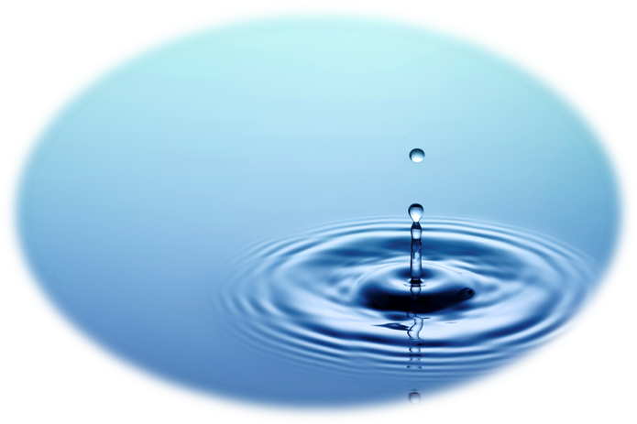

**Автор:**

**Ольга Михайловна Степанова**

**учитель английского языка**

**МБОУ «Цивильская СОШ №2»**

**города Цивильск**

**Чувашской Республики**

**2015**

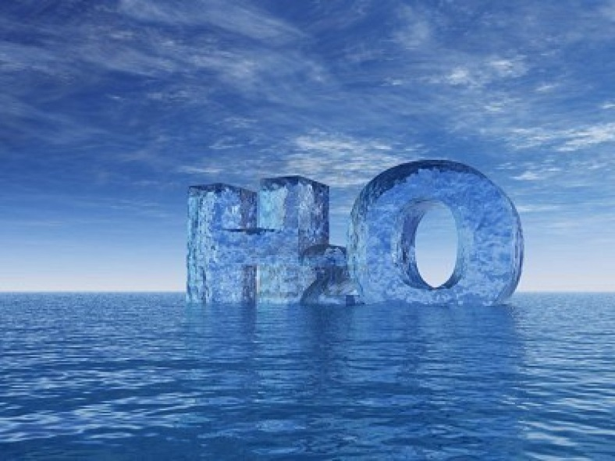

C:\Users\1\Desktop\water2.wmf

**Across**

1. “In troubled waters there's good ...” (Russian Proverb) (7)

4. Let the rain kiss you. Let the rain beat upon your headwith silver liquid drops. Let the rain sing you a ... . - Langston Hughes, April Rain Song, (7)

6. “No matter how high a ... flies, it has to come down for water. (American Proverb) (4)

8. By means of water, we give ... to everything. - Koran (4)

10. Water is H20, hydrogen two parts, ... one, but there is also a third thing that makes water and nobody knows what that is. - D. H. Lawrence (6)

13. “Only a fool tests the depth of the water with both ... ” (African Proverb). (4)

14. "Water is the driver of ... ." - Leonardo da Vinci (6)

16. “He who is thirsty goes to the ... .” KENYA (5)

17. “A little water is a sea to an ...” (Afghan Proverb) (3)

18. Expect ... from the standing water. - William Blake (6)

20. “Be on your guard against a silent ... and still water”.(Latin Proverb) (3)

22. “One would like to eat ... , but would not like to get into the water” (Russian Proverb) (4)

24. Pure water is the world’s first and foremost ... . ~Slovakian Proverb (8)

27. Everywhere water is a thing of beauty gleaming in the dewdrop, singing in the summer rain. - John Ballantine Gough Everywhere water is a thing of beauty gleaming in the dewdrop, singing in the summer rain. - John Ballantine Gough Everywhere water is a thing of ... gleaming in the dewdrop, singing in the summer rain. - John Ballantine Gough (6)

**Down**

2. As water reflects the face, so one's life reflects the ... . (5)

3. If there is ... on this planet, it is contained in water. ~Loren Eiseley (5)

5. Thousands have lived without ... , but not one without water. W.H. Auden (4)

6. “Donґt throw away the old ... until you know whether the new one holds water” (Swedish Proverb) (6)

7. “Water is the ... of food.” KENYA (4)

9. “... does not fall on one roof alone” (Cameroon Proverb) (4)

10. "Take your shoes off," purred the ... waves. ~Dr. SunWolf (5)

11. Water is the basis of life and the blue arteries of the ... ! Everything in the non-marine environment depends on freshwater to survive. - -Sandra Postel (5)

12. In one drop of water are found all the ... of the oceans. ~Khalil Gibran (7)

13. The ... does not drink up the pond in which he lives. - American Indian Saying (4)

15. I believe that water is the only drink for a wise ... . ~Henry David Thoreau (3)

19. “When you drink the water, remember the ...” (Chinese Proverb) (6)

21. We never know the worth of water till the ... is dry. ~Thomas Fuller, Gnomologia, 1732 (4)

23. You can lead a ... to water but you cannot make him drink. (5)

25. A lake is the landscape’s most beautiful and expressive feature. It is earth’s ...; looking into which the beholder measures the depth of his own nature. ~Henry David Thoreau (3)

26. “A scalded ... from cold water runs”. (Spanish Proverb) (3)

Адрес для доступа для решения кроссворда в онлайн режиме <file:///C:/Users/1/Desktop/Water%20the%20Life.html>

**C:\Users\1\Desktop\water2 (key).wmf**

**Across**

**1. FISHING**—“In troubled waters there's good ...” (Russian Proverb)

**4. LULLABY**—Let the rain kiss you. Let the rain beat upon your headwith silver liquid drops. Let the rain sing you a ... . - Langston Hughes, April Rain Song,

**6. BIRD**—“No matter how high a ... flies, it has to come down for water. (American Proverb)

**8. LIFE**—By means of water, we give ... to everything. - Koran

**10. OXYGEN**—Water is H20, hydrogen two parts, ... one, but there is also a third thing that makes water and nobody knows what that is. - D. H. Lawrence

**13. FEET**—“Only a fool tests the depth of the water with both ... ” (African Proverb).

**14. NATURE**—"Water is the driver of ... ." - Leonardo da Vinci

**16. RIVER**—“He who is thirsty goes to the ... .” KENYA

**17. ANT**—“A little water is a sea to an ...” (Afghan Proverb)

**18. POISON**—Expect ... from the standing water. - William Blake

**20. DOG**—“Be on your guard against a silent ... and still water”.(Latin Proverb)

**22. FISH**—“One would like to eat ... , but would not like to get into the water” (Russian Proverb)

**24. MEDICINE**—Pure water is the world’s first and foremost ... . ~Slovakian Proverb

**27. BEAUTY**—Everywhere water is a thing of beauty gleaming in the dewdrop, singing in the summer rain. - John Ballantine Gough Everywhere water is a thing of beauty gleaming in the dewdrop, singing in the summer rain. - John Ballantine Gough Everywhere water is a thing of ... gleaming in the dewdrop, singing in the summer rain. - John Ballantine Gough

**Down**

**2. HEART**—As water reflects the face, so one's life reflects the ... .

**3. MAGIC**—If there is ... on this planet, it is contained in water. ~Loren Eiseley

**5. LOVE**—Thousands have lived without ... , but not one without water. W.H. Auden

**6. BUCKET**—“Donґt throw away the old ... until you know whether the new one holds water” (Swedish Proverb)

**7. KING**—“Water is the ... of food.” KENYA

**9. RAIN**—“... does not fall on one roof alone” (Cameroon Proverb)

**10. OCEAN**—"Take your shoes off," purred the ... waves. ~Dr. SunWolf

**11. EARTH**—Water is the basis of life and the blue arteries of the ... ! Everything in the non-marine environment depends on freshwater to survive. - -Sandra Postel

**12. SECRETS**—In one drop of water are found all the ... of the oceans. ~Khalil Gibran

**13. FROG**—The ... does not drink up the pond in which he lives. - American Indian Saying

**15. MAN**—I believe that water is the only drink for a wise ... . ~Henry David Thoreau

**19. SPRING**—“When you drink the water, remember the ...” (Chinese Proverb)

**21. WELL**—We never know the worth of water till the ... is dry. ~Thomas Fuller, Gnomologia, 1732

**23. HORSE**—You can lead a ... to water but you cannot make him drink.

**25. EYE**—A lake is the landscape’s most beautiful and expressive feature. It is earth’s ...; looking into which the beholder measures the depth of his own nature. ~Henry David Thoreau

**26. CAT**—“A scalded ... from cold water runs”. (Spanish Proverb)

Источник

[**http://waterislife-comenius.blogspot.ru/2012/05/proverbs-and-popular-sayings-about.html**](http://waterislife-comenius.blogspot.ru/2012/05/proverbs-and-popular-sayings-about.html)

[**http://annettamiller.weebly.com/proverbs-on-water.html**](http://annettamiller.weebly.com/proverbs-on-water.html)

[**http://www.quotegarden.com/water.html**](http://www.quotegarden.com/water.html)