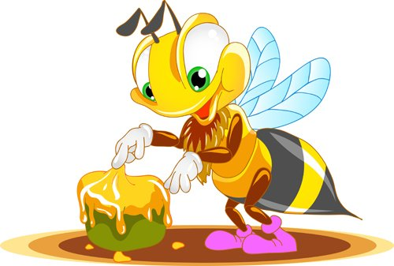

**Honey Bee and Honey**

**Кроссворд**

**для учащихся 8-11 классов,**

**влюбленных в английский язык**

**Автор:**

**Ольга Михайловна**

**Степанова**

**учитель английского**

**языка**

**МБОУ**

**«Цивильская СОШ №2»**

**города Цивильск**

**Чувашской Республики**

**2015**

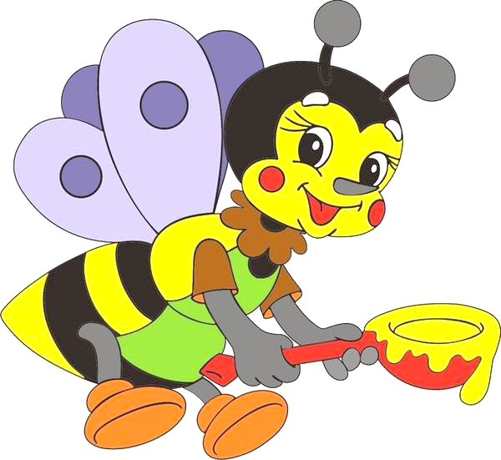

**Across**

5. A honey bee is a social insect - it lives in a ... with other honey bees. (6)

7. It has three pairs of jointed legs, feelers or antennae, and usually two pairs of ... . (5)

9. Worker bees, who are all ... , are the only ones who will attack you, and only if they feel threatened. (6)

11. The queen bee will lay around 1,500 ... a day. (4)

12. Bees communicate by smells called ‘pheromones’ and by performing special ‘...’. (6)

14. Honey is sweeter than table ... . (5)

16. A colony of bees can contain between 20,000 and 60,000 bees, but only one ... bee. (5)

18. A honey bee survives the ... by eating stored honey and keeping warm with the other bees. (6)

19. It has special 'baskets' made of stiff, curving hairs on its back legs, to carry pollen back to the ... . (4)

23. A honey bee has a hard skeleton that is on the outside of its ... (with holes for breathing) (4)

24. One bee will only make 1/12 of a ... on honey in its entire life. (8)

25. Bees have two separate ... ; one for food and another just for nectar. (8)

**Down**

1. It would take 1,100 bees to make 1kg of honey and they would have to visit 4 million ... . (7)

2. Bees have a long proboscis - type of ... - that helps them to get the nectar out of flowers, they collect pollen in pollen baskets on their body. (6)

3. Bees are the only insect in the world that make food that ... can eat (6)

4. There are 3 types of bees in a colony, drones, ... , and queens. (7)

6. Honey contains all of the substances needed to sustain life, including enzymes, ... , minerals and vitamins (5)

8. Many plants rely on insects like bees in order to be pollinated; which is why they provide ... to say thanks. (6)

10. A bee’s wings beat 190 times a second, that’s 11,400 times a ... ! (6)

13. It has a sting (ouch!) to defend itself - but when it stings a ... the bee dies!! (5)

15. A honey bee is an ... and has a body in three parts, a head, a thorax and an abdomen. (6)

17. Eating honey can help you smarter! It is the only food to contain ‘pinocembrin’ that is an antioxidant that improves ... function (5)

20. A honey bee has 5 ... and can see ultra violet light. (4)

21. Honey helps burn ... when we sleep. (4)

22. A honey bee can dance to show other bees where to find ... . (4)

**Учащимся будет интересно работать с этим кроссвордом в онлайн режиме, так как он одновременно помещается в интернете по адресу:**

<file:///C:/Users/1/Desktop/honey1.html>

Ответы ниже.

Answers



**Across**

**5. COLONY**—It is a social insect - it lives in a ... with other honey bees.

**7. WINGS**—It has three pairs of jointed legs, feelers or antennae, and usually two pairs of ... .

**9. FEMALE**—Worker bees, who are all ... , are the only ones who will attack you, and only if they feel threatened.

**11. EGGS**—The queen bee will lay around 1,500 ... a day.

**12. DANCES**—Bees communicate by smells called ‘pheromones’ and by performing special ‘...’.

**14. SUGAR**—Honey is sweeter than table ... .

**16. QUEEN**—A colony of bees can contain between 20,000 and 60,000 bees, but only one ... bee.

**18. WINTER**—A honey bee survives the ... by eating stored honey and keeping warm with the other bees.

**19. HIVE**—It has special 'baskets' made of stiff, curving hairs on its back legs, to carry pollen back to the ... .

**23. BODY**—A honey bee has a hard skeleton that is on the outside of its ... (with holes for breathing)

**24. TEASPOON**—One bee will only make 1/12 of a ... on honey in its entire life.

**25. STOMACHS**—Bees have two separate ... ; one for food and another just for nectar.

**Down**

**1. FLOWERS**—It would take 1,100 bees to make 1kg of honey and they would have to visit 4 million ... .

**2. TONGUE**—Bees have a long proboscis - type of ... - that helps them to get the nectar out of flowers, they collect pollen in pollen baskets on their body.

**3. PEOPLE**—Bees are the only insect in the world that make food that ... can eat

**4. WORKERS**—There are 3 types of bees in a colony, drones, ... , and queens.

**6. WATER**—Honey contains all of the substances needed to sustain life, including enzymes, ... , minerals and vitamins

**8. NECTAR**—Many plants rely on insects like bees in order to be pollinated; which is why they provide ... to say thanks.

**10. MINUTE**—A bee’s wings beat 190 times a second, that’s 11,400 times a ... !

**13. HUMAN**—It has a sting (ouch!) to defend itself - but when it stings a ... the bee dies!!

**15. INSECT**—A honey bee is an ... and has a body in three parts, a head, a thorax and an abdomen.

**17. BRAIN**—Eating honey can help you smarter! It is the only food to contain ‘pinocembrin’ that is an antioxidant that improves ... function

**20. EYES**—It has 5 ... and can see ultra violet light.

**21. FATS**—Honey helps burn ... when we sleep.

**22. FOOD**—It can dance to show other bees where to find ... .

Источники

<http://philotoyourhealth.blogspot.ru/2012/05/6-honey-facts-and-myths.html>

<http://www.bees4kids.org.uk/fun-facts-about-honey-bees/>

<http://www.bbka.org.uk/local/newcastle/facts/>