Ливерпуль: город, который диктует стиль
(материал к презентации «Liverpool, England»)

Шайдурова Валентина Федоровна
Учитель английского языка
ГБОУ «Школа №106»
Санкт-Петербург

2015

Материал «Ливерпуль: город, который диктует стиль» является частью проекта «Города Англии», который можно использовать к презентации «Liverpool,England» как дополнительную инфорацию на уроках страноведения.
Материал дан на русском и английском языках и будет полезен обучающимися разной языковой подготовки для подготовки проектных работ.

Ливерпуль: город, который диктует стиль

Ливерпу́ль (англ. Liverpool) — город в Великобритании, в конурбации Мерсисайд, порт на северо-западном побережье Англии.
География
Город расположен на северо-западе Англии, в устье реки Мерси. Климат страны определяется близостью океана и морей, своей мягкостью и влажностью он обязан Гольфстриму. Суровых зим в Англии не бывает. Температура редко опускается ниже 0°С, дни стоят яркие и свежие. Весной на севере господствуют холодные ветры и стоят туманы, на юге бархатная погода. Впрочем, где бы вы ни были, следует брать с собой шерстяные вещи и плащи, так как английское небо обманчиво в любой момент может начаться дождь. Летом, как правило, повсеместно тепло, но осадков не меньше. Если рано утром или поздно вечером стало прохладно, знайте: это пожаловала осень ничем другим сентябрь от августа не отличается, и лишь в октябре даже днем лучше выходить тепло одетым. Средняя температура в Лондоне в январе и феврале 4-5°С, в марте-апреле 6°С, в июне-августе 16-19°С, в сентябре -ноябре 12-7°С.
Пеннинские горы тянутся по территории Англии с севера на юг. В Пеннинах расположен и живописный Озерный край. На юге и юго-востоке Англии рельеф спокойный, лишь ряд холмов скрашивает его. Морские берега сильно изрезаны, устья рек образуют значительные заливы с удобными гаванями. Реки сравнительно коротки, но многоводны и издавна служат для судоходства. Главные реки: Темза, Северн, Тайн, Мерси.
История
На месте нынешнего города в 1190 г. существовало поселение под названием Ливерпул (Liuerpul), что означало «мутный водоем». Некоторые исследователи в качестве варианта этимологии приводят слово 'elverpool' — водоем с угрями. В 1207 г. король Иоанн Безземельный выпустил грамоту, предписывающую создание в этом месте нового поселка (borough) и приглашавшую поселенцев обосновываться там. После постройки ливерпульского замка городок превратился в пункт отправки войск в Ирландию.
В середине XVI века население Ливерпуля составляло лишь порядка 500 человек. В 1571 г. жители городка послали королеве Елизавете слезную петицию о предоставлении им субсидий. В 1644 г. во время гражданской войны Ливерпуль подвергся восемнадцатидневной осаде.
В XVIII веке благодаря развитию американских колоний Великобритании значение Ливерпуля как порта на западном побережье стало расти. В 1715 г. здесь был сооружен первый в Англии открытый портовый док. К началу XIX века через Ливерпуль проходило около 40 % мирового торгового трафика. Статус города Ливерпуль получил в 1880 г. В дальнейшем он продолжал динамично развиваться.
Жителей города официально называют "liverpudlians", но гораздо более известно их прозвище "scousers" (скаусеры), которое ливерпульцы получили благодаря похлебке lobscouse (лобскауз), изобретению норвежских моряков и главной пище бедного портового люда. Здесь говорят на особом диалекте, скаусе. Ливерпуль знаменит во всем мире не только своим легендарным речным портом и группой «Битлз», но и Большими национальными лошадиными бегами (Grand National Steeplechase). В этот оживленный город стоит приехать не только из-за достопримечательностей, но и из-за прекрасных возможностей для шопинга, большого количества спортивных мероприятий и бурной ночной жизни.

Ливерпуль — один из пяти крупнейших городов Великобритании, который находится в графстве Мерсисайд. Первые упоминания о городе появились в 1190 году, как о поселении. Вплоть до XVII века он оставался небольшим поселением с жителями, численность которых не превышала 500 человек. Лишь в XVIII веке, когда шла бурная трансатлантическая работорговля, Ливерпульский порт получил новый статус. Именно здесь был возведен первый в стране открытый портовый док.
В конце XIX века Ливерпуль получает статус города и продолжает динамично развиваться. Во времена Британской империи он был еще и одним из главных центров судостроения. Именно здесь в свое время был спущен на воду лайнер "Британник".
В 1960-х годах Ливерпуль становится местом молодежной духовной революции, центром которой является группа The Beatles. Сегодня город считается одной из культурных столиц Европы, численность населения которой составляет более 441 тысячи человек. Несмотря на его долгую историю, старинных сооружений сохранилось мало, и весь архитектурный облик города определяется постройками XVIII века.

Достопримечательности Ливерпуля
Ливерпуль считается лучшим местом для знакомства с Англией Викторианской эпохи. Здесь масса интересных мест, которые обязательно надо посетить: Ливерпульский собор, Альберт Док, Гудисон Парк, Музей The Beatles и замок Хальтон. Альберт Док — первый сухой док, площадь которого составляет 1 миллион квадратных футов. Расположенный на его территории комплекс из старых складов, был преобразован в рестораны, магазины, отели, пабы, музеи, галере, и внесен в списки ЮНЕСКО. Здесь находятся сразу два культурных объекта — Морской Музей Мерисайд и Музей Рабства, посещение которых абсолютно бесплатно.
Одной из самых знаменитых достопримечательностей Ливерпуля является музей истории «The Beatles». В выставочных павильонах вы окунетесь в неподражаемую атмосферу того времени, когда группа была на пике своей славы. Увлекательные рассказы гида поведают о четверых ливерпульских парнях, которые преодолели всё на пути к богатству и успеху, став самой популярной группой всех времен. Помимо биографии каждого участника, Вы сможете увидеть концертные костюмы и личные вещи легендарной четверки.
Ливерпульский католический собор был построен в XX веке в стиле модернизм. Его строительство было обусловлено резким ростом католической части населения. Считается, что собор вполне может соперничать своими размерами с Собором Святого Петра в Риме. Внутреннее просторное помещение со сдержанным оформлением, внушительный колокол и высокая колокольня стали отличительными чертами этого культового сооружения.
Галерея Тейт Ливерпуль — это один из филиалов целой системы галерей, которые также расположены в Лондоне и Корнуолле. До 2003 года ливерпульская галерея была крупнейшей за пределами Лондона. В её залах представлены произведения Британского искусства, начиная с 1500 года. Не менее интересна и обширна коллекция современного зарубежного искусства. Всего собрание музея насчитывает почти 60 тысяч экспонатов. Галерея Тейт размещается в одном из складских помещений района Альберт-Док.
Источник: http://tut1.ru/goroda-anglii/267-gorod-liverpul.html

Liverpool Sightseeing: What to See in Liverpool?
by Andy Hayes

Liverpool is one of the most famous cities in the UK, with thousands of tourists visiting the city each year to discover what makes it so special . But what to see in Liverpool?
The first thing most people think of when they hear the name Liverpool is, of course, The Beatles, who became the biggest band in the world when they revolutionised the music industry, but there is so much more to the city than just music. It’s popular for architectural tourism as the world’s first skyscraper was built here; it is also home to UNESCO world heritage sights, and it has one of the oldest Chinatowns in Europe. Come and explore this great city with our Liverpool sightseeing guide to the top 10 things to do in Liverpool and see why it is one of the most popular vacation destinations destinations in the UK.

Mathew Street & The Beatles Story
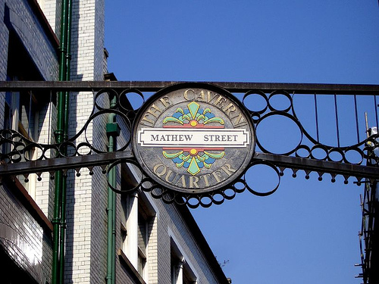
You cannot visit Liverpool and not check out Mathew Street, where it all began for The Beatles. Most of the pubs and clubs around the street are dedicated to the fab 4, most notably The Cavern Club, which although is not the original venue where it all started for the band, it has been built to resemble it as close as possible. There’s a statute of John Lennon leaning against the wall at the top of the street, which you will probably have to get in a small queue to have your photo taken with.
There’s also a museum at the Albert docks called The Beatles Story; dedicated to Paul, John, George and Ringo, detailing their rise to mega stardom with memorabilia from the 50s, 60s and 70s, plus a 3d interactive area where you can watch videos and play along to some of their most famous songs. It is a Liverpool sightseeing must.

Albert Dock
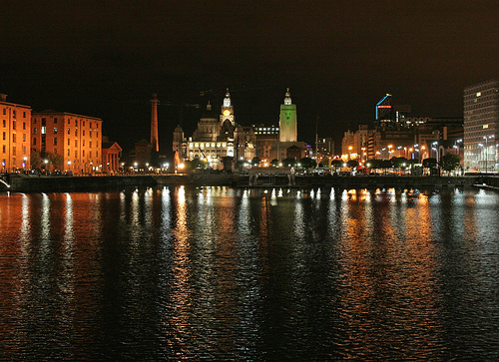
The Albert Dock is a five or ten minute walk from the town centre, but once you’re there you’ll find a lot of what to see in Liverpool is concentrated in this area — museums, an art gallery, bars, restaurants and boat tours, for example. The Tate Liverpool gallery is free for everyone, and is home to modern art with special temporary exhibitions put on throughout the year.
As mentioned above, there’s The Beatles Story museum, along with the Maritime museum, and the International Slavery museum.
You can also check out the skyline of Liverpool from nearly 200ft in the air, on the Liverpool Echo wheel, a smaller version of the London Eye. If you’re at the Albert Dock, then you have to get on the Duckmarine – a tour bus that also doubles up as a boat, and ends in the water of the dock. The Duckmarine tours the city so you can see the likes of St George’s Hall, The Pier Head and The Cathedrals, before you plunge into the water and continue the tour by boat.

Watch a show at the Echo Arena
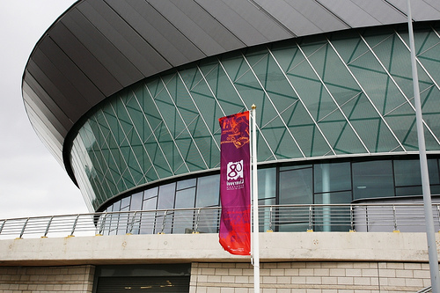
Liverpool has its own concert venue which opened in 2008, and has since been a fixture on many superstar’s world tours, with the likes of Beyonce, Michel Buble, Justin Bieber, Kings of Leon, The Killers, Lady Gaga, Oasis, Katy Perry, Rihanna, Usher and Kanye West all playing there in recent years. The Echo Arena has also hosted WWE events, boxing, football masters, basketball and it is rumoured to be one of the venues under consideration for the next UFC event in the UK.

See a Comedy Gigs or Pantomime
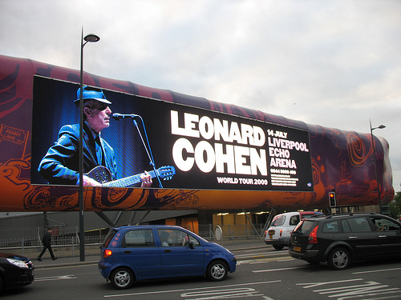
There are a few smaller venues around the city, where there are comedy gigs on most weekends, such as the Slaughterhouse pub, the Royal Court or the Liverpool Empire. The Royal Court and the Empire sometimes act as intimate venues for concerts, although more often than not they are pantomime venues. (And by pantomime, that’s “panto“, not a “mime” – often confused by Americans.)

Visit the World Museum & the Museum of Liverpool
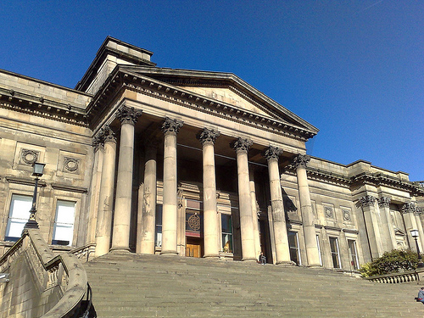
The World Museum is free to enter for everyone, and is home to many different areas including a planetarium, and aquarium, a bug house, a treasure house, films and a discovery centre with musical instruments and various objects from all corners of the globe. There’s also areas dedicated to the ancient world, dinosaurs, space and time – it’s definitely a Liverpool sightseeing highlight. Coming soon is the Museum of Liverpool opening up on the docks which will have four themes: the great port, the global city, the People’s Republic and wondrous place. There will be memorabilia explaining the history of the shipping port of Liverpool, botanic collections, archaeological material and sporting items.
Liverpool was once the “Second City” of the British empire, often surpassing London in terms of trade and commerce. The city has the Guinness Book of World Records title for being the Capitol of Pop (more artists than from any region), and it’s often used as a film backdrop. It was also home to the first passenger-carrying railway in the world.

Watch a football match or Take a stadium Tour
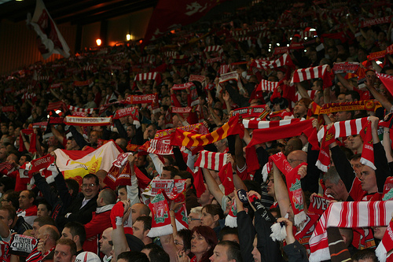
Between August and May, Liverpool and Everton will be playing at home on alternate weekends if you want to watch a game. If you haven’t been to a football game in Britain, you should try it – it can be an eye opening cultural experience.
Tickets can cost up to £45 (approx $75) depending on who they’re playing, and for the bigger games you might struggle to get a ticket, however for most games you should be able to pick up a ticket from the ticket office a few days before the game. On the days before and after a match, many of the hotels in Liverpool get booked up quickly due to the number of supporters who travel over for the weekend to watch their favourite teams in action.
If you can’t get a ticket (or just aren’t that interested), there are tours of both Anfield & Goodison Park stadiums available, and it is less than a mile between the two stadiums. You’ll learn about the history of both clubs, and be taken around the museum and trophy rooms where there’s ample opportunity to take pictures of the vast amounts of silverware on display. At Anfield, there’s the 5 European Cups proudly on display – something no other football team in the country can boast.

Visit the Cathedrals
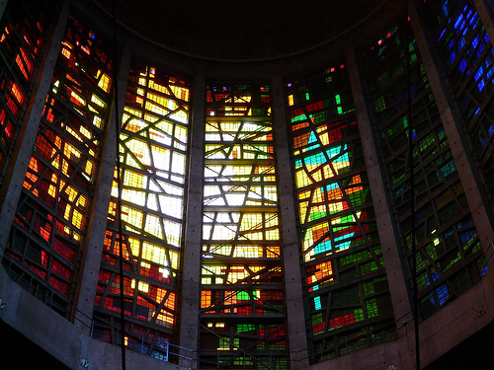
Liverpool is home to two cathedrals, both of which are located on opposite ends of Hope Street, just a few minutes walk apart. Liverpool Cathedral opened in 1978, taking 75 years to complete, and although it is a place of worship, it is often used as a base for learning courses. You are still free to visit and take pictures in and around the grounds, with guided tours available.
At the other end of the street stands Liverpool Metropolitan Cathedral, known by locals as ‘Paddy’s Wigwam’ due to its circular shape with a stunning stained glass ceiling. There are four large bells outside which ring out loudly on before evening prayers, and on Sunday mornings.

Go Shopping!
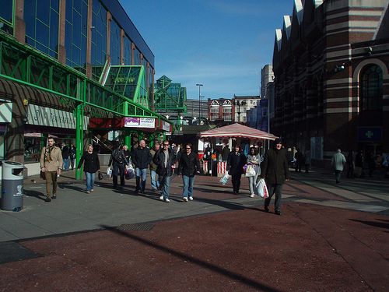
The recently opened Liverpool One development has over 160 stores ranging from clothing to jewellery to technology & music stores, featuring high street names and designer brands. Just round the corner from Liverpool One is the Metquarter, a small shopping centre with designer stores in – you might even spot a celebrity shopping in there.

Eat!
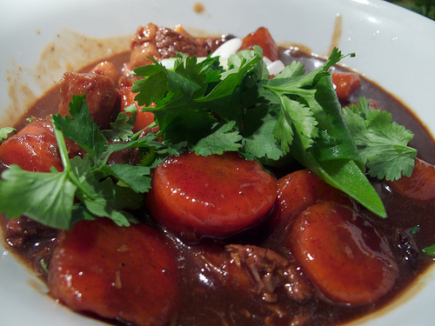
Above Liverpool One there are a number of restaurants offering everything from sushi to burgers, pizzas and burritos, all at a relatively low price. Celebrity chef Jamie Oliver has his own Italian restaurant there, while around the town there’s something for everyone – Chinese, Indian, Mexican, French, Spanish Tapas and a new Catalan restaurant. Try a bowl of scouse, an old fashioned Liverpudlian stew that includes lamb or beef, cabbage, carrot, potatoes and onion.

Watch Live Music
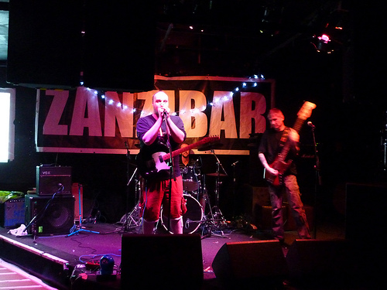
Music and Liverpool are synonymous with each other, again because of The Beatles, but today many of the city’s bars have live music on where you can catch tribute acts or local bands playing their own tunes. Check out The Cavern Pub, Lennon’s Bar, Heebie Jeebies, The Shipping Forecast, Zanzibar club, Bumper or O’Neills to hear everything from rock to traditional Irish music – it’s cheap entertainment that can create a great atmosphere, so head to one of the above mentioned and see what’s on offer.
As you can see, when it comes to choosing what to see in Liverpool, there are a number of choices; pick a few priorities and build your Liverpool sightseeing experience around that. The best part about it is that all the landmarks and things to do are within short distance of each other, so you’ll never have to venture out too far to be entertained.
http://www.orangesmile.com/destinations/liverpool/

