Shakespeare's Birthplace
(материал к презентации «Stratford-upon- Avon, England»)

Шайдурова Валентина Федоровна
Учитель английского языка
ГБОУ «Школа №106»
Санкт-Петербург

2015

Материал «Shakespeare's Birthplace» является частью проекта «Города Англии», который можно использовать к презентации «Stratford-upon- Avon, England» как дополнительную информацию на уроках страноведения.
Материал на английском языке. Рекомендуется учащимся с хорошим уровнем языковой подготовки для создании проектных работ.

Shakespeare's Birthplace

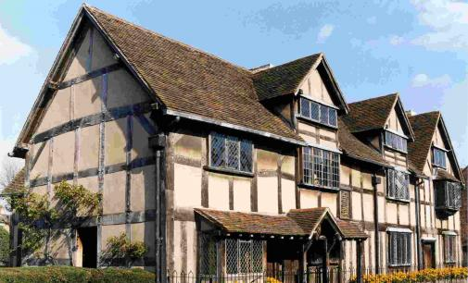
- Previous

- Next
Shakespeare's Birthplace from Henley Street

This is where the Shakespeare story began.
William Shakespeare was born in this house and lived here until he was old enough to marry and spend the first five years of family life here with his new wife, Anne Hathaway.
For millions of Shakespeare enthusiasts worldwide, this house is a shrine. Here you will discover the world that shaped the man and find out what other famous writers thought when they visited here. Follow in the footsteps of not only Shakespeare, but other well-known visitors such as Charles Dickens, John Keats, Walter Scott and Thomas Hardy.
Shakespeare's Birthplace is a fascinating house that offers a glimpse into Shakespeare's early world.

Highlights at Shakespeare's Birthplace
What on Earth? Giant Wallbook of Shakespeare
Come and see our giant wallbook on display in the garden at Shakespeare's Birthplace. See 38 of his plays unfold before your eyes on a timeline that stretches over 9 meters!
Plus
Watch Shakespeare's plays being brought to life by our very own troupe of professional actors, Shakespeare Aloud! You can see live performances every day, so join in with the actors and request an excerpt from your favourite play.
Visit the Shakespeare's Treasures Exhibition, showcasing a selection of treasures from our Collections. A new display of items is curated every 6 months, so there's always something new to discover!

Children's Activities
Be sure to look out for the latest puzzles, quizzes and trails to help bring your visit to life!
July - October:
Shakespeare's Hidden Animal trail. Find the animals hidden in the house and discover how Shakespeare wrote about them in his plays.
Shakespeare Word Hunt. Find Shakespeare's words hidden around the house and garden and discover what their meaning was in Tudor England!
Poetry Festival Make and Take. (2 Jul - 2 Aug) Join in with our Poetry Festival and write your very own poetry in the Birthplace cafe.

While you're here, you may be invited to record a video for the Birthplace blog, Living Shakespeare, where you can hear the stories of some of our visitors from all over the world.
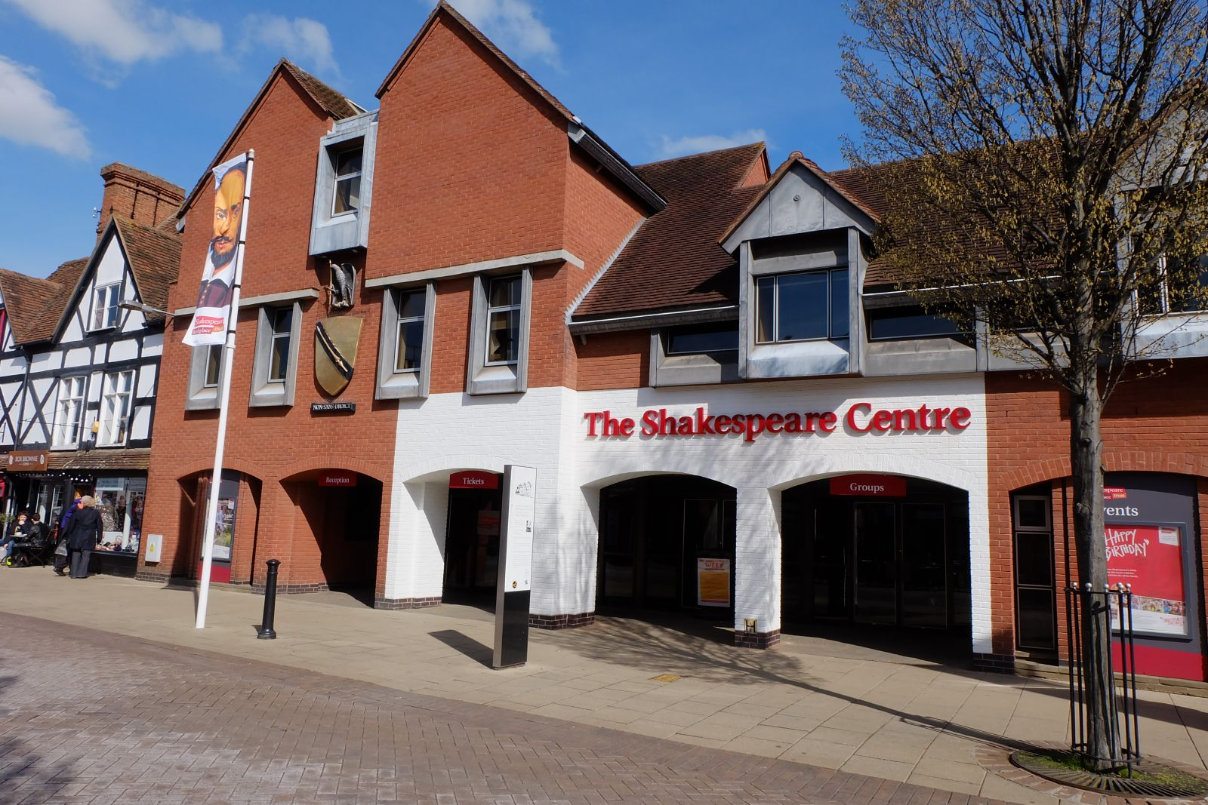

Tickets and location
Save on tickets with the Shakespeare Five House Pass; including entry to all 5 of Shakespeare’s family homes and Shakespeare’s final resting place at Holy Trinity Church.
Shakespeare's Birthplace is situated on Henley Street in the town centre of Stratford-upon-Avon.
Dogs are welcome in the gardens at Shakespeare's Birthplace, provided they are accompanied and on a lead.
The Shakespeare Centre,
Henley St,
Stratford-upon-Avon,
Warwickshire
CV37 6QW
Tel: 01789 204016

Read visitors' reviews of their visit to Shakespeare's Birthplace:
Shakespeare's Birthplace was rewarded The Certificate of Excellence for consistently earning exceptional traveler ratings over the past year. See what people have to say about us and add a review of your own:

http://www.shakespeare.org.uk/visit-the-houses/shakespeares-birthplace.html
http://www.shakespeare.org.uk/home.html
http://english-globe.ru/index.php?id=255&Itemid=57&option=com_content&task=view
http://fr.slideshare.net/jmpcard/stratford-uponavonshakespeares-birthplace

