What a Great Way to Celebrate Apple Day
(материал к презентации «How to Make an Apple Pie»)

Шайдурова Валентина Федоровна
Учитель английского языка
ГБОУ «Школа №106»
Санкт-Петербург

2015
Материал «What a Great Way to Celebrate Apple Day» предназначен для уроков по страноведению и внеурочной работы по английскому языку по теме «Праздники и традиции Великобритании».
В данной подборке материала рассказывается о традициях празднования «Apple Day», даны рецепты приготовления традиционного английского яблочного пирога и яблочного соуса, а также яблочное меню монастыря Ampleforth Abbey.

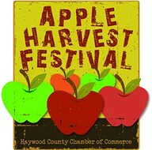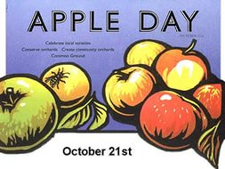

What a Great Way to Celebrate Apple Day!

What is Apple Day?
Tuesday October 21st is British Apple Day, a day when throughout Britain we celebrate our wonderful native apples.
The Romans first brought the apple to the Britain and how hard it is to imagine our landscape without the orchard or gardens without the apple tree. Nevertheless, if we let things continue the way they have in recent times, this, sadly, will be the reality. The arrival of cheap imported supermarket fruits – polished impostors with their EU imposed shape and size – has led to a rapid decline of many orchards with the loss of many old applevarieties.
The charity Common Ground, started Apple Day in 1990, it is now held every year on October 21st. Apple Day is recognized throughout the country with apple festivals, events, competitions – The Longest Peel – but mainly the day raises awareness of the fantastic apples we have.
There are over 1200 native apples for eating, cooking, as well as for cider making and crab apples for pickling. They have enchanting names: Acklam Russets, Barnack Beauty, Nutmeg Pippin, Knobby Russet and many more. Despite this, most growers concentrate on a few commercially proven varieties, leaving us with little choice.

Apple Day Lunch at Ampleforth Abbey
To celebrate Apple Day events are held throughout the UK and at one beautiful setting, three chefs gathered together to prepare and serve a wonderful apple-inspired menu to an appreciative audience, which I am happy say included me.
The setting for the lunch was Ampleforth Abbey, a monastery of Benedictine Monks in the picturesque Howardian Hills in North Yorkshire. As well as being a monastery, Ampleforth is also a school and college and is home to 2 hectares of around 2,000 apple trees of rare varieties tended by the monks. The coven of chefs whipping up their magical food was Michelin starred chef Andrew Pern from the Star at Harome, the lovely chef Stephanie Moon, and chef Darren Clemmit from The White Swan Inn, Pickering.
This inspirational menu from three of Yorkshire's top chefs show the versatility of apples and as can be seen in the menu below, there is so much to do with them than just a pie or sauce (not there's an thing wrong with either.
Each dish had been carefully thought through to make the most of the varying tastes, textures, juices and by-products (cider, brandy) of the heritage Ampleforth Apples. As would be expected from chefs of this calibre the food was beautifully presented and executed.
The apples shone through in some of the dishes (Pork Fillet Stuffed with Apples) or provided a lovely support to other ingredients and dishes (Date and Pippin Puree, Vanilla Rice Pudding) or were part of the cooking process (the marinade for the salmon, the juices for the partridge). It was very innovative and clever cooking.
It would be unfair to single out one single dish as the menu was a careful balance whole with each component accommodating the next in the same way the impeccable service supported the food. A very agreeable lunch.
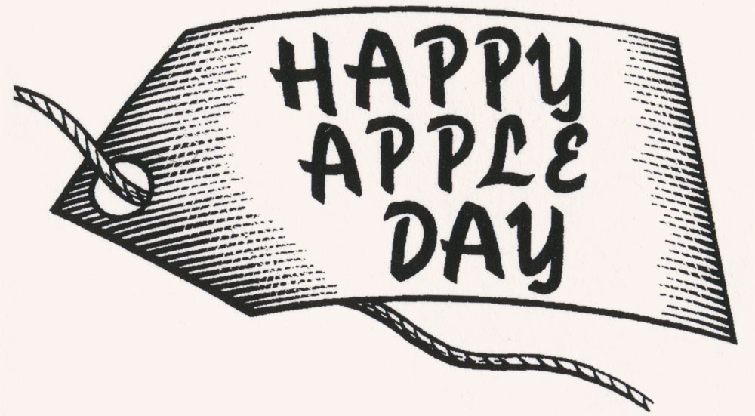

Ampleforth Abbey, Michelin-Starred Apple Lunch Menu
Canapes by Darren Clemmit
- Home-smoked Venison Haunch with Fennel and Apple Remoulade.
- Ampleforth Abbey Brandy Cured Gravlax on Sourdough Toasts and Potato Salad
Starter by Stephanie Moon, Executive Chef, Rudding Park
Textures of Local Pork with Ampleforth "Ingrid Marie" Apples
- Potted Pork, Black Pudding, Crispy Crackling, Crispy Pancetta, Braised Pork Belly in Ampleforth Cider, Pork Fillet Stuffed with Lord Lambourne Apples from the orchard.
Fish and Main Course by Chef Andrew Pern, The Star at Harome
- Gratin of Ampleforth Cider-Poached Whitby Turbot with Creamed Celeriac, Egremont Russet Apples, "Sauce Mousseline"
- Pot Roasted Riveaulx Grey Legged Partridge with Faggot of Cockpit Apple, Wilted Curly Kale, Date and Pippin PurÃ©e. York Ham and Ampleforth Abbey Brandy Juices, Autumn Truffle Mash
Dessert by Darren Clemmit, The White Swan Pickering
- Vanilla Rice Pudding with Spiced Sunset Apples and Raisin Compote
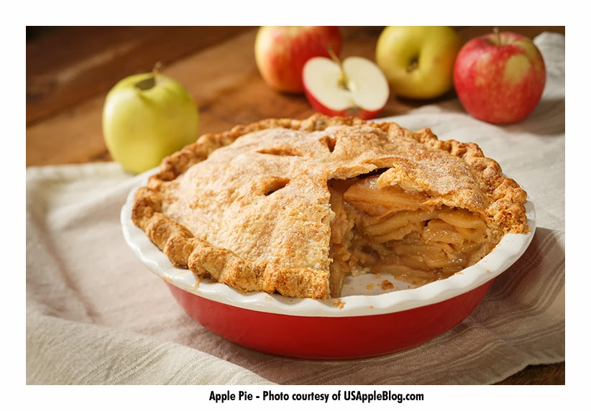

Traditional British Apple Pie
A British apple pie has to be the classic dessert or tea time treat. It is the stalwart of baking and I have yet to meet someone who does not enjoy a slice of the pie.
Practically every country has their own style of pie and this one is a traditional British and Irish one. Cinnamon for me is an option (i am not a huge lover of the flavour, much preferring just apple and sugar) but that is up to you and your taste.
This traditional British recipe is quick and easy and ensures a perfect result every time. Use cooking or Bramley apples for the best filling, eating apples don't soften the same way.

Ingredients
- Pastry
- 200g / 1 2/3 cups all purpose/plain flour
- pinch of salt
- 110g / 4 oz, cubed butter or an equal mix of butter and lard
- 2-3 tbsp cold water
- Filling
- 700g / 1 ½ lb cooking apples, peeled, cored and quartered
- 2 tbsp lemon juice
- 110g / 4 oz sugar
- 4 - 6 tbsp cold water
- 1 level tsp ground cinnamon (optional)
- 25g / 1 oz butter
- Milk to glaze
- Prep Time: 30 minutes
- Cook Time: 25 minutes
- Total Time: 55 minutes
- Yield: Serves 6

Preparation
- Place the flour, butter and salt into a large clean bowl.
- Rub the butter into the flour with your fingertips until the mixture resembles fine breadcrumbs, working as quickly as possible to prevent the dough becoming warm.
- Add the water to the mixture and using a cold knife stir until the dough binds together, add more cold water a teaspoon at a time if the mixture is too dry.
- Wrap the dough in Saran wrap/Clingfilm and chill for a minimum of 15 minutes, up to 30 minutes.
The dough can also be made in a food processor by mixing the flour, butter and salt in the bowl of the processor on a pulse setting. When the mixture resembles breadcrumbs, add the water, slowly, through the funnel until the dough comes together in a ball. Wrap in Saran wrap/ Clingfilm and chill as above Heat the oven to 220°C/425°F/gas 7.
- Meanwhile simmer the apples with the lemon juice and water in a large pan until soft. Add the sugar and cinnamon to the cooked apples. Remove from the heat and add the butter and leave to cool.
- Roll out half the pastry and line a 13cm / 7" pie dish. Put the cooled, cooked apple mixture into the pastry case.
- Roll out the remaining pastry to make a lid for the pie. Damp the edges of the pastry in the dish with a little cold water, cover with the lid, press the edges firmly together and crimp to decorate.
- Brush the top of the pie with milk and bake at the top of a hot oven for 20 - 25 minutes.
- Serve hot or cold with cream, ice cream or custard sauce.

Make Applesauce!

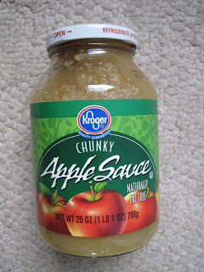
If the UK has so many apple varieties that they want to save but are not supermarketable, then why not make applesauce out of them? I’ve never understood why applesauce is sold in such tiny jars in England. In the States, a typical jar of applesauce (pictured) is 25 ounces / 1 lb 9 oz / 708 grams or about 1 quart’s worth (that’s not imperial quarts, mind). The large jar weighs 50 oz / 3 bl 2 oz / 1.41 kg. And it’s not eaten by the spoonful as a condiment but by the bowl full like real fruit.

So in England, if you want to eat applesauce by the bowlful, then make your own. You don’t have to use Bramley apples but any kind will do, and it’s dead easy. And if you want all the healthy stuff in them (eating an apple a day is now scientifically proven to be healthwise), leave the skins on.

• core and cut up four larger apples into bitesize pieces
• boil them in an inch of water in a saucepan until soft, about 10 minutes (or longer if quite runny in order to boil off some of the fluid)
• remove from heat and mash up with a potato masher
• stir in ¼ cup of sugar and cinnamon to taste

Voila! You have made applesauce! Now, if everyone used UK apples in all their knobbly, blemished varieties to make applesauce, we would really be helping to keep our apple diversity alive. Then if the companies would follow suit and made larger jars of UK applesauce, we would really be on a roll

http://www.bbc.com/news/uk-15412169
http://gleeb-livinginengland.blogspot.ru/2011/10/apple-day-in-uk.html
http://gleeb-livinginengland.blogspot.co.uk/2011/10/make-applesauce.html
http://britishfood.about.com/od/festivecooking/ss/Celebrate-Apple-Day.htm

