**Marie Curie**

**Кроссворд**

**для учащихся 8 класса**

**Spotlight – 8 Module 3d p.48**

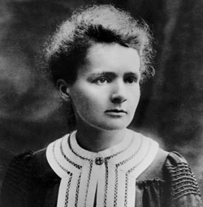

**Автор:**

**Ольга Михайловна Степанова**

**учитель английского языка**

**МБОУ «Цивильская СОШ №1 имени М.В. Силантьева»**

**города Цивильск Чувашской Республики**

**2015**

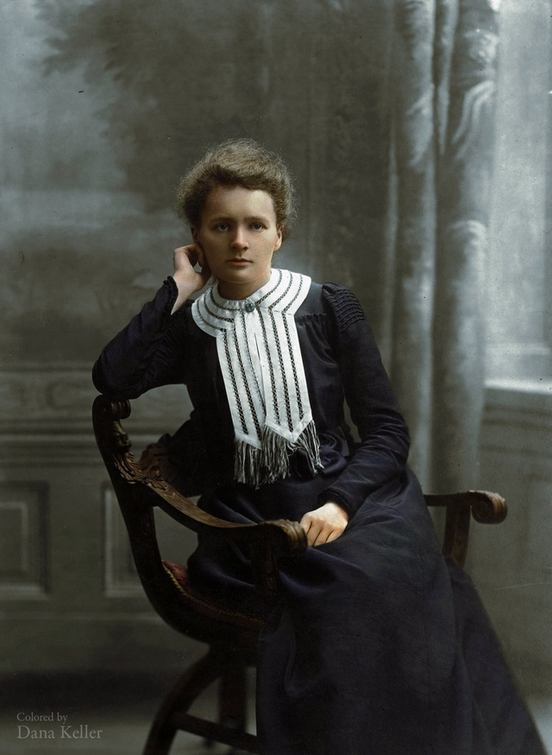



**Across**

2. When she graduated from university , she started research for ... . (9)

5. In 1906 her husband died in an ... . (8)

9. Maria became a ... to a family. (5)

10. They won a Nobel Prize in ... in 1903. (7)

12. It took them four years to isolate the radioactive source which she named ... . (6)

15. During World War I she designed the first mobile X-Ray ... . (7)

16. Her parents brought her up to love ... . (8)

18. We all owe Marie Curie our respect and ... . (10)

19. Her ... worked as teachers. (7)

**Down**

1. She died of ... poisoning . (9)

2. She enjoyed her term and could send ... to her father and her sister. (5)

3. She met soon Pierre Curie, a young ... . (8)

4. Maria was the youngest of five children in the ... . (6)

6. In 1911 she got a Nobel Prize in ... . (9)

7. Maria died in ... 1934 in Paris. (4)

8. Maria's sister Bronya was studying madicine in ... . (5)

10. Maria Curie was born in Warsaw, ... in 1867. (6)

11. Her ... died in 1877. (6)

13. Marie and Pierre started examining ... and other elements. (7)

14. When her sister Bronya got married, she invited Maria to live with them and study at the ... . (8)

16. Pierre and Marie fell in ... immediately and got married. (4)

17. Maria studied Fhysics and ... . (5)

Адрес для решения кроссворда в онлайн режиме

<file:///C:/Users/1/Desktop/Marie%20Curie.html>

Ответы:



.

**Across**

**2. MAGNETISM**—When she graduated from university , she started research for ... .

**5. ACCIDENT**—In 1906 her husband died in an ... .

**9. TUTOR**—Maria became a ... to a family.

**10. PHYSICS**—They won a Nobel Prize in ... in 1903.

**12. RADIUM**—It took them four years to isolate the radioactive source which she named ... .

**15. MACHINE**—During World War I she designed the first mobile X-Ray ... .

**16. LEARNING**—Her parents brought her up to love ... .

**18. ADMIRATION**—We all owe Marie Curie our respect and ... .

**19. PARENTS**—Her ... worked as teachers.

**Down**

**1. RADIATION**—She died of ... poisoning .

**2. MONEY**—She enjoyed her term and could send ... to her father and her sister.

**3. SCENTIST**—She met soon Pierre Curie, a young ... .

**4. FAMILY**—Maria was the youngest of five children in the ... .

**6. CHEMISTRY**—In 1911 she got a Nobel Prize in ... .

**7. JULY**—Maria died in ... 1934 in Paris.

**8. PARIS**—Maria's sister Bronya was studying madicine in ... .

**10. POLAND**—Maria Curie was born in Warsaw, ... in 1867.

**11. MOTHER**—Her ... died in 1877.

**13. URANIUM**—Marie and Pierre started examining ... and other elements.

**14. SORBONNE**—When her sister Bronya got married, she invited Maria to live with them and study at the ... .

**16. LOVE**—Pierre and Marie fell in ... immediately and got married.

**17. MATHS**—Maria studied Fhysics and ... .