**The Thames**

**Кроссворд**

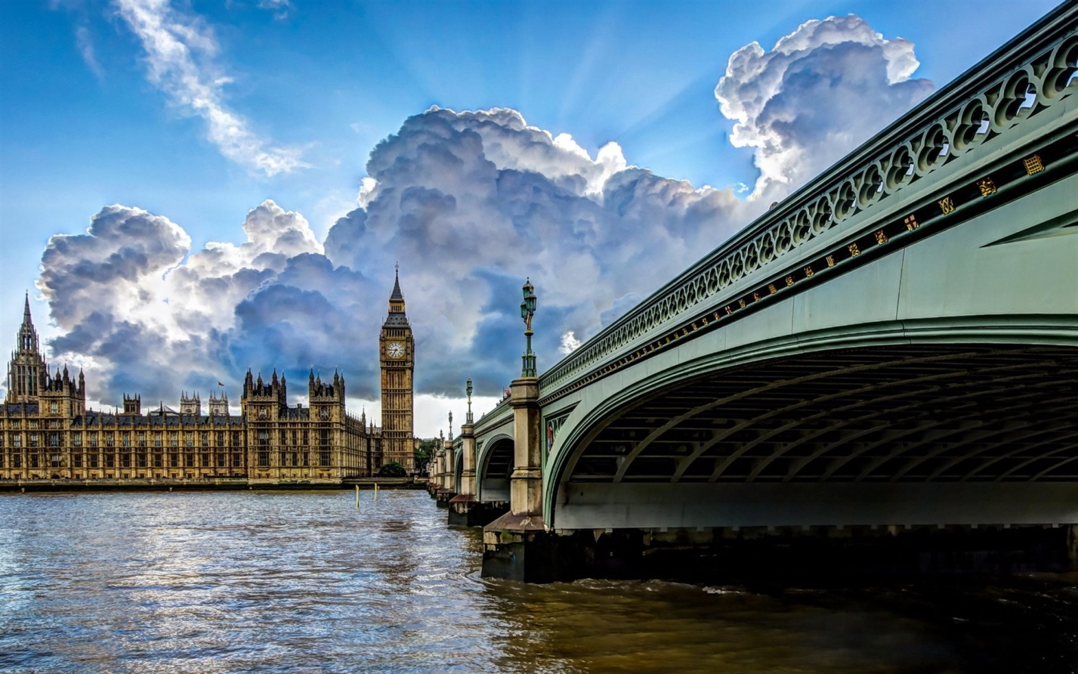**для учащихся 8 класса**

**Spotlight-8 Module 6 Culture Corner p.101**

**Автор:**

**Ольга Михайловна Степанова**

**учитель английского языка**

**МБОУ «Цивильская СОШ №1 имени М.В. Силантьева»**

**города Цивильск Чувашской Республики**

**2015**

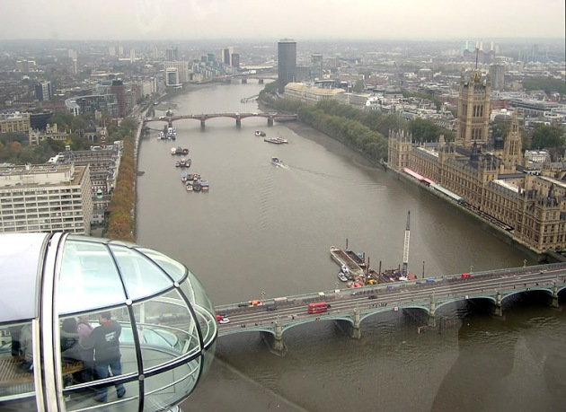****

**Across**

2. Thirsty ... and sheep were aa common sight along the banks of the Thames. (4)

4. Today the Thames has become a ... of London, just as much as Big Ben or Buckingham Palace. (6)

6. People from the London area got their drinkable ... from the Thames. (5)

7. People became rich and many of them built beautiful houses to live in along the ... of the river. (5)

10. London would not be ... without the river Thames. (6)

12. The famous London's rowing event , the Oxford and Cambridge Boat ... , takes place on the river every spring. (4)

13. The Thames has played an extremely important part in making ... what it is today. (7)

14. People could also send supplies of food and other goods to and from London by ... . (4)

15. If you take a stroll along its banks, you'll have a day full of pleasant ... . (9)

16. England had very few roads in the past, so the Thames provide a major ... between London and many parts of the country. (7)

**Down**

1. The most famous bridge across the Thames is ... Bridge. (5)

3. Tower Bridge across the Thames opens up 1,000 times a year to let ... through. (5)

5. In times of war, London was protected from sea attacks because they built castles and forts at the ... of the river. (5)

6. With the industrial Revolution in the 18th century, the Thames became one of the busiest ... in the world. (9)

7. You can admire ... built across the river in many different architectural styles. (7)

8. The famous writer Charles Dickens spent of his ... there and later wrote about the Thames in his books. (9)

9. Whether you are a Londoner or a visitor , the Thames will always have ... to offer you. (9)

11. The Thames flows 215 miles across the countryside and then through the .... of the great city before it reaches the sea. (5)

Адрес для решения кроссворда в онлайн режиме

<file:///C:/Users/1/Desktop/the%20thames%20crossworddd.html>

Ответы:



**Across**

**2. COWS**—Thirsty ... and sheep were a common sight along the banks of the Thames.

**4. SYMBOL**—Today the Thames has become a ... of London, just as much as Big Ben or Buckingham Palace.

**6. WATER**—People from the London area got their drinkable ... from the Thames.

**7. BANKS**—People became rich and many of them built beautiful houses to live in along the ... of the river.

**10. LONDON**—London would not be ... without the river Thames.

**12. RACE**—The famous London's rowing event , the Oxford and Cambridge Boat ... , takes place on the river every spring.

**13. ENGLAND**—The Thames has played an extremely important part in making ... what it is today.

**14. BOAT**—People could also send supplies of food and other goods to and from London by ... .

**15. SURPRISES**—If you take a stroll along its banks, you'll have a day full of pleasant ... .

**16. HIGHWAY**—England had very few roads in the past, so the Thames provide a major ... between London and many parts of the country.

**Down**

**1. TOWER**—The most famous bridge across the Thames is ... Bridge.

**3. SHIPS**—Tower Bridge across the Thames opens up 1,000 times a year to let ... through.

**5. MOUTH**—In times of war, London was protected from sea attacks because they built castkes and forts at the ... of the river.

**6. WATERWAYS**—With the industrial Revolution in the 18th century, the Thames became one of the busiest ... in the world.

**7. BRIDGES**—You can admire ... built across the river in many different architectural styles.

**8. CHILDHOOD**—The famous writer Charles Dickens spent of his ... there and later wrote about the Thames in his books.

**9. SOMETHING**—Whether you are a Londoner or a visitor , the Thames will always have ... to offer you.

**11. HEART**—The Thames flows 215 miles across the countryside and then through the .... of the great city before it reaches the sea.