Penrhyn Castle
(материал к презентации"Penrhyn Castle, Wales")

Шайдурова Валентина Федоровна
Учитель английского языка
ГБОУ «Школа №106»
Санкт-Петербург

2016

Материал "Penrhyn Castle" является частью проекта «Уэльс прекрасный», который можно использовать к презентации "Penrhyn Castle, Wales")как дополнительную информацию на уроках страноведения.

Материал дан на английском языке и будет полезен обучающимся для подготовки

Penrhyn Castle

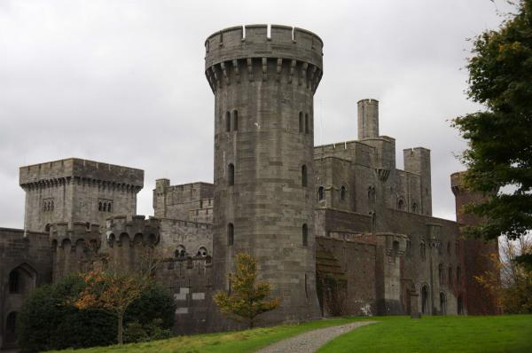

Penrhyn Castle is a country house in Llandegai, Bangor, Gwynedd, North Wales, in the form of a Norman castle. It was originally a medieval fortified manor house, founded by Ednyfed Fychan. In 1438, Ioan ap Gruffudd was granted a licence to crenellate and he founded the stone castle and added a tower house. Samuel Wyatt reconstructed the property in the 1780s.

The present building was created between 1820 and 1845 to designs by Thomas Hopper, who expanded and transformed the building beyond recognition. However a spiral staircase from the original property can still be seen, and a vaulted basement and other masonry were incorporated into the new structure. Hopper's clients were the Pennant family, who had made their fortune from Jamaican sugar and local slate quarries. As such, it may be viewed as a monument commemorating the lives of the slaves whose labour and suffering created it.

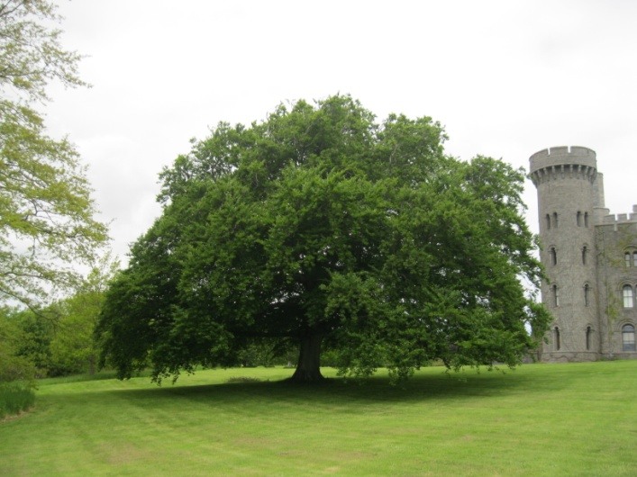

Penrhyn is one of the most admired of the numerous mock castles built in the United Kingdom in the 19th century; Christopher Hussey called it, "the outstanding instance of Normal revival." ["English Country Houses: Late Georgian" (1988 edition), page 181. ISBN 1-85149-032-9] The castle is a picturesque composition that stretches over 600 feet from a tall donjon containing family rooms, through the main block built around the earlier house, to the service wing and the stables.

Penrhyn Castle occupies one acre (.4ha), with curtain walls, four towers and a massive keep. The main rooms are done in the same style as the exterior, with fairy-tale Gothic embellishments. There is a grand hall, library and drawing room, and a grand staircase with carvings of heads and human hands. An ebony room shows off furniture made of real ebony.

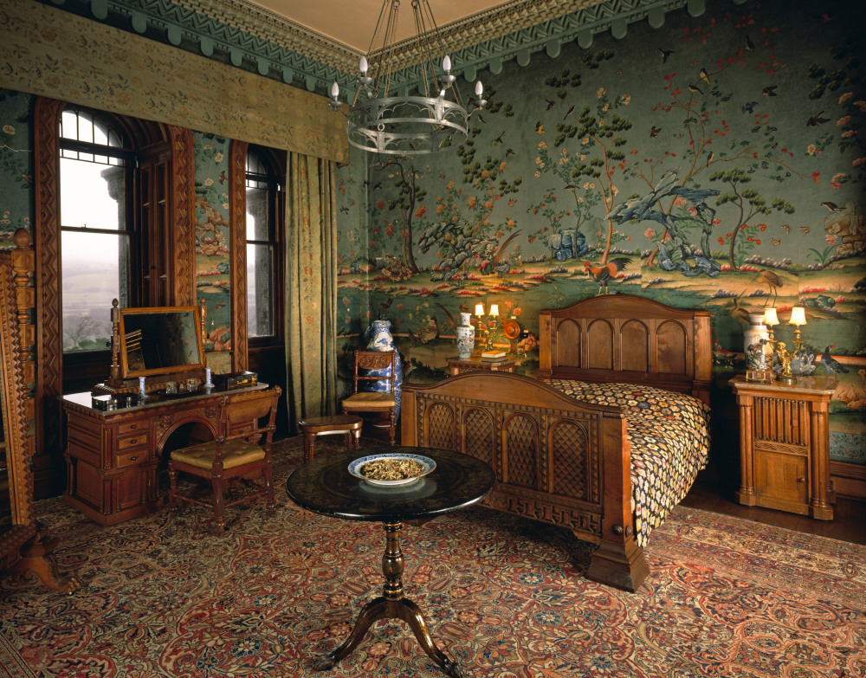

It is in a very solid, sombre style which allows it to possess something of the medieval fortress air despite the ground-level drawing room windows. Hopper designed all the principal interiors in a rich but restrained Norman style, with much fine plasterwork and wood and stone carving. The castle also has some specially designed Norman style furniture, including a one ton slate state bed used by Queen Victoria when she visited in 1859.

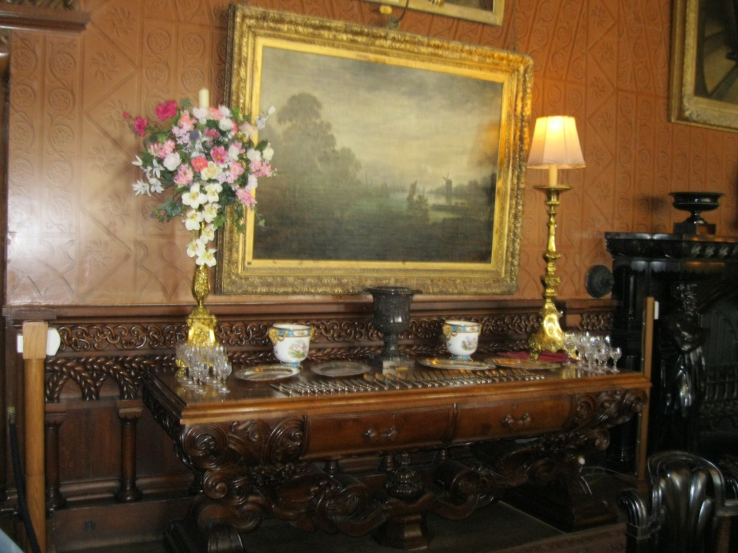

A collection of Old Masters paintings is part of the castle's treasures.

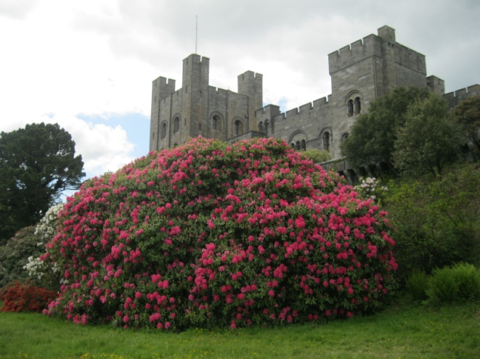

A 40 acre garden surrounds the house. The gardens are decidedly Victorian in character, with a formally terraced walled garden, lawns, a wild garden, and carefully decorative pools.

In 1951 the castle and 40,000 acres (160 km²) of land were accepted by the Treasury in lieu of death duties. It now belongs to the National Trust and is open to the public. Penrhyn's attractions include a formal walled garden, extensive informal gardens, a dolls museum, an industrial railway museum, a model railway museum and an adventure playground. It has views over the Snowdonia mountains.

The castle is also used by the People to People Ambassador Program for delegates to rappel down with the Full On team, a New Zealand group helping children to reach outside their comfort zones through team building activities.

http://en.academic.ru/dic.nsf/enwiki/2453482
http://www.britainexpress.com/attractions.htm?attraction=504

