**Муниципальное Бюджетное Общеобразовательное Учреждение**

**«Цивильская средняя общеобразовательная школа №1**

**имени Героя Советского Союза М.В. Силантьева»**

**города Цивильск Чувашской Республики**

**Apples**

**from all over the world**

**Развлекательно-познавательный кроссворд**

**для учащихся 7-11 классов**

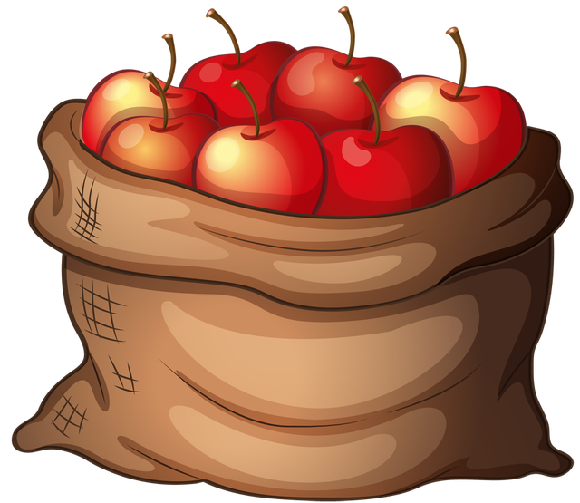

**Автор:**

**учитель английского языка**

**Степанова Ольга Михайловна**

**2017**

**C:\Users\Учитель\Desktop\apples 2.wmf**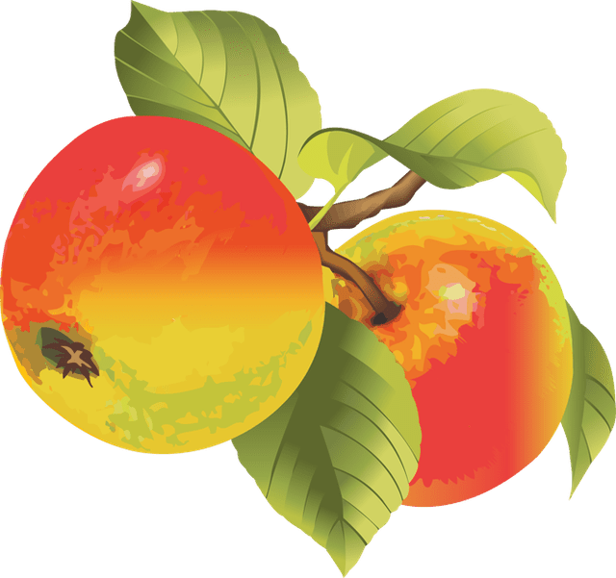

**Across**

1. The ___________ may be dark, but the apples have been counted. Afghan proverb

3. A worm-eaten apple on a branch until the first _________.Russian proverb.

4. One of the two partners always bites the best ________ of the apple.Indian proverb

5. Take an apple for eating, a pear for tasting, but a __________ - bite and throw. Chechen proverb

7. A bad ________ does not yield good apples.English proverb.

8. Better an apple __________ than apple blossom.English proverb

9. An apple thrown into the _________ will turn thousand times before it reaches the ground.Persian proverb

14. A __________ from the hand of a friend is an apple. Moroccan proverb

15. Apple blossoms are beautiful, but _________ dumplings are better.Japanese proverb

16. The old ___________ gets the apple.French proverb

17. Give an apple to the little ones, a _________ to the old.Sicilian saying

18. The nice apples are always eaten by nasty __________. Bulgarian proverb

19. If there is no apple one eats a little ___________.Latvian proverb

20. From the __________ to the apples (Ab ovo usque ad mala). Latin proverb

**Down**

1. He that is won with a _________ , may be lost with an apple. Galician proverb

2. ________ ate the apple, and our teeth still ache. Hungarian proverb.

4. A __________ tree cannot bear an apple. Bosnian saying.

5. If the ___________ wants an apple, his servants take the tree.German proverb

6. The best apple is eaten by the ___________ .Turkish proverb

7. The apple is sweetest at the __________ of the tree.American proverb

10. An apple in the morning - a _________ on the heart, a pear in the morning — a poison on the heart. Oriental proverb

11. No apple tree is immune from __________ . Russian proverb

12. In a world full of apples be a _____________ .American saying

13. Different men have different opinions: some prefer apples, some ___________. Indonesian proverb

15. There was not enough _________ for an apple to drop ( a room is really crowded ).Russian saying

17. One bad apple spoils the whole __________.English proverb

Ответы ниже.

Ответы:



**Across**

**1. NIGHT**—The ___________ may be dark, but the apples have been counted. Afghan proverb

**3. WIND**—A worm-eaten apple on a branch until the first _________.Russian proverb.

**4. PART**—One of the two partners always bites the best ________ of the apple.Indian proverb

**5. PLUM**—Take an apple for eating, a pear for tasting, but a __________ - bite and throw. Chechen proverb

**7. TREE**—A bad ________ does not yield good apples.English proverb.

**8. PIE**—Better an apple __________ than apple blossom.English proverb

**9. AIR**—An apple thrown into the _________ will turn thousand times before it reaches the ground.Persian proverb

**14. STONE**—A __________ from the hand of a friend is an apple. Moroccan proverb

**15. RICE**—Apple blossoms are beautiful, but _________ dumplings are better.Japanese proverb

**16. MONKEY**—The old ___________ gets the apple.French proverb

**17. BOOK**—Give an apple to the little ones, a _________ to the old.Sicilian saying

**18. PIGS**—The nice apples are always eaten by nasty __________. Bulgarian proverb

**19. CARROT**—If there is no apple one eats a little ___________.Latvian proverb

**20. EGG**—From the __________ to the apples (Ab ovo usque ad mala). Latin proverb

**Down**

**1. NUT**—He that is won with a _________ , may be lost with an apple. Galician proverb

**2. ADAM**—________ ate the apple, and our teeth still ache. Hungarian proverb.

**4. PEAR**—A __________ tree cannot bear an apple. Bosnian saying.

**5. PRINCE**—If the ___________ wants an apple, his servants take the tree.German proverb

**6. BEAR**—The best apple is eaten by the ___________ .Turkish proverb

**7. TOP**—The apple is sweetest at the __________ of the tree.American proverb

**10. ROSE**—An apple in the morning - a _________ on the heart, a pear in the morning — a poison on the heart. Oriental proverb

**11. WORMS**—No apple tree is immune from __________ . Russian proverb

**12. PINEAPPLE**—In a world full of apples be a _____________ .American saying

**13. ONIONS**—Different men have different opinions: some prefer apples, some ___________. Indonesian proverb

**15. ROOM**—There was not enough _________ for an apple to drop ( a room is really crowded ).Russian saying

**17. BUNCH**—One bad apple spoils the whole __________.English proverb

Источник информации , взятый для составления кроссворда:

Proverbs and sayings about apples <http://toncha.org/catalog/en/ItemDetail.aspx?itemId=i32&word=apple>