**Муниципальное Бюджетное Общеобразовательное Учреждение**

**«Цивильская средняя общеобразовательная школа №1**

**имени Героя Советского Союза М.В. Силантьева»**

**города Цивильск Чувашской Республики**

**Nessie**

**Учебный кроссворд для учащихся 9 класса**

**по теме See it to believe it: Модуль 3, урок 3a**

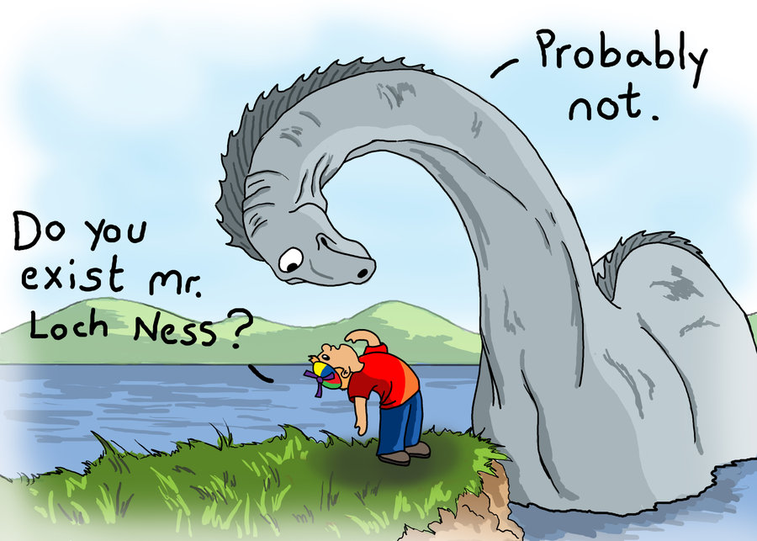

**Автор:**

**учитель английского языка**

**Степанова Ольга Михайловна**

**2017**

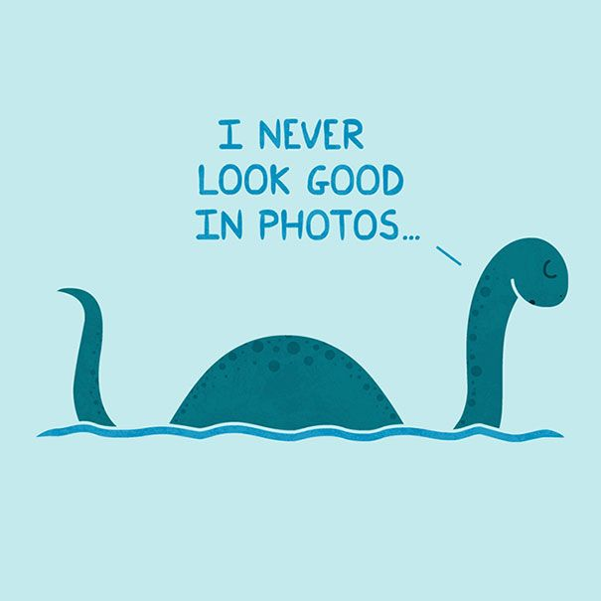



**Across**

1. Since 1901, Nessie hunters have used underwater cameras, sonar, fish bait, and even submarines to try to locate the ____________ . (8)

4. The loch contains more fresh water than all the lakes in England and ___________ combined. (5)

5. George Spicer stated that the Loch Ness Monster was 4 feet high, 25 feet long and had a long neck that looked like an elephant’s ___________ . (5)

9. About 40 small rivers and streams run into the loch, and the water level in Loch Ness can be adjusted by several feet by the local power company, to prevent ____________ . (8)

10. There are two Loch Ness Monster visitor centres and _______________ . (7)

14. In 2014, it was reported that the Loch Ness Monster could be seen using ____________ Maps. (5)

17. The Loch Ness Monster is also known by its nickname, ‘_____________’. (6)

19. The first full scientific survey of Loch ____________ was carried out in 1901. (4)

21. In 2003, the BBC TV network commissioned a show that did a thorough search of Loch Ness. They found nothing and concluded that the Monster was a ____________ . (4)

22. There are many explanations for the Loch Ness Monster. Some believe that people have misidentified other animals or ___________ ; others think that it has always been a hoax. (7)

23. 1934 also saw an expedition to Loch Ness by Edward Mountain, who stationed 20 men around the Loch from 9am to 6pm every day, for 5 weeks. They never found any ______________ of the Monster. (8)

**Down**

2. Some scientists think that a family of creatures might have become trapped in the loch at the end of the last ice __________ , about 10,000 years ago. (3)

3. In 1933, a man claimed the monster crossed the __________ in front of him – a sighting which led to increased interest. (4)

4. The monster has appeared in hundreds of books, films and TV shows, becoming the most famous lake monster in the ___________ . (5)

6. The first ever photograph of the Loch Ness Monster was taken on December 6th, 1933, by Hugh Gray and was published in the Daily Express _______________ (10)

7. The waters of the loch never freeze over, and millions of peat particles floating in the water give the loch its darkish ____________ . (6)

8. Loch Ness is located in the _____________ of Scotland, a few miles southwest of Inverness. (9)

11. Loch Ness is the second largest loch (________) in Scotland with depths reaching over 750 feet. (4)

12. Loch Ness is part of the 60 mile Caledonian Canal that was constructed in the early 19th ______________ and has 29 locks along its length. (7)

13. Some theories suggest the monster is a huge slug or ____________ . (4)

15. Some people even believed that the Loch Ness Monster was actually an _____________ from a local circus. (8)

16. Loch Ness is famous for its ____________ , known as Nessie, which has supposedly been sighted since the 6th century. (7)

18. The first modern sighting of the Loch Ness Monster was by George Spicer in 1933, who described what he saw as a ‘___________ ’. (6)

20. There is a Loch Ness monster roller-coaster _________ in Busch Gardens in Virginia. (4)

21. Loch Ness is 23 __________ long and about a mile wide for most of its length. (5)

Ответы на следующей странице.

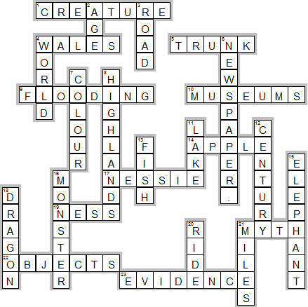

**Across**

**1. CREATURE**—Since 1901, Nessie hunters have used underwater cameras, sonar, fish bait, and even submarines to try to locate the ____________ .

**4. WALES**—The loch contains more fresh water than all the lakes in England and ___________ combined.

**5. TRUNK**—George Spicer stated that the Loch Ness Monster was 4 feet high, 25 feet long and had a long neck that looked like an elephant’s ___________ .

**9. FLOODING**—About 40 small rivers and streams run into the loch, and the water level in Loch Ness can be adjusted by several feet by the local power company, to prevent ____________ .

**10. MUSEUMS**—There are two Loch Ness Monster visitor centres and _______________ .

**14. APPLE**—In 2014, it was reported that the Loch Ness Monster could be seen using ____________ Maps.

**17. NESSIE**—The Loch Ness Monster is also known by its nickname, ‘_____________’.

**19. NESS**—The first full scientific survey of Loch ____________ was carried out in 1901.

**21. MYTH**—In 2003, the BBC TV network commissioned a show that did a thorough search of Loch Ness. They found nothing and concluded that the Monster was a ____________ .

**22. OBJECTS**—There are many explanations for the Loch Ness Monster. Some believe that people have misidentified other animals or ___________ ; others think that it has always been a hoax.

**23. EVIDENCE**—1934 also saw an expedition to Loch Ness by Edward Mountain, who stationed 20 men around the Loch from 9am to 6pm every day, for 5 weeks. They never found any ______________ of the Monster.

**Down**

**2. AGE**—Some scientists think that a family of creatures might have become trapped in the loch at the end of the last ice __________ , about 10,000 years ago.

**3. ROAD**—In 1933, a man claimed the monster crossed the __________ in front of him – a sighting which led to increased interest.

**4. WORLD**—The monster has appeared in hundreds of books, films and TV shows, becoming the most famous lake monster in the ___________ .

**6. NEWSPAPER.**—The first ever photograph of the Loch Ness Monster was taken on December 6th, 1933, by Hugh Gray and was published in the Daily Express _______________

**7. COLOUR**—The waters of the loch never freeze over, and millions of peat particles floating in the water give the loch its darkish ____________ .

**8. HIGHLANDS**—Loch Ness is located in the _____________ of Scotland, a few miles southwest of Inverness.

**11. LAKE**—Loch Ness is the second largest loch (________) in Scotland with depths reaching over 750 feet.

**12. CENTURY**—Loch Ness is part of the 60 mile Caledonian Canal that was constructed in the early 19th ______________ and has 29 locks along its length.

**13. FISH**—Some theories suggest the monster is a huge slug or ____________ .

**15. ELEPHANT**—Some people even believed that the Loch Ness Monster was actually an _____________ from a local circus.

**16. MONSTER**—Loch Ness is famous for its ____________ , known as Nessie, which has supposedly been sighted since the 6th century.

**18. DRAGON**—The first modern sighting of the Loch Ness Monster was by George Spicer in 1933, who described what he saw as a ‘___________ ’.

**20. RIDE**—There is a Loch Ness monster roller-coaster _________ in Busch Gardens in Virginia.

**21. MILES**—Loch Ness is 23 __________ long and about a mile wide for most of its length.

Кроссворд составлен к уроку по учебнику (стр 42-43 ) : Английский язык. 9 класс: учеб. для общеобразоват. учреждений/ (Ю.Е. Ваулина, В. Эванс, Дж. Дули, О.Е. Подоляко) – 2-изд., доп. и перераб. – М.:Express Publishing Просвещение, 2010. – 216 с: ил. – (Английский в фокусе).