**Муниципальное Бюджетное Общеобразовательное Учреждение**

**«Цивильская средняя общеобразовательная школа №1**

**имени Героя Советского Союза М.В. Силантьева»**

**города Цивильск Чувашской Республики**

**Garlic festival**

**Учебный кроссворд для учащихся 9 класса**

**по теме Celebrations: Модуль 1, Grammar Check , стр.139**

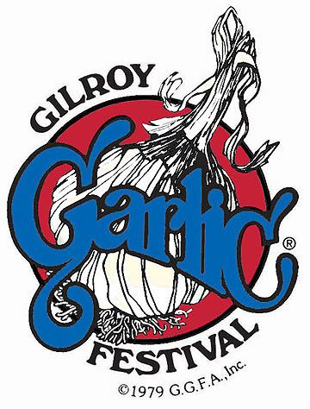

**Автор:**

**учитель английского языка**

**Степанова Ольга Михайловна**

**2017**

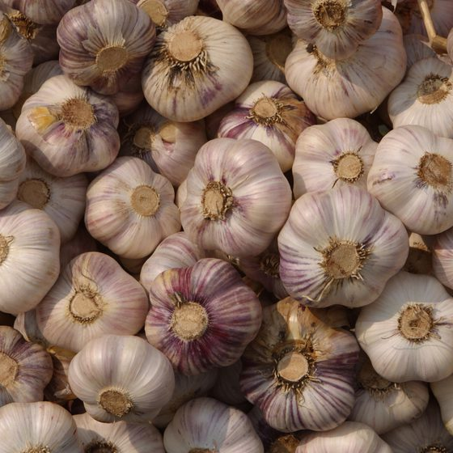****

**Across**

1. The stinking ______________ , aka garlic, is more than just the secret to your awesome sauce. (4)

3. By the way, ____________ gets its name from garlic. (7)

6. Garlic has antibacterial properties and is used to treat infections, stave off colds and flus, lower cholesterol, promote heart _______________ and more. (6)

9. This garlic festival, which started as a regional festival, has now become an international ___________ . (5)

11. Have you ever experienced a garlic __________? (8)

13. Since 1979, when this festival first took __________ , it has raised over S7,500,000! (5)

15. Garlic bulbs are full of Vitamin C, iron, potassium, magnesium, ____________ and more. (4)

17. Garlic also has 17 amino _____________. (5)

20. Each year cooks submit their ___________ and the best ones win a place in the final at the festival. (7)

21. It isn't only adults who can enjoy musical ______________. (13)

**Down**

1. Miss Gilroy Garlic Festival Queen's ___________ , among others, is to represent Gilroy at various festivals. (4)

2. Garlic _____________ who have been trying the unusual recipes for almost 30 years hope to do so for many more years to come. (11)

3. There is also a children’s area where there are arts and crafts and a beauty ____________ . (11)

4. The garlic festival takes place in Gilroy, California, every year on the last full weekend in ___________ . (4)

5. There is also a Miss Gilroy Garlic Festival _____________ . (5)

7. You can dive in and taste garlic ice cream, wear garlic ___________ , watch garlicky cooking shows, and see people dressed up as garlic. (4)

8. If you never experienced a garlic festival, then you have never been to Gilroy, ________________ . (10)

10. Garlic has historically been used to treat snakebites and bug bites, and it is said if you eat enough garlic _____________ will leave you alone. (9)

11. Most garlic festivals have live music, entertainers and people having tons of ____________ with their favorite herb. (3)

12. It is a very popular event and this is the _____________ why you have to book early so as not to miss it! (6)

13. Garlic can heal and even ward off _____________ . (5)

14. Even if attending a garlic festival is not in your plans, remember that National Garlic Day is ____________ 19th and celebrate with a favorite garlic dish or by wearing that garlic shirt you couldn't resist! (5)

16. You can participate in a garlic festival poster _____________ ! (7)

18. Gilroy Garlic Festival features delicies such as garlic fries and garlic ice _____________ . (5)

19. Gilroy is also home to an amusement park, Gilroy Gardens, which includes a spinning-garlic ______________. (4)

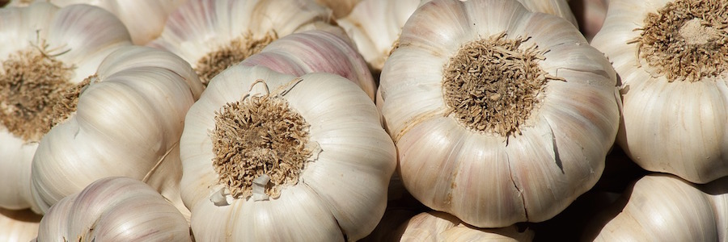

**Ответы на следующей странице**

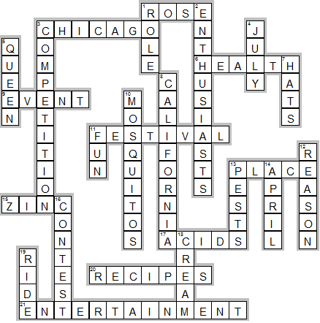

**Across**

**1. ROSE**—The stinking ______________ , aka garlic, is more than just the secret to your awesome sauce.

**3. CHICAGO**—By the way, ____________ gets its name from garlic.

**6. HEALTH**—Garlic has antibacterial properties and is used to treat infections, stave off colds and flus, lower cholesterol, promote heart _______________ and more.

**9. EVENT**—This garlic festival, which started as a regional festival, has now become an international ___________ .

**11. FESTIVAL**—Have you ever experienced a garlic __________?

**13. PLACE**—Since 1979, when this festival first took __________ , it has raised over S7,500,000!

**15. ZINC**—Garlic bulbs are full of Vitamin C, iron, potassium, magnesium, ____________ and more.

**17. ACIDS**—Garlic also has 17 amino _____________.

**20. RECIPES**—Each year cooks submit their ___________ and the best ones win a place in the final at the festival.

**21. ENTERTAINMENT**—It isn't only adults who can enjoy musical ______________.

**Down**

**1. ROLE**—Miss Gilroy Garlic Festival Queen's ___________ , among others, is to represent Gilroy at various festivals.

**2. ENTHUSIASTS**—Garlic _____________ who have been trying the unusual recipes for almost 30 years hope to do so for many more years to come.

**3. COMPETITION**—There is also a children’s area where there are arts and crafts and a beauty ____________ .

**4. JULY**—The garlic festival takes place in Gilroy, California, every year on the last full weekend in ___________ .

**5. QUEEN**—There is also a Miss Gilroy Garlic Festival _____________ .

**7. HATS**—You can dive in and taste garlic ice cream, wear garlic ___________ , watch garlicky cooking shows, and see people dressed up as garlic.

**8. CALIFORNIA**—If you never experienced a garlic festival, then you have never been to Gilroy, ________________ .

**10. MOSQUITOS**—Garlic has historically been used to treat snakebites and bug bites, and it is said if you eat enough garlic _____________ will leave you alone.

**11. FUN**—Most garlic festivals have live music, entertainers and people having tons of ____________ with their favorite herb.

**12. REASON**—It is a very popular event and this is the _____________ why you have to book early so as not to miss it!

**13. PESTS**—Garlic can heal and even ward off _____________ .

**14. APRIL**—Even if attending a garlic festival is not in your plans, remember that National Garlic Day is ____________ 19th and celebrate with a favorite garlic dish or by wearing that garlic shirt you couldn't resist!

**16. CONTEST**—You can participate in a garlic festival poster _____________ !

**18. CREAM**—Gilroy Garlic Festival features delicies such as garlic fries and garlic ice _____________ .

**19. RIDE**—Gilroy is also home to an amusement park, Gilroy Gardens, which includes a spinning-garlic ______________.

Кроссворд составлен к уроку по учебнику (стр 139 ) : Английский язык. 9 класс: учеб. для общеобразоват. учреждений/ (Ю.Е. Ваулина, В. Эванс, Дж. Дули, О.Е. Подоляко) – 2-изд., доп. и перераб. – М.:Express Publishing Просвещение, 2010. – 216 с: ил. – (Английский в фокусе).

Дополнительный источник текста к кроссворду:

Fun Garlic Facts <http://redtri.com/garlic-facts-for-kids/>