**Муниципальное Бюджетное Общеобразовательное Учреждение**

**«Цивильская средняя общеобразовательная школа №1**

**имени Героя Советского Союза М.В. Силантьева»**

**города Цивильск Чувашской Республики**

**Cabbage time**

**Учебный, познавательно-развлекательный кроссворд**

**для учащихся 8 - 11 классов**

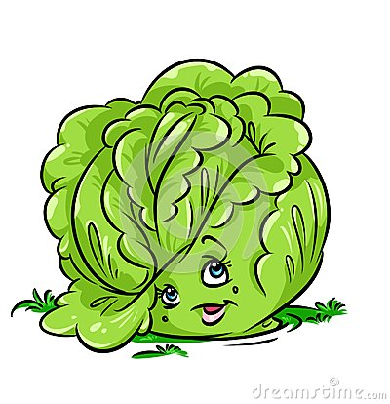

**Автор:**

**учитель английского языка**

**Степанова Ольга Михайловна**

**2017**

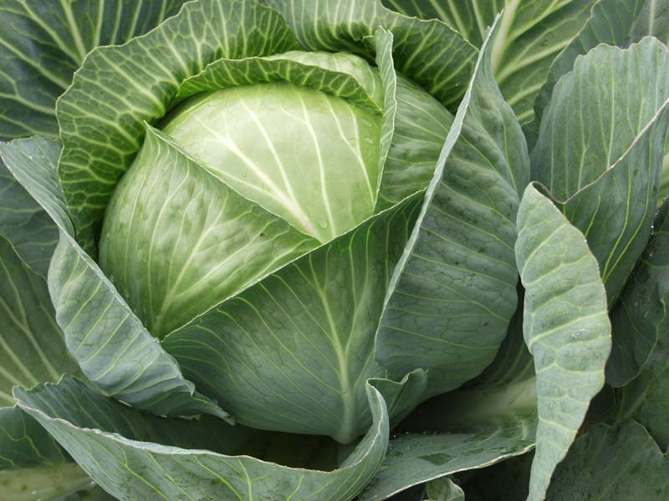

**Across**

2. The rabbit is too honest to steal grapes, and the ________ is too honest to steal cabbage.American proverb

3. When there are many ________ , the cabbage will be spoiled. Ethiopian proverb

4. He who can't get ________ , must be content with cabbage. Danish Proverb

5. He who has plenty of ________ will pepper his cabbage. Romanian Proverb

9. Both the ________ has enough to eat and the cabbage remains. Hungarian Proverb

11. A louse in the cabbage is better than no ________ at all.Dutch proverb

12. Soft words butter no parsnips, but they won't harden the ________ of the cabbage either. Irish Proverb

13. I starve by horseradish and ________ , and white cabbage.Russian saying

14. Know, cabbages, that there is ________ in the stew. Spanish Proverb

19. Throw January cabbages in the ________ . Sicilian Proverb

21. Cabbage is not empty, goes in ________ itself.Russian proverb

**Down**

1. Having a good wife and rich cabbage ________ , seek not other things. Russian proverb

2. Cabbage soup and porridge are our ________ .Russian proverb

4. He who has plenty of ________ , may put some in his cabbage. Danish Proverb

6. He who would have good cabbage, must pay its ________ . Danish Prove

7. If they ask you for cabbages, don't give them ________ . American proverb

8. Fair ________ butter no cabbage. American Proverb

10. Horseradish and radish, ________ and cabbage will not allow the bad.Russian saying

12. When a cabbage tree is broken it shoots up, and grows a new ________ of leaves. Maori prover

15. The ________ became the gardener, is picking carrots, turnips, white cabbages.Russian proverb

16. Cabbage in ________ , sturgeon in March.Russian proverb

17. Some prefer ________ while others like cabbage. Irish Proverb

18. Cabbage twice cooked is ________ . Romanian Proverb

20. He is like the gardener's ________ , who don't eat cabbage and will let no one else eat them. French Proverb

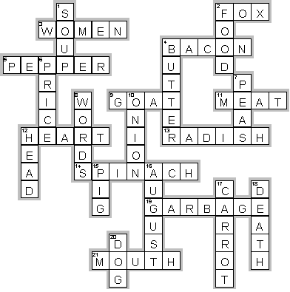

**Across**

**2. FOX**—The rabbit is too honest to steal grapes, and the ________ is too honest to steal cabbage.American proverb

**3. WOMEN**—When there are many ________ , the cabbage will be spoiled. Ethiopian proverb

**4. BACON**—He who can't get ________ , must be content with cabbage. Danish Proverb

**5. PEPPER**—He who has plenty of ________ will pepper his cabbage. Romanian Proverb

**9. GOAT**—Both the ________ has enough to eat and the cabbage remains. Hungarian Proverb

**11. MEAT**—A louse in the cabbage is better than no ________ at all.Dutch proverb

**12. HEART**—Soft words butter no parsnips, but they won't harden the ________ of the cabbage either. Irish Proverb

**13. RADISH**—I starve by horseradish and ________ , and white cabbage.Russian saying

**14. SPINACH**—Know, cabbages, that there is ________ in the stew. Spanish Proverb

**19. GARBAGE**—Throw January cabbages in the ________ . Sicilian Proverb

**21. MOUTH**—Cabbage is not empty, goes in ________ itself.Russian proverb

**Down**

**1. SOUP**—Having a good wife and rich cabbage ________ , seek not other things. Russian proverb

**2. FOOD**—Cabbage soup and porridge are our ________ .Russian proverb

**4. BUTTER**—He who has plenty of ________ , may put some in his cabbage. Danish Proverb

**6. PRICE**—He who would have good cabbage, must pay its ________ . Danish Prove

**7. PEAS**—If they ask you for cabbages, don't give them ________ . American proverb

**8. WORDS**—Fair ________ butter no cabbage. American Proverb

**10. ONION**—Horseradish and radish, ________ and cabbage will not allow the bad.Russian saying

**12. HEAD**—When a cabbage tree is broken it shoots up, and grows a new ________ of leaves. Maori prover

**15. PIG**—The ________ became the gardener, is picking carrots, turnips, white cabbages.Russian proverb

**16. AUGUST**—Cabbage in ________ , sturgeon in March.Russian proverb

**17. CARROT**—Some prefer ________ while others like cabbage. Irish Proverb

**18. DEATH**—Cabbage twice cooked is ________ . Romanian Proverb

**20. DOG**—He is like the gardener's ________ , who don't eat cabbage and will let no one else eat them. French Proverb

# Для составления кроссворда использованы ресурсы:

## Proverbs about cabbage <http://www.special-dictionary.com/proverbs/keywords/cabbage/3.htm>

# Proverbs and sayings about cabbage <http://toncha.org/catalog/en/ItemDetail.aspx?itemId=i32&word=cabbage>