**Муниципальное Бюджетное Общеобразовательное Учреждение**

**«Цивильская средняя общеобразовательная школа №1**

**имени Героя Советского Союза М.В. Силантьева»**

**города Цивильск Чувашской Республики**

**An apple a day…**

**Познавательно-развивающий кроссворд**

**для учащихся 7- 9 классов**

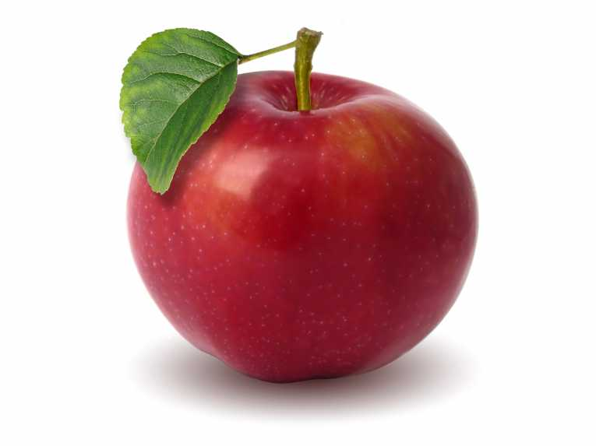

**Автор:**

**учитель английского языка**

**Степанова Ольга Михайловна**

**2017**





**Across**

1. Give an apple to the little ones, a ________ to the old. Sicilian Proverb (4)

5. The rotten apple injures its ________ . Italian Proverb (9)

6. The ________ may be dark, but the apples have been counted. Afghan Proverb (5)

8. The old ________ gets the apple. French Proverb (6)

11. A ________ tree cannot bear an apple. Serbo Croatian Proverb (4)

12. An apple, an egg, and a ________ , You may eat after a slut. French Proverb (3)

13. The apple falls on the ________ that's under it. Irish Proverb (4)

18. One rotten apple in the ________ infects the whole. Dutch Proverb (6)

19. One who doesn't appreciate the apple, won't appreciate the ________. Afghan Proverb (7)

21. Things for ________ , apple, almonds and hazel nuts. Sicilian Proverb (8)

22. Adam ate the apple, and our ________ still ache. Hungarian Proverb (5)

**Down**

1. One bad apple spoils the ________ . German Proverb (5)

2. A ________ from the hand of a friend is an apple. Moroccan Proverb (5)

3. Never look for a ________ in the apple of your eye. French Proverb (4)

4. Apple blossoms are beautiful, but ________ dumplings are better. Japanese Proverb (4)

7. If the prince wants an apple, his servants take the _______. German Proverb (4)

9. Different men have different opinions -- some prefer apples, some ________. Indonesian Proverb (6)

10. One rotten apple spoils the whole ________ . English Proverb (6)

11. The nice apples are always eaten by nasty ________ . Bulgarian Proverb (4)

14. An apple a day keeps the ________ away. English Proverb (6)

15. What's the good of a fair apple if it has a worm in its ________ ? American Proverb (5)

16. There is small ________ in rotten apples. English Proverb (6)

17. If there is no apple one eats a little ________ . Russian proverb (6)

20. Don't upset the apple ________ . American Proverb (4)



**Across**

**1. BOOK**—Give an apple to the little ones, a ________ to the old. Sicilian Proverb

**5. NEIGHBOUR**—The rotten apple injures its ________ . Italian Proverb

**6. NIGHT**—The ________ may be dark, but the apples have been counted. Afghan Proverb

**8. MONKEY**—The old ________ gets the apple. French Proverb

**11. PEAR**—A ________ tree cannot bear an apple. Serbo Croatian Proverb

**12. NUT**—An apple, an egg, and a ________ , You may eat after a slut. French Proverb

**13. HEAD**—The apple falls on the ________ that's under it. Irish Proverb

**18. BASKET**—One rotten apple in the ________ infects the whole. Dutch Proverb

**19. ORCHARD**—One who doesn't appreciate the apple, won't appreciate the ________. Afghan Proverb

**21. CHILDREN**—Things for ________ , apple, almonds and hazel nuts. Sicilian Proverb

**22. TEETH**—Adam ate the apple, and our ________ still ache. Hungarian Proverb

**Down**

**1. BUNCH**—One bad apple spoils the ________ . German Proverb

**2. STONE**—A ________ from the hand of a friend is an apple. Moroccan Proverb

**3. WORM**—Never look for a ________ in the apple of your eye. French Proverb

**4. RICE**—Apple blossoms are beautiful, but ________ dumplings are better. Japanese Proverb

**7. TREE**—If the prince wants an apple, his servants take the _______. German Proverb

**9. ONIONS**—Different men have different opinions -- some prefer apples, some ________. Indonesian Proverb

**10. BARREL**—One rotten apple spoils the whole ________ . English Proverb

**11. PIGS**—The nice apples are always eaten by nasty ________ . Bulgarian Proverb

**14. DOCTOR**—An apple a day keeps the ________ away. English Proverb

**15. HEART**—What's the good of a fair apple if it has a worm in its ________ ? American Proverb

**16. CHOICE**—There is small ________ in rotten apples. English Proverb

**17. CARROT**—If there is no apple one eats a little ________ . Russian proverb

**20. CART**—Don't upset the apple ________ . American Proverb

**Для составления кроссворда использован источник *Famous proverbs*** [***http://www.special-dictionary.com/proverbs/keywords/apple/***](http://www.special-dictionary.com/proverbs/keywords/apple/)