**Муниципальное Бюджетное Общеобразовательное Учреждение**

**«Цивильская средняя общеобразовательная школа №1**

**имени Героя Советского Союза М.В. Силантьева»**

**города Цивильск Чувашской Республики**

**The Power of Chocolate**

**Kроссворд для учащихся 9 -11 классов**

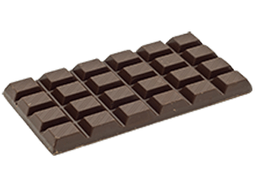 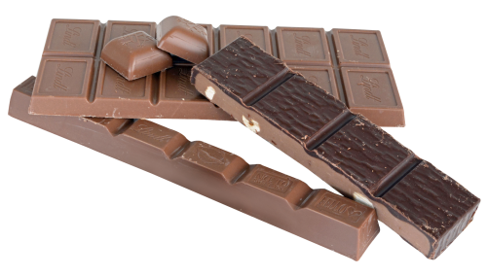

**Автор:**

**учитель английского языка**

**Степанова Ольга Михайловна**

**2018**



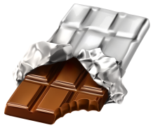



**Across**

3. Dark chocolate bars, which are high in cocoa actually deject tooth decay and can even whiten your ________! (5)

4. Chocolate can be a solid form like a candy ________ or it can be in a liquid form like hot chocolate. (3)

6. Chocolate has great health benefits. It helps with depression, high blood ________, Tumors and Pre-menstrual syndromes. (8)

9. A long time ago, cacao was used as a ________. (8)

12. Chocolate can be deadly for ________. (4)

13. One ounce of baking chocolate or cocoa contains 10% of the daily recommended intake of ________. (4)

14. Chocolate is able to act as an anti-depressant by increasing serotonin and endorphin levels in the ________. (5)

15. The ________ of chocolate increases theta brain waves which triggers relaxation. (5)

18. Scientists have proved against the myth that chocolate cause ________. (4)

21. Chocolate does not cause or aggravate acne, this is a ________. (4)

22. Chocolate contains an ingredient called “Theobromine” which can be toxic to a dogs central nervous ________ and cardiac muscles. (6)

24. About 70% of the world’s cacao is grown in ________. (6)

25. Chocolate magnate, Milton Hershey was a candy _______ in actual. (4)

26. It takes 400 cocoa ________ to make one pound of chocolate. (5)

**Down**

1. Cacao is native to Central and South America, but it is grown commercially throughout the ________. (7)

2. Chocolate grows on the tropical tree called the Theobroma cacao, or simply, “cacao.” Theobroma is Greek for “food of the ________.” (4)

3. Chocolate is a food made from the seeds of a cacao ________. (4)

5. People spend more than $7 billion dollars a ________ on chocolate. (4)

7. Chocolate is actually a valuable energy source. A single chocolate chip can provide enough ________ for an adult human to walk 150 ft. (6)

8. White chocolate does not contain cocoa solids chocolate liquor so technically, it is not a ________. (9)

10. It’s important to find chocolate that has a high cacao ________. (7)

11. Chocolate is a powerful ________. (11)

16. Chocolate is used in many ________ like pudding, cakes, candy, and ice cream. (8)

17. The Cadbury ________ made the first chocolate bar in 1842. (7)

19. ________, the stuff that chocolate is made from, is quite good for you. (5)

20. Eating dark chocolate everyday reduces the risk of ________ disease by one third. (5)

21. It is a known fact that chocolate has caffeine in it. There are about 5 to 10 mg of caffeine in one ounce of bitter chocolate, 5 mg in ________ chocolate, and 10 mg in a six-ounce cup of cocoa. (4)

23. Chocolate is made from a ________ of cocoa tree. (4)

Answers:

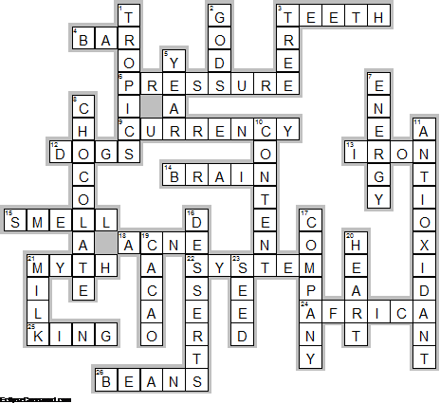

**Across**

**3. TEETH**—Dark chocolate bars, which are high in cocoa actually deject tooth decay and can even whiten your ________!

**4. BAR**—Chocolate can be a solid form like a candy ________ or it can be in a liquid form like hot chocolate.

**6. PRESSURE**—Chocolate has great health benefits. It helps with depression, high blood ________, Tumors and Pre-menstrual syndromes.

**9. CURRENCY**—A long time ago, cacao was used as a ________.

**12. DOGS**—Chocolate can be deadly for ________.

**13. IRON**—One ounce of baking chocolate or cocoa contains 10% of the daily recommended intake of ________.

**14. BRAIN**—Chocolate is able to act as an anti-depressant by increasing serotonin and endorphin levels in the ________.

**15. SMELL**—The ________ of chocolate increases theta brain waves which triggers relaxation.

**18. ACNE**—Scientists have proved against the myth that chocolate cause ________.

**21. MYTH**—Chocolate does not cause or aggravate acne, this is a ________.

**22. SYSTEM**—Chocolate contains an ingredient called “Theobromine” which can be toxic to a dogs central nervous ________ and cardiac muscles.

**24. AFRICA**—About 70% of the world’s cacao is grown in ________.

**25. KING**—Chocolate magnate, Milton Hershey was a candy _______ in actual.

**26. BEANS**—It takes 400 cocoa ________ to make one pound of chocolate.

**Down**

**1. TROPICS**—Cacao is native to Central and South America, but it is grown commercially throughout the ________.

**2. GODS**—Chocolate grows on the tropical tree called the Theobroma cacao, or simply, “cacao.” Theobroma is Greek for “food of the ________.”

**3. TREE**—Chocolate is a food made from the seeds of a cacao ________.

**5. YEAR**—People spend more than $7 billion dollars a ________ on chocolate.

**7. ENERGY**—Chocolate is actually a valuable energy source. A single chocolate chip can provide enough ________ for an adult human to walk 150 ft.

**8. CHOCOLATE**—White chocolate does not contain cocoa solids chocolate liquor so technically, it is not a ________.

**10. CONTENT**—It’s important to find chocolate that has a high cacao ________.

**11. ANTIOXIDANT**—Chocolate is a powerful ________.

**16. DESSERTS**—Chocolate is used in many ________ like pudding, cakes, candy, and ice cream.

**17. COMPANY**—The Cadbury ________ made the first chocolate bar in 1842.

**19. CACAO**—________, the stuff that chocolate is made from, is quite good for you.

**20. HEART**—Eating dark chocolate everyday reduces the risk of ________ disease by one third.

**21. MILK**—It is a known fact that chocolate has caffeine in it. There are about 5 to 10 mg of caffeine in one ounce of bitter chocolate, 5 mg in ________ chocolate, and 10 mg in a six-ounce cup of cocoa.

**23. SEED**—Chocolate is made from a ________ of cocoa tree.

Источники информации , взятые для составления кроссворда:

**10 Delicious Facts about Chocolate** [**http://topfoodfacts.com/10-delicious-facts-about-chocolate/**](http://topfoodfacts.com/10-delicious-facts-about-chocolate/)

**Chocolate facts** [**https://kidskonnect.com/fun/chocolate/**](https://kidskonnect.com/fun/chocolate/)

**Chocolate** [**http://easyscienceforkids.com/best-melting-chocolate-video-for-kids/**](http://easyscienceforkids.com/best-melting-chocolate-video-for-kids/)