**Муниципальное Бюджетное Общеобразовательное Учреждение**

**«Цивильская средняя общеобразовательная школа №1**

**имени Героя Советского Союза М.В. Силантьева»**

**города Цивильск Чувашской Республики**

**The Nobel Prize**

**Crossword for the Students of the 8-10 Grades**

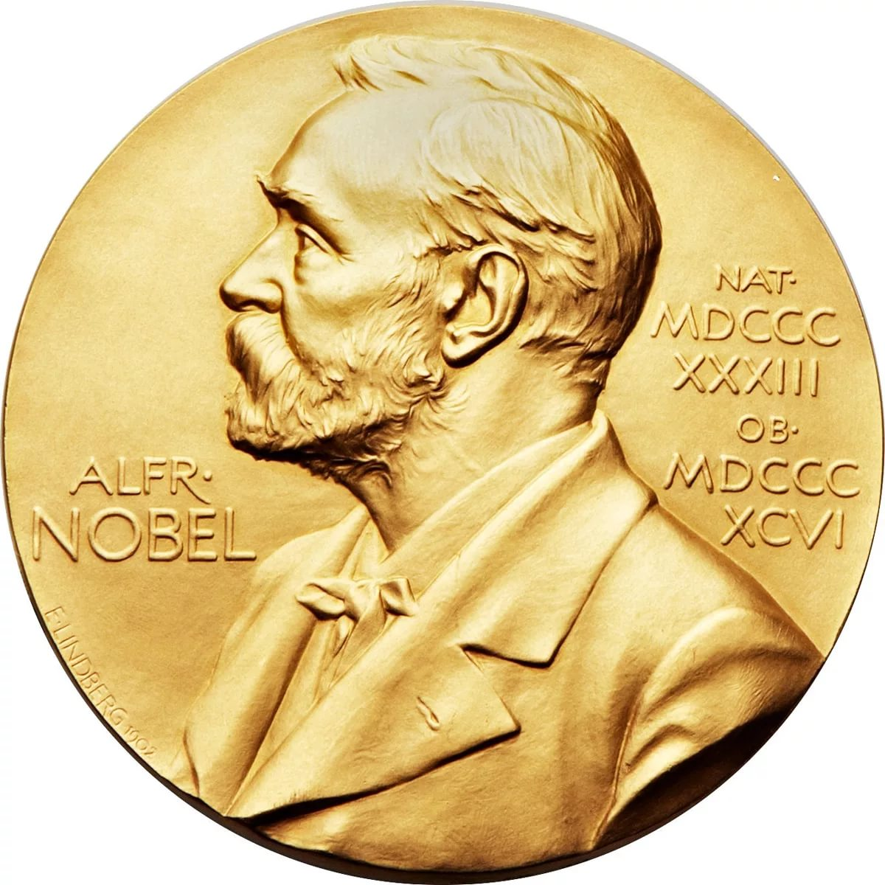

**Автор:**

**учитель английского языка**

**Степанова Ольга Михайловна**

**2018**





**Across**

1. The Nobel prize is awarded for outstanding contribution in the areas of Physics, Chemistry, Physiology or ________ , Literature, Peace and Economic Sciences.

2. In 1901 the Nobel Prize was awarded to Jacobus van’t Hoff, a Dutch ________ , for his contribution to Chemical thermodynamics.

4. The Nobel Prize, considered the most prestigious _________ in the world.

8. Alfred Nobel was a Swedish scientist, ________ and author.

10. In 1901, the Nobel prizes were awarded to Wilhelm Röntgen , a German Physicist, for his contribution to Physics by discovering X -________ .

11. Alfred Nobel wrote in his will, that his vast fortune was to be used to create annual prizes for those who confer the greatest benefit to ________.

12. The oldest Nobel ________ so far, is Leonid Hurwicz, having received the prize at the age of 90, in 2007.

13. The first Nobel ________ were awarded in 1901.

14. In 1901 the Nobel Prize was awarded to Sully Prudhomme, a French ________ , for his contribution to Literature.

15. The Nobel Laureates receive their awards at a ceremony that takes place in ________ on December 10th.

**Down**

1. Each or laureate (recipient) receives a gold ________ , a diploma and a sum of money, which is decided by the Nobel Foundation.

2. Th Nobel Prize is set of annual international awards bestowed on people and organizations for outstanding ________ to mankind in their respective fields.

3. Famous examples include Albert Einstein, Mother ________ , Barack Obama among many others.

5. Nobel was the inventor of ________/

6. The average ________ of Nobel prize winners is 59.

7. The __________ was started by Alfred Nobel.

9. Every year, laureates are awarded this ________ for distinguished advances or achievements in six areas.

13. The youngest Nobel Laureate is Malala Yousafzai, who was awarded the Nobel ________ prize in 2014.

Answers :

**Across:**

**1. MEDICINE**—The Nobel prize is awarded for outstanding contribution in the areas of Physics, Chemistry, Physiology or ________ , Literature, Peace and Economic Sciences.

**2. CHEMIST**—In 1901 the Nobel Prize was awarded to Jacobus van’t Hoff, a Dutch ________ , for his contribution to Chemical thermodynamics.

**4. AWARD**—The Nobel Prize, considered the most prestigious _________ in the world.

**8. INVENTOR**—Alfred Nobel was a Swedish scientist, ________ and author.

**10. RAYS**—In 1901, the Nobel prizes were awarded to Wilhelm Röntgen , a German Physicist, for his contribution to Physics by discovering X -________ .

**11. MANKIND**—Alfred Nobel wrote in his will, that his vast fortune was to be used to create annual prizes for those who confer the greatest benefit to ________.

**12. LAUREATE**—The oldest Nobel ________ so far, is Leonid Hurwicz, having received the prize at the age of 90, in 2007.

**13. PRIZES**—The first Nobel ________ were awarded in 1901.

**14. POET**—In 1901 the Nobel Prize was awarded to Sully Prudhomme, a French ________ , for his contribution to Literature.

**15. STOCKHOLM**—The Nobel Laureates receive their awards at a ceremony that takes place in ________ on December 10th.

**Down**

**1. MEDAL**—Each or laureate (recipient) receives a gold ________ , a diploma and a sum of money, which is decided by the Nobel Foundation.

**2. CONTRIBUTION**—Th Nobel Prize is set of annual international awards bestowed on people and organizations for outstanding ________ to mankind in their respective fields.

**3. TERESA**—Famous examples include Albert Einstein, Mother ________ , Barack Obama among many others.

**5. DYNAMITE**—Nobel was the inventor of ________/

**6. AGE**—The average ________ of Nobel prize winners is 59.

**7. TRADITION**—The __________ was started by Alfred Nobel.

**9. HONOR**—Every year, laureates are awarded this ________ for distinguished advances or achievements in six areas.

**13. PEACE**—The youngest Nobel Laureate is Malala Yousafzai, who was awarded the Nobel ________ prize in 2014.

Источник информации , взятой для составления кроссворда: Nobel Prize Facts <http://mocomi.com/nobel-prize/>