Муниципальное автономное общеобразовательное учреждение
Средняя общеобразовательная школа № 1
Свердловская область, г. Сысерть

Исследовательская работа учащихся 8 класса

Тема: «School magazine helps us to learn English
(Школьный журнал помогает нам учить английский язык)»

Предмет: Английский язык

Руководитель: Ваторопина Елена Васильевна,
учитель английского языка МАОУ СОШ № 1,
высшая квалификационная категория

2021/2022 уч. год
CONTENTS

INTRODUCTION ………………………………………………………. | 3
I. MAKING THE MAGAZINE …………………………………………. | 4
II. SCHOOL MAGAZINE AS A MEANS OF DEVELOPING  STUDENTS' INTEREST IN LEARNING ENGLISH AND FORMING THEIR TOLERANCE AND PATRIOTISM ……………………………. | 7
III. OUR ACHIEVEMENTS ……………………………………………. | 10
CONCLUSIONS ………………………………………………………… | 11
BIBLIOGRAPHY ………………………………………………………. | 12
Appendix 1. Our achievements …………………………………………. | 13

INTRODUCTION

The actuality of the work. The knowledge of the English language is a skill that everyone who wants to be in success should possess. Every educated person should know English, the language of international communication. English is very important for us. We like English and try to do all our best to acquire it.
To have more chances to improve our English we decided to make a school magazine «Friendship». It helps us to develop language skills and expands our knowledge of journalism. It informs, educates and entertains our schoolmates.
School № 1 is the youngest school of Sysert. Our schoolmates and teachers take an active part in school and municipal contests, festivals, Olympiads, sports competitions. «Friendship» lets our schoolmates and teachers know about interesting events and discuss important issues. School magazine tells everyone about our school life and makes us closer to all the society. It became a cultural and educational center of the school.

The aim of our research work is to prove that school English magazine is an effective means of developing students’ interest in learning English and forming their tolerance and patriotism.
The objectives of the work are:
- to describe the process of making our English magazine;
- to give some advice how to make a popular school magazine and to work out the plan for making it;
- to tell about our achievements and plans for the future.

The object of the investigation is students' project and research work.
The subject of the investigation is the process of making school English magazine.

I. MAKING THE MAGAZINE.

The magazine is a way of association of children of different ages. It helps to form public opinion at school, serves a means of development of children’s personality, and promotes a sense of collectiveness.
Creating magazine is very important, because it helps a teenager to solve problems and undertake such actions which would allow the person to find his or her own place in the adult world. It makes it possible to produce something new. It is teenager’s action that enables him to express his own point of view. It is the sphere of pupils’ activity connected with research work, solving problems, composing. Creating magazine schoolchildren develop the following personal abilities: to make a choice and take a decision; to be responsible for these decisions, for oneself and for one’s doings; to be independent. It is participation of schoolchildren in applied activities.
A survey was conducted among the participants of the educational process, its results were analyzed. A meeting of school activists was held. It was decided that the most active students would be the editor-in-chief, correspondents, designers, photographers.
The editor-in-chief should be a leader and a good organizer. His duty is to unite different pupils and inspire them to run collective business. His main responsibility is to manage the newspaper and to make it possible to edit the issue in any circumstances. He solves all the problems concerning the contents, photos, headlines of the issue, he arranges the articles and pictures on the papers, shortens some materials and decides about the print. He makes a model of the issue together with the editor and other pupils.
Correspondents or journalists are the students who find interesting information, collect and analyze it. Then they write articles, interviews and other items. Tastes differ. That is why some pupils write about sport, others are interested in ecological issues, etc.
The designer creates the lay-out of the issue, the cover of the newspaper, makes illustrations to the texts, and works out new styles of a newspaper design. He is supposed to work in different computer programs.
The photographer is a person who takes photos to illustrate the newspaper articles. He can write his own articles, too.
To be popular among the readers the magazine should have fresh ideas, new interpretation of old themes, and new original topics. The magazine should provide its readers with unusual, creative unexpected information, give the ideas to think over and discuss with friends, relatives and teachers. It should be connected with its readers. They should have an opportunity to write to the magazine, to come here with their problems and be sure that the magazine will be able to help them. So, the magazine is successful only if it has close relations with its readers.
One of the most difficult but very interesting stages in creating a magazine is the layout of the magazine. Our English teacher helps us in this work and often gives students useful advice how to make a magazine. A step-by-step guide to getting a magazine you like – https://uchportfolio.ru/public_files/605726047.pdf.
We have already made 22 issues of the magazine.
The main headings in «Friendship» are: School life, My native land, Travelling around the world, Our guests, It is interesting to know, Projects. Investigations, Discussion club, Our achievements.
The main topics for each issue of the journal are discussed by students and teachers.
In the heading «School life» you can see many photos and interesting information about our school life, different events and school activities.
There is a special part for teachers – «Teacher’s comments». In this heading teachers tell students about their life experiences and give advice their students how to improve the English language, how to prepare for exams, and what to do to be able to communicate in English, etc.
«Travelling around the world» is one of the most interesting heading. Teachers and students write about their trips to interesting places of Russia and abroad.
We often have meetings with native English speakers. In 2016 young volunteers from Salt Lake City told us about popular sports in America and Canada. In 2018 and 2019, in our school there were meetings with US citizen Bruce Bertrand. He travels around the world. He has been to many countries and visited Russia several times. Bruce Bertrand told our schoolmates about Lake Placid, his native town, its history and sights, about the Olympic Games and the peculiarities of the English language. He shared his impressions of Russia and his visiting Yekaterinburg and Sysert with all the audience. The students asked him a lot of questions. The members of «Friendship» editorial board told him about their work and presented the guest with the fresh issue of the magazine. Children recited some poems in English for him. After that our guest attended several lessons of English. Our schoolmates made a tour of the school for him. Bruce Bertrand is our correspondent. He often sends us his pictures and articles. Everybody can see his interesting materials in all the issues of the magazine.
In the heading «It’s interesting to know» you can read about things which are interesting for students and teachers. The heading «At your leisure» contains information about where you can relax, what you can read, different crosswords, etc.

The heading «Projects. Investigations» includes information about surveys, research works, and different contests and Olympiads in English. Our schoolmates take part in them and often are in success.
You can read «Friendship» in our school library, in all the English studies, on the school website, «Friendship» website and school YouTube channel «Дружба. Школьные новости». Some information about our school magazine you can find in electronic and print media.
Read our magazine and keep up to date!

II. SCHOOL MAGAZINE AS A MEANS OF DEVELOPING
STUDENTS’ INTEREST IN LEARNING ENGLISH AND FORMING THEIR TOLERANCE AND PATRIOTISM.

Our magazine contains articles written in English, and it is rather difficult for students not only to compose them but also to write them in English correctly. So, our authors are the students who really love English and have fluency in it, and of course our English teachers who always help us. But many students who don’t have fluency in English yet (among them - the pupils of Primary school), want to become correspondents of the school magazine. So, without any doubts, they have to do all their best to improve their English. They have to work hard to learn English grammar and increase their vocabulary. We often read books in English, write compositions and sketches, translate texts from English into Russian and from Russian into English. So, creating our magazine we develop our cognitive interest in learning the foreign language and improve our English.

The heading «Projects. Investigations» contains materials about research works and projects, and contests and Olympiads in English our schoolmates take part in and often are in success, as well as excerpts from students’ research works.
Here you can see some students’ projects:
- «My native land in P.Bazhov's tales»
- «Alice's Adventures in Wonderland by Lewis Carroll: extraordinary world of the fairy tale»
- «We are for healthy way of life»
- «School of the future: what it should be like»
Working in the magazine our schoolmates develop their interest in studying English and Russian literature. They improve their skills in reading and translating. Students broaden horizons and try to do all their best to master the English language.
In the part «Reading is a ticket to everywhere», our students write about the books they have read, about their favorite heroes and their features of character. And some of the students even draw the pictures of the books. In different issues of the magazine we published students’ works and interesting materials about famous foreign and Russian writers, about biographies and literary works of Pavel Bazhov and Lewis Carroll, Katherine Paterson and Billy Collins, Jonathan Swift and Robert L. Stevenson.
You can read some of our schoolmates’ notes and articles in the following issues of «Friendship»: «Pavel Bazhov, the singer of the Urals» - «Friendship» № 1, p. 16-19; «Alice's Adventures in Wonderland by Lewis Carroll: extraordinary world of the fairy tale» - «Friendship» № 3, p. 16-17; «My native land in P.Bazhov's tales» - «Friendship» № 4, p. 16-17; «Alice’s Adventures in Wonderland by Lewis Carroll. Our translations» - «Friendship» № 6, p. 16-17; «Jules Verne – 190», «P.P. Bazhov, our countryman» - «Friendship» № 7, p. 6-7; «Gulliver’s Travels by Jonathan Swift», «Bridge to Terabithia», «Heather Ale by Robert Louis Stevenson», «Enjoy Reading!» - «Friendship» № 10, p. 8-10; «Pavel Bazhov and Sysert», «Heroes of Bazhov’s fairy tales in the monuments of Sysert» - «Friendship» № 17, p. 18-21; «Lermontov State Museum-Reserve» - «Friendship» № 21, р. 14-15. You can read some interesting English proverbs and sayings and about how they reflect the English character in «Friendship» № 19, p. 12-13.
«My native land» is one of the most popular headings of our magazine. The main topics for each issue of the journal are discussed by students and teachers. In each issue there are students’ articles and essays related to the state holidays of Russia (Victory Day, Mother’s Day, Defender of the Fatherland Day), important events in the life of our native town (285th Anniversary of Sysert), materials about our famous countrymen (Pavel Bazhov, the heroes of the Great Patriotic War), interesting places, holidays, festivals, traditions and customs of the peoples of the Urals. Our guys often go on hikes and excursions around the Urals. They share their impressions on the pages of the magazine.
The history of Sysert is the history of the Urals, the history of the whole country. We need to know it in order to become a real patriot of Russia, to understand the prospects for the development of our native land. It is necessary to tell young people more about the history and future of the region where they were born and live, to awaken and develop the interest of schoolchildren in studying their native land, to form a respectful attitude towards the monuments of architecture and the nature of their area.
The 18th issue of «Friendship» contains a research project «Sysert, my native land. Pages of history». Students of 5th-11th classes took part in the project and wrote interesting articles for the magazine. Here you can read about Sysert in different times: Imperial and Soviet eras, and in modern times. Correspondents wrote about heroes of Bazhov’s fairy tales in the monuments of Sysert and natural attractions of Sysert and its surroundings. Some articles are devoted to the project «Improvement of the embankment in Sysert». This project won the All-Russia Contest among the small towns and historical settlements, which was organized on behalf of President Vladimir Putin. The goal of the project is preservation of monuments of industrial heritage, stimulation of the creative economy through the creation of clusters and the production of creative industries and, as a result, the development of the territories surrounding such objects.
To our mind, in the future, the embankment will become a favorite resting place for all residents of Sysert. It will decorate our city and make it even more attractive. Children will have a new place to play, and adults will be able to relax and enjoy nature. Our residents will be given additional new jobs. Thanks to the development of the embankment, more tourists will come to Sysert. Many people will learn about our small, but very beautiful town.
We love our motherland and Sysert, our native town. We are patriots of Russia!

III. OUR ACHIEVEMENTS.

All the students of our school (from 2 to 11 grades) learn English. Many of them are engaged in extracurricular activities in English, working on projects in English. We take an active part in school, municipal, and regional competitions on creativity.
During the last five years we presented our projects and research works in different contests and conferences. In 2016-2021, our students became the prize-winners of International Contest of Projects in English among School and University Students, Open Humanitarian Conference «Malachite Casket», Regional Contest of translations among school students «Young Linguist», All-Russia Contest of Projects «Созидание и творчество», School Poetry Recitation Contest «Victory Poems», and others.

CONCLUSION

The idea of making the school magazine is very interesting for us. We are sure it helps to reveal the active, cute and gifted pupils and teachers, unites people of different age, not indifferent to school problems. Besides, making the school magazine develops positive traditions in school life.
We are sure that our magazine helps us to study English, improve and keep it up. Our magazine helps us keep up to date, discuss and solve school problems. It informs, educates and entertains us. It is an effective means of developing students’ cognitive interest in learning English and forming their tolerance and patriotism, too.
We'll continue our work and try to do all our best to make it interesting, useful and unforgettable.

Our plan for the future:

Dissemination of information about the magazine on the Internet.

Inviting students from other schools, teachers, parents, foreign authors as correspondents.

Increasing complex of project activities for students; introducing new interesting rubrics in the journal; application of modern ICT to create an even more spectacular, informative magazine that meets the requirements of modern print media.

Improving the knowledge of the project participants in the field of journalism by participating in thematic seminars, master classes, contests.

Participation in creative contests, scientific conferences of different levels with presentation and exchange of experience on the topic of the project.

BIBLIOGRAPHY

How to make a magazine: A step-by-step guide to getting a look you love [Электронный ресурс]. – Режим доступа: https://www.canva.com/learn/how-to-recreate-a-magazine-layout-from-scratch/ (дата обращения: 15.11.2021 г.).

Ваторопина Е.В. Мастер-класс «Верстка школьного журнала: советы и рекомендации» [Электронный ресурс]. – Режим доступа: https://uchportfolio.ru/public_files/605726047.pdf (дата обращения: 15.11.2021 г.).

Appendix 1

Our achievements
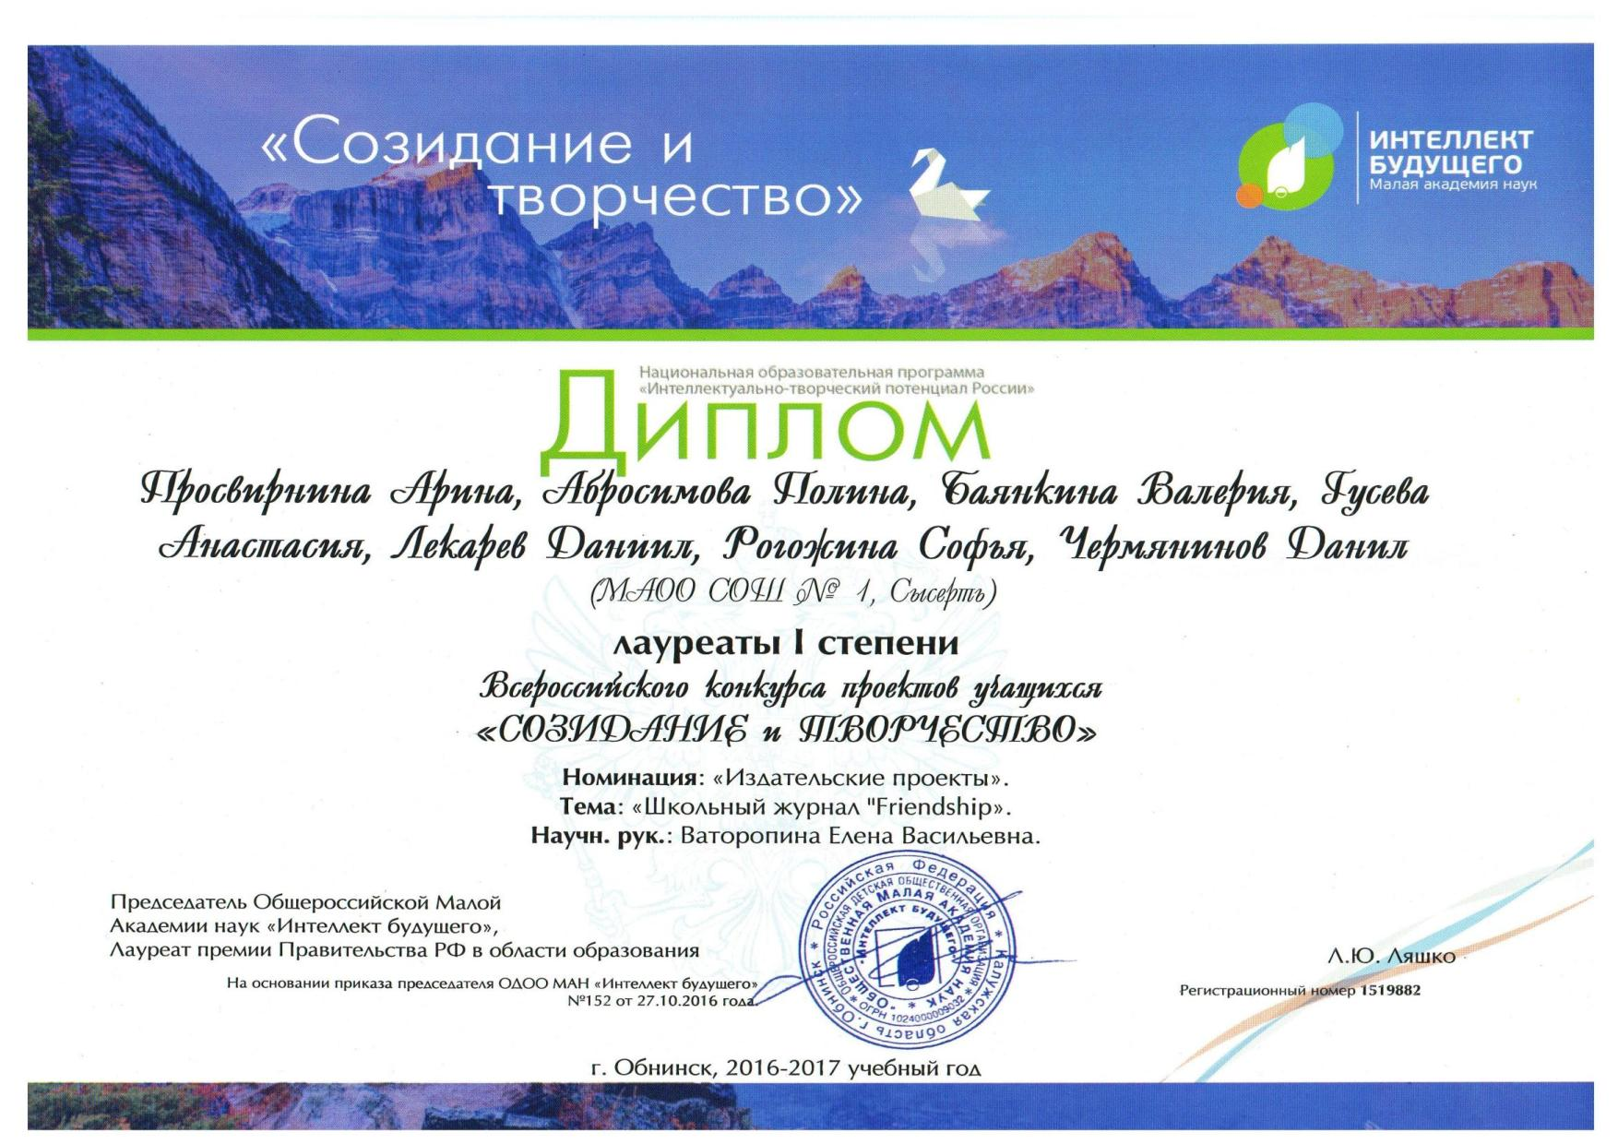 | 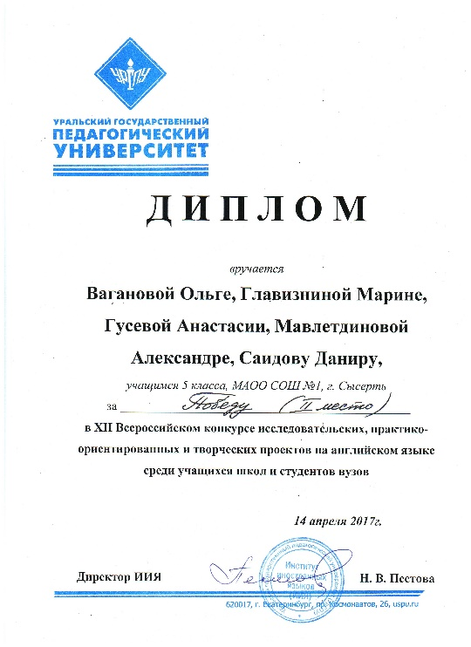
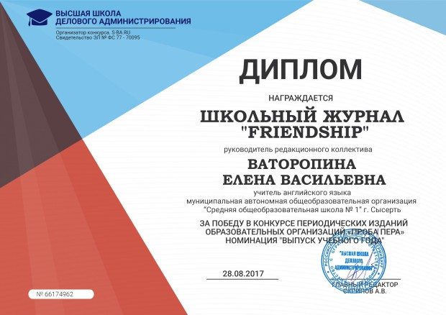 | 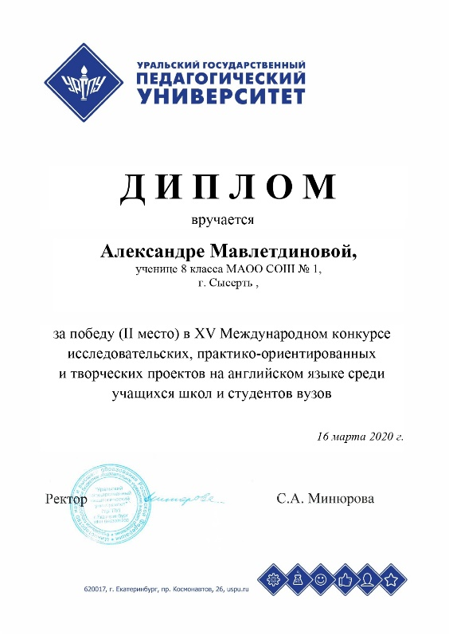

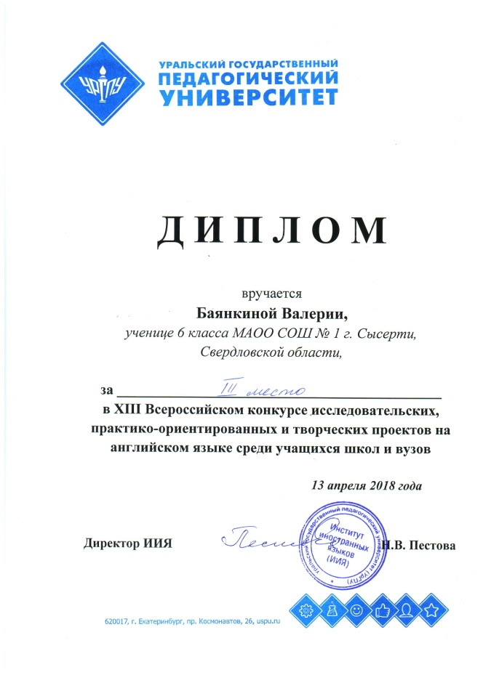 | 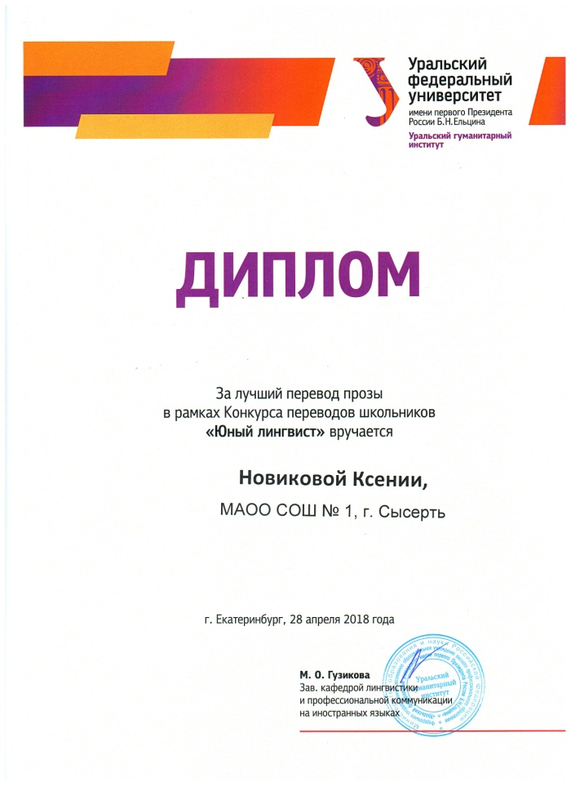
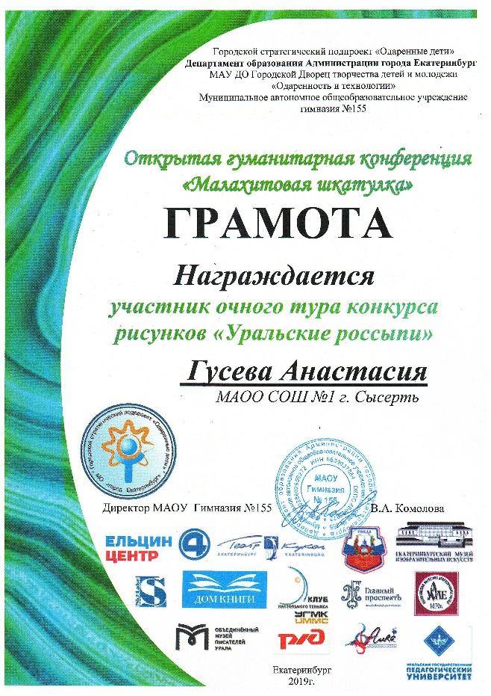 | 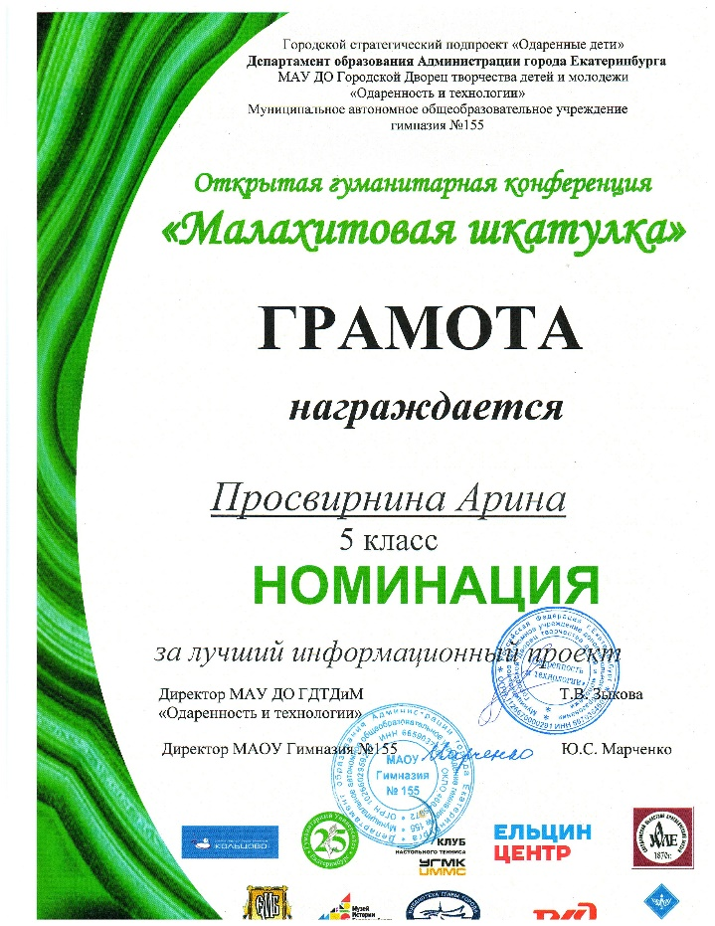

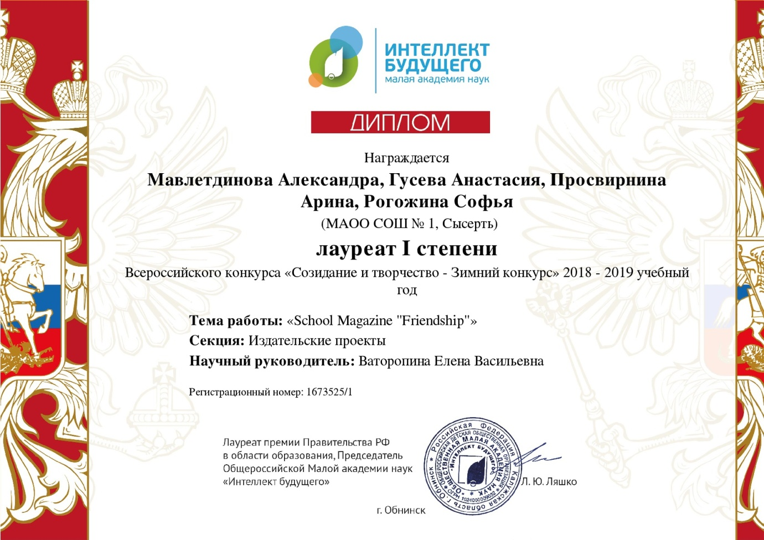 | 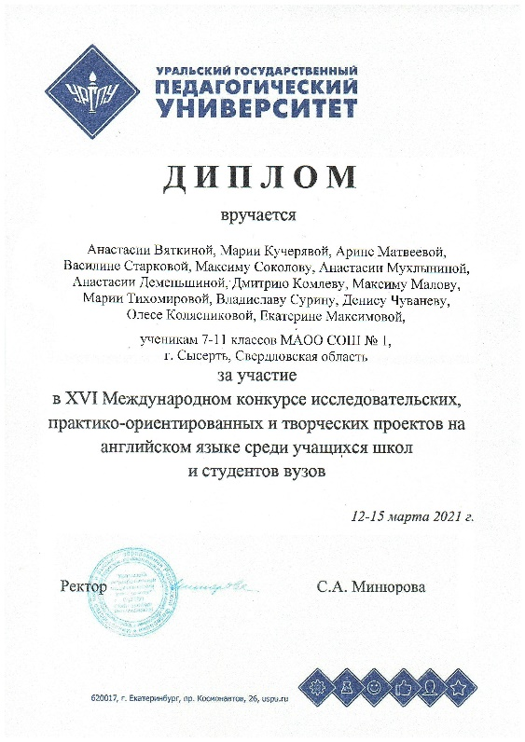
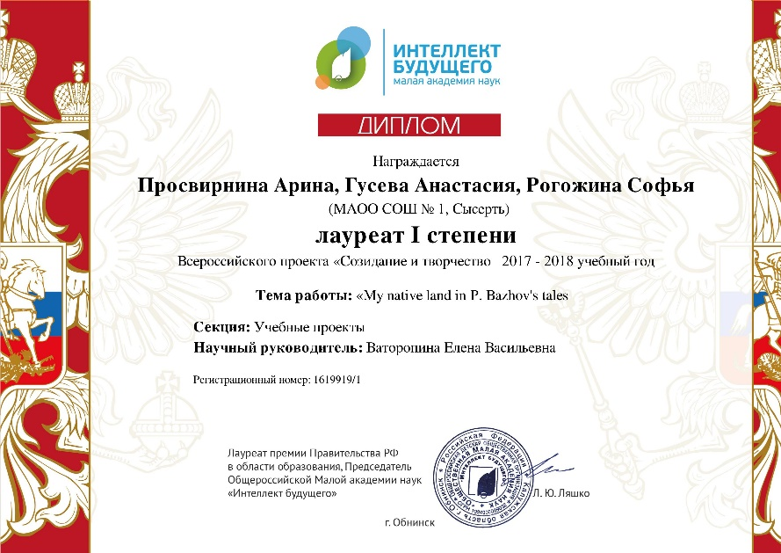 | 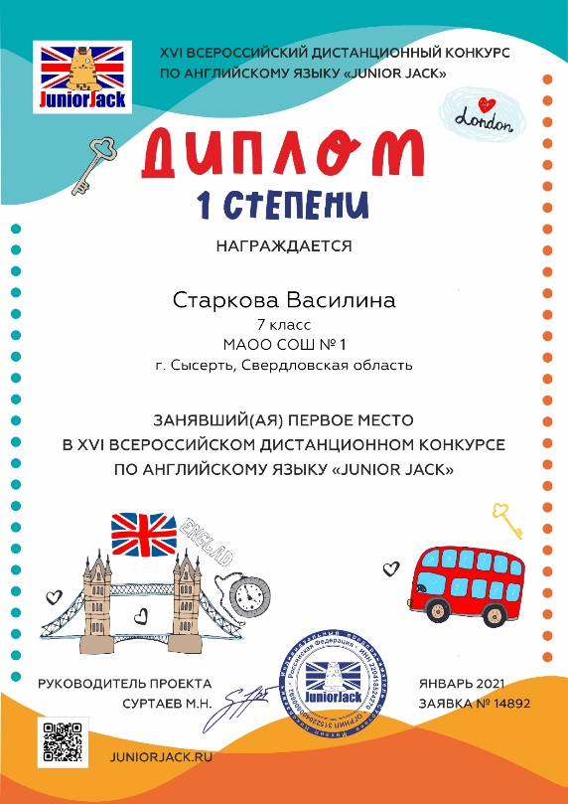

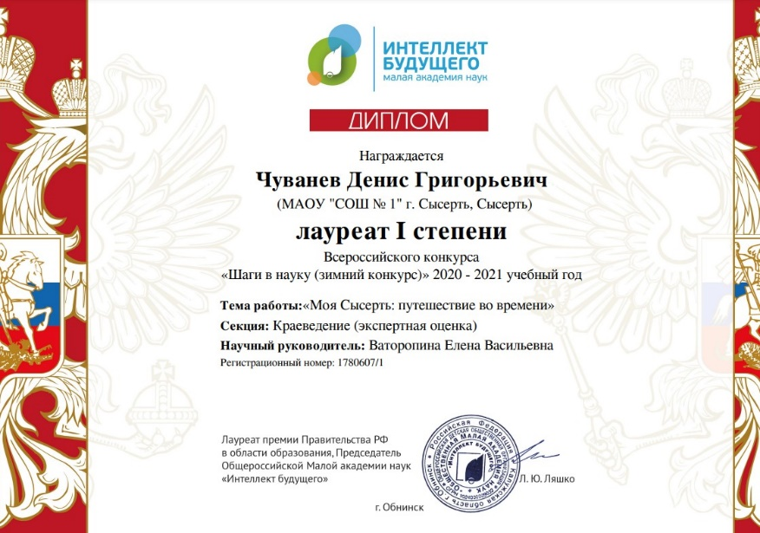 | 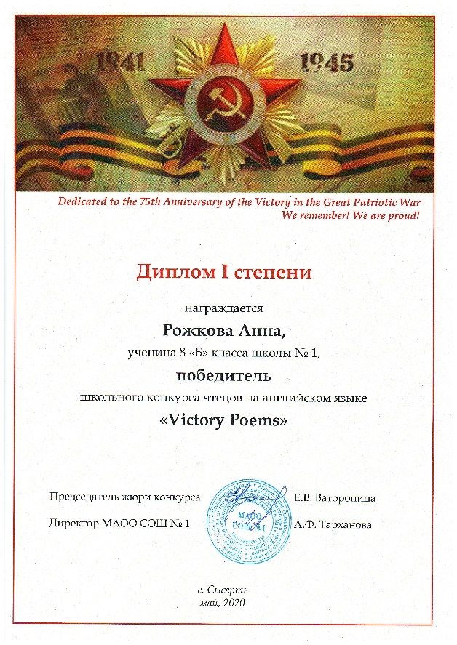
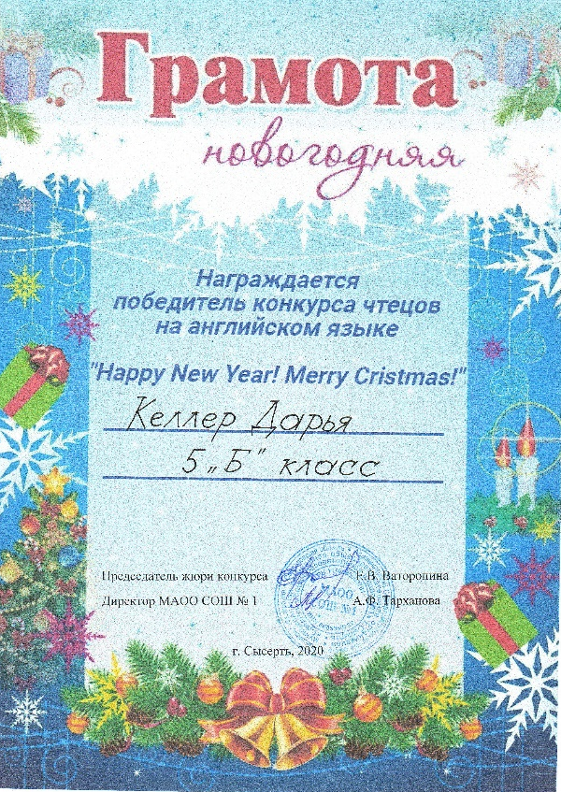 | 