Муниципальное автономное общеобразовательное учреждение
Средняя общеобразовательная школа № 1
Свердловская область, г. Сысерть

Исследовательская работа учащихся 8 класса

Тема: «The world of cartoons through the eyes of the modern eighth graders
(Мир мультфильмов глазами современных восьмиклассников)»

Предмет: Английский язык

Руководитель: Ваторопина Елена Васильевна,
учитель английского языка МАОУ СОШ № 1,
высшая квалификационная категория

2022/2023 уч. год
CONTENTS

INTRODUCTION ………………………………………………. | 3
I. FROM THE HISTORY OF CARTOONS ……………….…...… | 4
II. THE MOST POPULAR CARTOONS FOR CHILDREN …… | 7
III. OUR SERVEY ……………………………………………….. | 10
IV. THE INFLUENCE OF CARTOONS ON CHILDREN’S COGNITIVE DEVELOPMENT AND BEHAVIOR …………….. | 12
CONCLUSIONS …………………………………………………. | 14
BIBLIOGRAPHY ………………………………………………… | 15
Appendix 1. The results of the survey ………..………………….. | 16
Appendix 2. The main characters traits ………………………….. | 18

INTRODUCTION

Most children and teenagers think that watching cartoons is one of the most pleasant and interesting ways of spending free time. Many of them prefer watching cartoons to playing games. The most fascinating memories from childhood are connected with cartoons! Generations grow up watching those sad and merry, miraculous and educating, funny and mysterious cartoons.
The topic we have chosen is very interesting and actual because there is a great number of cartoons these days. They differ in content and design. They can also have different effects on the development and behavior of children.

The aim of the work: to study how modern cartoons of home and foreign production can affect the children’s mind and what kind of cartoons are the most popular among the young.
The tasks of the work:
- to study literature on the topic of the project;
- to describe some of the popular cartoons and their characters;
- to conduct the survey among the students of 7-8 grades of the school and analyze its results;
- to investigate the influence of cartoons on children’s cognitive development and behavior.
The object of the investigation: popular children’s cartoons.
The subject of the investigation: the content of some cartoons and their influence of cartoons on children’s cognitive development and behavior.

The methods of the investigation: studying literature, interview, survey, analysis.

I. FROM THE HISTORY OF CARTOONS.

Animated movies are part of ancient traditions in storytelling, visual arts and theatre. Popular techniques with moving images before film include shadow play, mechanical slides, and mobile projectors in magic lantern shows. Techniques with similarly fanciful three-dimensional moving figures include masks, costumes, and puppetry. Illustrated children's books, caricature, and comic strips are closely related to animation.
The first cartoon in the world was created in 1898. In the puppet cartoon «Circus of the Lilliputians» wooden toys were used. Unfortunately, no information about them has been preserved. Therefore, the first animation is considered to be «Phantasmagoria» by Emil Kohl (1908). It was there that viewers were able to see the plot and interesting characters.
«Circus of the Lilliputians» was shot in the simplest way: a frame – the movement of wooden toys – a new frame. Things that moved around the screen «on their own» were a real miracle at that time.
Surprisingly, even at that time there were cinemas where people could watch cartoons. For the first time, cartoons began to be shown in cinemas three years later after their opening.
New technologies and discoveries have changed the world of animation.
- Frame-by-frame animation
Blackton and Stewart managed to achieve the effect of frame-by-frame movement. They slightly adjusted the position of the subjects (in their case, wooden toys) when the camera was turned off. This method allowed to create the illusion of continuous movement. Any animation is built on this elementary technology to this day.
- Graphic animation
Emile Kohl became the founder of graphic animation in its classical sense. It was he who first breathed life into the drawings of men, which he called “phantoshs” (Phantasmagoria or The Nightmare of Phantosh, 1908). To liven up, Kohl used frame-by-frame animation, that is, he drew each pose manually, and then combined the drawings into a single sequence of actions.
- Rotoscope
In 1914, Max Fleischer began using the method of projecting a full-scale film image onto a «lumen» (animator's table) and transferring it to a sheet of paper. Thus, he managed to achieve a realistic movement. The invention was called «rotoscope». Together with his brothers Joe and Dave, he made an experimental work, which later developed into the famous TV series «Out of the Inkwell».
- Total animation
In 1951, Alexander Alekseev together with his wife Claire Parker, developed a laborious technique of «total animation» – frame-by-frame animation of not only moving, but also stationary objects, that is, background elements.
Totalization is still considered to be one of the most complex animation techniques.
- Computer animation
In 1962, American scientist Ivan Sutherland developed the Sketchpad system, which allows you to control the image on the computer screen. For this, he received the Alan Turing Award.
In 1963, Disney studios began to use the Audio Anomatronics system, which make computer models of animals and people to move. Digital technology gradually began to take over the world of animation.
- 3D animation
The first experimental work in the technique of 3D animation is the short film «Computer Animation of the Hand» (1971). It was created by two students: Edwin Catmull (who later became president of Disney and Pixar) and Fred Park (a future scientist in the field of computer engineering).

Technology advancement has brought a lot of changes into the modern cartoon creating. The quality and expressiveness of cartoons have increased many times.

II. THE MOST POPULAR CARTOONS FOR CHILDREN.

We love watching cartoons. In our opinion, cartoons can inform, educate and entertain people. They are a source of good mood and positive emotions. Cartoons can teach us a lot and broaden our horizons. Cartoons in English help us learn the language.
To our mind, the most interesting Russian cartoons are the following.

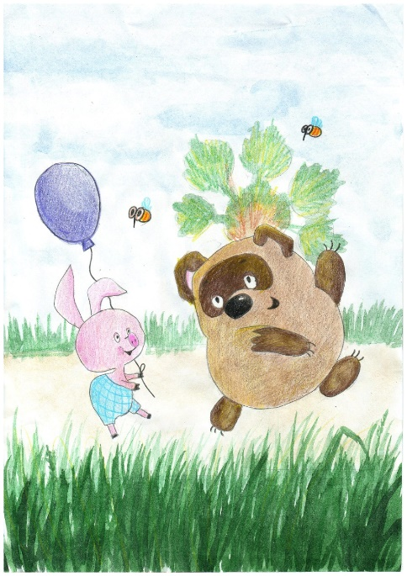 | «Winnie-the-Pooh»  The cartoon tells about a Pooh Bear and his friends enjoying adventures in a hundred-acre forest.  Winnie-the-Pooh is not very clever but sometimes has good ideas. Winnie-the-Pooh loves honey more than anything else and he loves to recite poems in hums really softly.
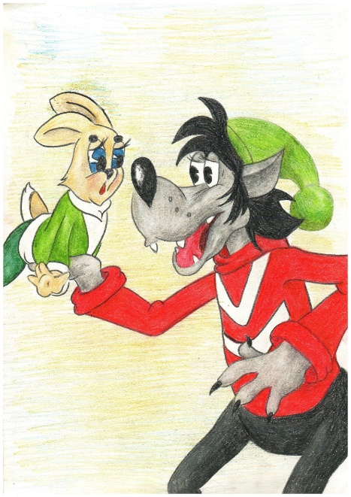 | «Well, just you wait!»  The story focuses on the eternal battle between a wolf and a hare, reminiscent of the cat-and-mouse rivalry in «Tom and Jerry».
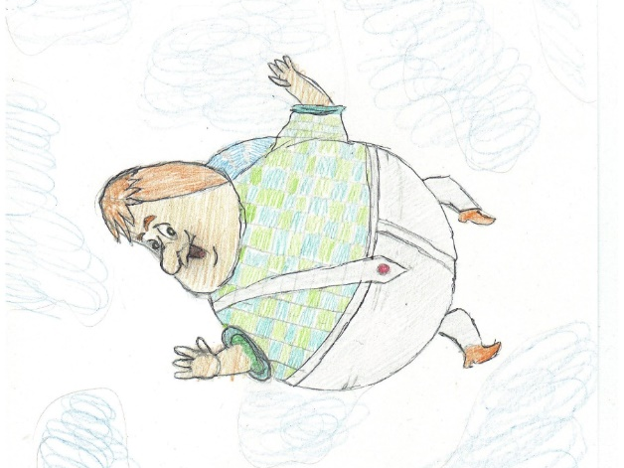 | «Junior and Karlson»  The cartoon tells a story of a lonely seven-year-old boy who meets a strange and mischievous little fat man with a propeller on his back. Junior’s parents tried to listen to their son's wishes, but they often do not fulfill them.
«The three from Prostokvashino»
Cartoon tells about a boy named Uncle Fyodor and his friends Matroskin the cat and Sharik the dog and their life and funny adventures in the village.
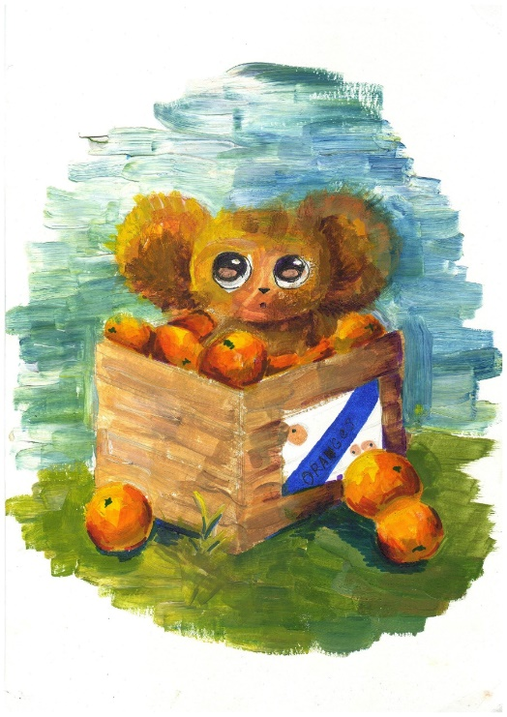 | «Cheburashka»  This cartoon is about friendship of Gena the crocodile. His life changed after he found a Cheburashka in a box of oranges and tried to make friends with everyone.
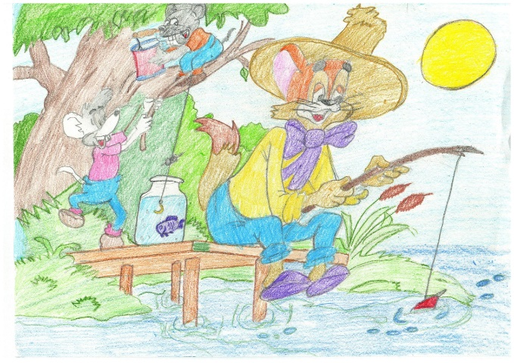 | «The adventures of Leopold the cat»  The series of cartoons about Leopold the cat who is pestered by two bully mice in numerous situations. A kind cat tries to make friends with them in every way.
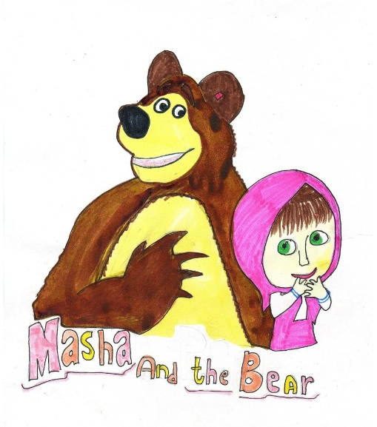 | «Masha and the Bear»  Masha is a 4-year-old girl who is portrayed as naughty and hyperactive, and always thinks about playing. Near her house there is a path that leads to the Bear's house. Masha loves the bear very much, but during her games she tends to create problems for him. In each episode of the show, Masha is portrayed as a bright but mischievous little girl who loves exploring the world around her.

Our students took part in the school art exhibition-contest «In the magical world of cartoons» – https://youtu.be/a1gzOIKDCXQ .

III. OUR SERVEY.

In order to learn about favourite cartoons of our schoolmates we conducted a survey.
The questions of the survey were the following.
- Do you watch cartoons?
- What are your favourite Russian cartoons?
- Who are your favourite cartoon characters?
- Why do you like them?
- What foreign cartoons do you like?
- Which foreign cartoons’ characters do you like? Why?

50 students of the 8th classes of our school took part in the survey.
According to the results of the survey (Appendix 1), almost all the students often watch cartoons on TV or at the cinema (Diagram 1). Among their favourite Russian cartoons are «Well, just you wait!» (16% of respondents think so), «Masha and the Bear» (15%), «Three from Prostokvashino» (14%), «Winni-the-Pooh» (12%), «Junior and Carlson» (11%), «Cheburashka and Gena the crocodile» (8%), «Bremen town musicians» (7%), «In the country of unlearned lessons» (5%), «About Leopold the cat» (5%) (Diagrams 2, 3).
Students describe some of the characters in such a way (Appendix 2):
Karlson – kind, funny, mischievous, friendly, and a little arrogant, overconfident;
Junior – a lonely, dreamy boy, kind and trusting;
Сheburashka – very kind, positive, pleasant, cheerful, sometimes a little inattentive, but very responsible;
Winnie-the-Pooh – well-behaved, imaginative, energetic, optimistic, respectful, naive, dreamy, honest, thoughtful, helpful, brave;
Owl – wise, reasonable, artistic, illiterate;
Piglet – kind, gentle and quite shy, but with Pooh by his side, he often overcomes his fears, brave when faced with a crisis and given sufficient encouragement (usually by Pooh);
Uncle Fyodor – responsible, hospitable;
Matroskin the cat – enterprising, parsimonious, touchy;
Sharik the dog – open-hearted, kind, merry;
Masha – too active and obsessive, super-active, but cheerful and funny;
Hedgehog – sensible, dreamy.

According to the results of the survey, the most popular foreign cartoons are «Gravity Falls» (20% of our schoolmates think so), «Tom and Jerry», «The Little Mermaid», «Ladybug & Cat Noir», «Spider-Man», «Cinderella», «Coraline», «WALL-E» (Diagram 4).
Students describe the main characters of these cartoons like this:
Dipper Pines – curious, smart, brave, and resourceful;
Princess Ariel – Bright, kind, delicate, energetic, headstrong, with a strong sense of adventure and exploration;
Coraline – kind, curious, courageous;
Jerry – smart, cunning, never gives up;
WALL-E the robot – responsible, inquisitive, dreamy.

IV. THE INFLUENCE OF CARTOONS ON CHILDREN’S COGNITIVE DEVELOPMENT AND BEHAVIOR.

Cartoons are essential part of every childhood. They are the most popular entertainment for children.
Cartoons can have both positive and negative effects on the cognitive development and behavior of children.

Positive and negative effects of watching cartoons on children
Positive effects of watching cartoons on children | Negative impact of watching some cartoons
Helps children learn about different things  Helps them get an early start on learning  Helps in the cognitive development  Helps in the language development  Enhances creativity  Promotes laughter and relieves stress | Promotes bad role models  May lead to health problems due to sedentary lifestyle  Lack of time for communication with friends and relatives

With the help of cartoons, children can learn about the world around us, about local customs, traditions, and some facts from the history, about new emotions, life issues and other important things.
Watching cartoons helps children develop their cognitive skills. It can help to develop logic and discussing ability, and attention of a child. Watching cartoons made in the foreign languages can help in the language studying and improving children's pronunciation and manner of talking.

Watching cartoons helps increase children’s imagination and creativity.
It helps to relax and promotes laughter. Laughter is a good stress buster and a confidence builder. It also boosts immunity and causes positive feelings.

Watching cartoons can also have negative impact on children. It may lead to health problems due to sedentary lifestyle. They include obesity, vision problems, and nutritional deficiencies due to bad food habits.

Spending too much time on watching cartoons may lead to lack of time for communication with friends and relatives and studying.
Some young viewers spend hours before the screen, ignoring their study, outdoors activities and even their family. These children are indifferent to nearly everything including communication with their friends and family.
Psychologists believe that Soviet and Russia's cartoons have a more positive impact on young viewers then foreign ones. After watching them children become friendlier, kinder, and more sociable.

We think cartoons have more positive effects than negative ones. Psychologists believe that Soviet and Russia's cartoons have a more positive impact on children then foreign ones. After watching them children become friendlier, kinder, more sociable.
We advise you to watch the cartoon «The Adventures of Leopold the Cat». It teaches children kindness, optimism and proper dispute resolution.

CONCLUSIONS

With the help of cartoons, children find out a lot of new things, learn useful skills, and have a good rest.
We enjoy watching spectacular and exciting cartoons but not all of them are useful for children. Cartoons can have different effects on the young viewers. Of course, cartoons can’t be easily divided into bad or good ones. Your friends, parents, and teachers can help you choose interesting and useful cartoons.

BIBLIOGRAPHY

How are New Technologies Improving the Creation of Animation Films? [Электронный ресурс]. – Режим доступа: https://www.rswebsols.com/tutorials/technology/technologies-creation-animation-films (дата обращения: 28.12.2022 г.).

Positive and Negative Effects of Cartoons on Child Behaviour and Development [Электронный ресурс]. – Режим доступа: https://parenting.firstcry.com/articles/positive-and-negative-effects-of-cartoons-on-child-behaviour-and-development/ (дата обращения: 28.12.2022 г.).

The Influence of Cartoons on Children’s Socialization [Электронный ресурс]. – Режим доступа: https://enlightngo.org/language/en/post/7795 (дата обращения: 28.12.2022 г.).

Appendix 1
The results of the survey
Diagram 1
Diagram 2
Diagram 3

Diagram 4

Appendix 2

The main characters traits

Cheburaska | very kind, positive, cheerful, sometimes a little inattentive, but very responsible
Matroskin the Cat | enterprising, thrifty, and touchy
Sharik the Dog | open-hearted, kind and merry
Karlson | kind, funny, friendly, a little arrogant, and overconfident
Junior | a lonely, dreamy boy, kind and trusting
Winnie-the-Pooh | well-behaved, imaginative, optimistic, respectful, dreamy, honest, thoughtful, helpful, and brave
Masha | super-active, smart, and curious
Leopold the Cat | kind, gentle and quite shy
Uncle Fyodor | rand hospitable
Hedgehog | naive, inquisitive, sensible, and dreamy

