Municipal Budget Establishment Secondary School № 6

Sergach Nizhegorodskaya oblast

The Tradition of Tea Drinking

in Great Britain and in Russia

Carried out by

Snatina L. Berezina V.(17 th years old)

form 11 «A»

Scientific adviser:

Lazareva M.S.

2013

**Content**

1. Hypothesis 3
2. Tea in England 4
3. Tea in Russia 7
4. Attitude to tea 12
5. Tea proverbs and idioms 13
6. Conclusion 14
7. Resources 15

**Hypothesis**

tradition of tea drinking is important for both our countries.

**The aim of our work is:**

studying tea drinking traditions in England and in Russia.

**Hypothesis:**

tradition of tea drinking is important for both our countries.

**Method:**

we want to compare English and Russian traditions of tea drinking. We are going to ask my classmates and teachers about their habits of tea drinking.

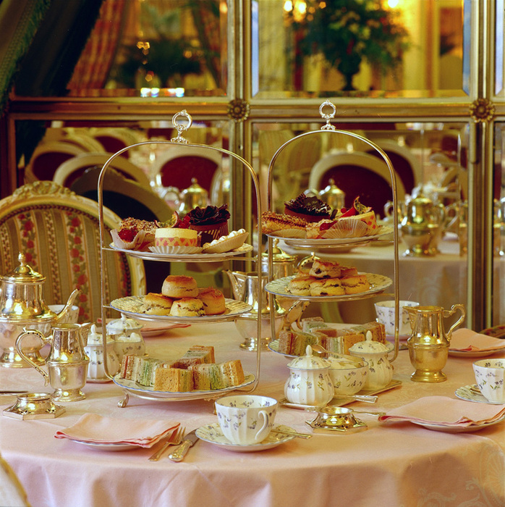

**Tea in England**

English tea drinking traditions have a long history. Tea was brought to England in the seventeenth century by a Portuguese princess, who married king Charles II of England, and has been popular in the country ever since.   
When the first clippers began to bring tea to England from China and India, it was very expensive. The reason was that the members of the church called it a “sinful ii drink” because it was coming from a non-Christian country. So it was taxed to 119%iii and therefore tea became a drink for the elite. A drink for the rich, the aristocracy, tea was locked up in the households in enamel containers.

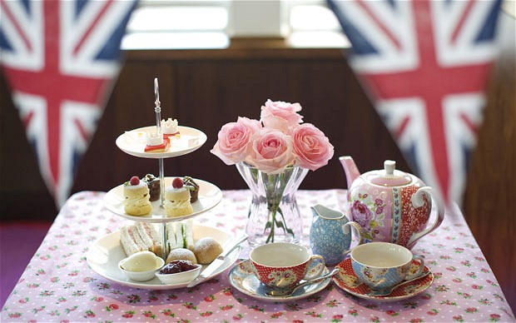

However from the 18th century tea began to be used by the common people too, thanks to tea-smuggling in Cornwall. Tea was brought in illegally - it was not imported by the East India Company, and it did not pass through customs. Tea was lighter and easier to transport than gin and brandy, small sacks of tea were easy to hide under clothes, so it was very profitable for tea-smugglers.

Traditional tea time in English is late afternoon, when world-famous 5 o’clock tea is served. Five o’clock tea is a ceremony, a work of art. It is not only about a perfect combination of the tablecloth, the napkins, the flowers, the vases and the tea set, it means a certain way of behaving and talking too. But tea is also drunk in the morning and during the day because the English believe it to be healthy and refreshing. There are a lot of traditional tea-rooms in England, where ideally you should not ask for a cup of tea, but say you want an Earl Grey or an English Breakfast because you should drink your teas according to how you are feeling. For example, English Breakfast is a strong tea, which fills you with energy, and Prince of Wales or Earl Grey are more relaxing. Green teas are very refreshing, very light and good after meals.

Tea is traditionally served with lemon or milk. Tea used to be drunk black without anything in it, but as people became more in a hurry they added milk to drink it more quickly. It is possible that milk was used to cool the tea down when the hostess did not want to have her guests for too long. Another explanation of milk in tea is the fear to break the delicate porcelainthat tea cups were made of. Real porcelain does not normally break but early examples of British porcelain cups sometimes fell apart. Because porcelain was very expensive at that time, it was safer to put in some milk first to reduce the temperature of the tea so the cups did not break. This is how the habit of putting milk in tea remained.

These days much is being done to restore old traditions. Tea rooms and museums that carefully store anything associated with tea are very popular. For a long time the Cutty Sark – the

last of the tea clippers – stood at Greenwich and was visited by thousands of tourists interested in the history of tea.

Unfortunately, it was destroyed by a fire in 2007. The ship was 138 years old.

The essence of tea-drinking has not changed. Tea is drunk with milk, usually from china cups. The atmosphere is more important than quality of the food and the tea. Finally, tea should not be drunk in a hurry and should be accompanied by friendly conversation.

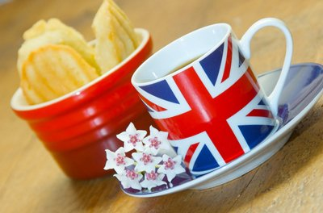

**Tea in Russia**

What is the samovar? In the Dictionary of Russian it is spoken: " the Samovar - the metal device for кипячения waters with a furnace inside, filled углями ". In the explanatory Dictionary of alive great russian language of V.I.Dalja (SPB - M., 1912г., т.4) it is said: " the Samovar - water-heating for tea a vessel, Copper with трубою and жаровнею inside ".

Deaf melancholy without the reason  
And dumas a constant intoxication.  
Let's pin luchins-  
Let's inflate to themselves a samovar!  
For fidelity to an ancient grade,  
Living slowly!  
Perhaps, also will steam out sorrow  
Soul taken to tea!

In what attractive force of a samovar why it has remained the steadiest attribute of a domestic cosiness consists, it is possible to understand, only having understood features of Russian tradition - tea drinking. Well-known, that tea has come to Russia from the East. It does not mean, that before Russia drank only vodka. A hard liquor were in Russia in honour, its inhabitants cooked home-made beer. Tea also was

the: from leaves, fruits, кореньев grasses, in huge assortment collected, dried up and prepared for various purpose - medical and tonic. For example, as tea leaves it was used inflorescences of one-tea, leaves of a cherry, mint, a currant

etc. But, the most important, new, that has come from the East together with is expected as tea leaves is a special ritual

action, some kind of a holiday. Introduction and distribution of tea in Russia occurred on the prepared ground, and the basic feature, the reason of popularity of tea was in the ceremony, the truth, adapted to psychology of the Russian person.

BITTERNS the SEAGULL - you will FORGET MELANCHOLY.

East tea ceremony in the basis is directed on a deepening of the person, dialogue with the private world. She as though pulls out it from every day vanity. Ways of the tea leaves of tea and his submission on a table is a preparation of ground for discharge from all vain.

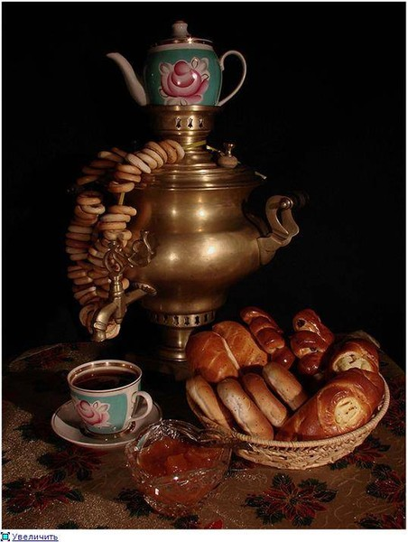  
  
Russian ceremony of tea drinking is directed on reception of absolutely opposite effect - associations of a spiritual world of people collected behind a table, disclosings of each separate soul before a society, family, friends, reception of

new knowledge. Tea drinking creates conditions for heart-felt conversation.

The SAMOVAR BOILS - TO LEAVE DOES NOT ORDER.

Frank conversation directly with the interlocutor and furthermore with several interlocutors, always it is combined psychologically. It is aggravated some more themes, that behind a table there are, as a rule, some age groups - from children up to great-grandfathers and great-grandmothers. Children the tradition of respect for adults constrains, their parents - reverence of the parents. The careless remark, collision of two opinions sometimes destroys доверительность conversations, and speaking becomes silent and leaves " in

itself ". " The silent interlocutor " was necessary for creation of spirit of democratic character certain, looking on which, and, addressing to which, it would be possible to state the most secret, not being afraid to be not understood. This role is allocated in Russian tea drinking to a samovar.

TEA TO DRINK - NOT FIRE WOOD TO CUT.

|  |
| --- |
| Got dark. On a table, shining, The evening samovar hissed, The Chinese teapot heating up, Under it curled easy pairs …  (Alexandr Pushkin) |

Such subject on a table was necessary for Russian ceremony of tea drinking. And it was invented on a boundary of XVIII century by Russian masters. The samovar has come in each house. The samovar became a symbol of goods and a domestic cosiness. Children received knowledge, absorbed traditions,

studied to speak and listen at a samovar. This subject has come in classics of the Russian literature and art as indispensable attribute of family rest. He became object of

art interest, and a lot of masters of arts and crafts took part in creation of its decorative furniture.

What is the samovar? In the Dictionary of Russian it is spoken: " the Samovar - the metal device for кипячения waters with a furnace inside, filled углями ". In the explanatory Dictionary of alive great Russian language of V.I.Dalja (SPB - M., 1912г., т.4) it is told: " the Samovar - water-heating for tea a vessel, Copper with a pipe and jarovneyinside ".

Its device is simple, as all ingenious. He consists of a seamless thin-walled vessel. It is pierced vertically with a pipe beginning from topki from below and finishing by a ring. Last serves as for installation on it of a teapot for tea leaves, and for realization of a current of air when the ring is closed by a cover. From other devices for кипячения the waters, known long before occurrence of a samovar and which people use now, the samovar differs first of all that he has united in itself all practical experience of mankind on economy of energy. All heat rising on a pipe, is given water environmental it. The big surface of a pipe quickly leads up water to boiling and maintains temperature. The natural current of warm air upwards creates ideal draft in топке. Topka it is attached from below to a vessel (tulovu) a samovar on necessary distance from a surface of a table on which the samovar is put. The distance it is adjusted by legs of a samovar which give to it stability and fire safety. The pipe, being a constructive core, forms a basis for a cover of a vessel put on on it, a ring, a cover of the pipe. Through a pipe fuel is pawned

and the samovar is kindled. As fuel serve pine shishki, vetki, chips, Their charge is minimal. For injection of water the

cover of a vessel is removed. For filling a glass there is a convenient crane with притертыми surfaces. The crane is

located on some distance from a bottom of a samovar that allows to not get suspensions in cups. Such elements as the crane (Vetka), the handle for carry of a samovar, a leg on which it costs, are made with the help of moulding and are soldered to a vessel. These elements have the various form and decorative ornaments. Their remoteness from a source of heating keeps the soldering centuries. Samovars were used both for preparation of tea, and for preparation of soup, porridge, sbitnya. In such samovars vessels were divided on two or three compartments and a dish prepared

simultaneously. Use a samovar the child can even - water is poured, fuel is pawned and the set fire chip falls to a pipe. In crude weather or at wet fuel the samovar needs to be inflated. It do or through apertures in walls топки, or a "country" way - with the help of a boot put on on a pipe which carries out function of fur in a forge forge. At boiling water on a ring the brewing teapot, ceramic or porcelain is established, depending on taste, a habit or a solvency making tea. Draft is slowed down, and the samovar slowly leads up water to boiling, qualitatively making tea. Tea from a samovar usually drink in snack, that is sugar moves separately.

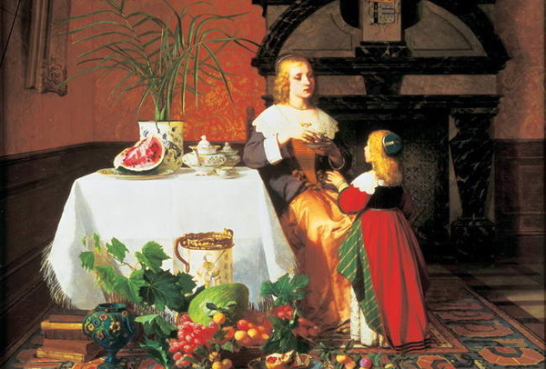

**Attitude to Tea**

We are going to ask our classmates and teachers about their habits of tea drinking.





Now we know that most of our teachers and students prefer black tea

**Tea proverbs and idioms**

The British drink their afternoon tea round the fire in winter and out in the garden on sunny summer days. The British have many tea proverbs and idioms.

*Tea proverbs and idioms***:**

1. Husband's tea.

2. Reading the tea-leaves.

3. Not for all the tea in China.

4. Easy as tea-drinking.

5. Make the cup run over.

6. My cake is dough.

7. Kiss the cup.

*Russian proverbs about tea:*

1. Чай попил - орлом летаю, водку пью - свиньёй лежу.

2. За чаем не скучаешь – по три чашки выпиваешь.

3. Чай не пить – на свете не жить.

4. Самовар кипит – уходить не велит.

5. Пей чай – удовольствие получай.

6. Выпей чайку – позабудешь тоску.

**Conclusion**

People from different countries like tea. They follow their own traditions of tea drinking and try to keep their traditions.

Many Britishtraditions and customs are characteristic of the British scene. Britain is changing together with the rest of the world, but traditions remain.

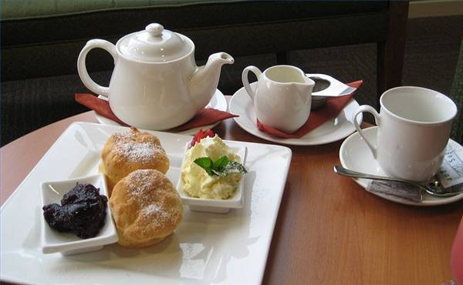

**Resourses**

1. Майол Энтони, Милстед Дэвид. «Эти странные англичане»,Эгмонт, Россия Лтд, 1999
2. Налбандян Зураб «Чаепитие у королевы. В начале XXI века» в Британии», Время 2007
3. Офф Хайнц «Инструкция АО применению», Аякс пресс, 2006http://narody.ru/video-topiki-dlya-shkolnikov-tea.html
4. http://en.wikipedia.org/wiki/Russian_tea_culture
5. http://www.shopsamovar.com.ru/trad.html
6. http://www.russianteacompany.com/russian_tea_history.php
7. http://www.teafestival.ru/statiy/page3.php

Управление образования администрации Сергачского района

Муниципальное бюджетное образовательное учреждение Сергачская средняя общеобразовательная школа №6

Исследовательская работа

Секция: английский язык

**Традиции чаепития Британии и России**

авторы: Снатина Лилия и

Березина Виктория (17 лет),

11 «а» класс

руководитель: Лазарева М.С,

учитель англ. Яз.

Сергач, 2013