[](http://img1.liveinternet.ru/images/attach/c/9/107/983/107983343_large_EuJ0baYpKM.jpg)

[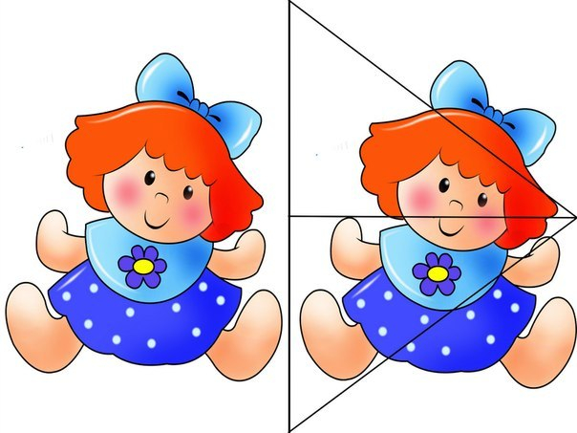](http://img1.liveinternet.ru/images/attach/c/9/107/983/107983345_large_Hdot8a07mFI.jpg)   
  
3.  
[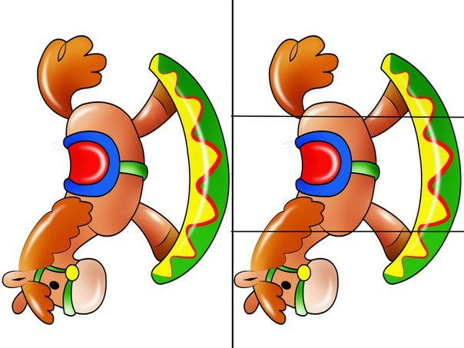](http://img1.liveinternet.ru/images/attach/c/9/107/983/107983347_large_PI3OV4dnKmo.jpg)   
  
[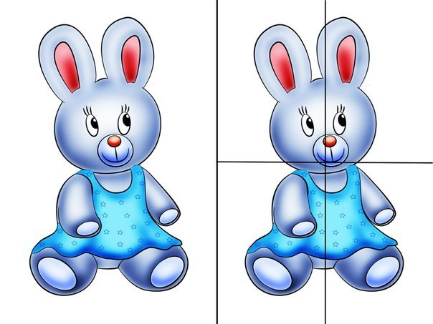](http://img1.liveinternet.ru/images/attach/c/9/107/983/107983349_large_PLYojWd7_II.jpg)   
  
[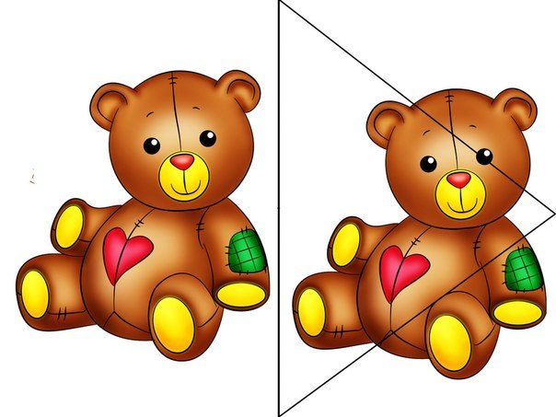](http://img1.liveinternet.ru/images/attach/c/9/107/983/107983353_large_puNQoNi7BEw.jpg)

6.[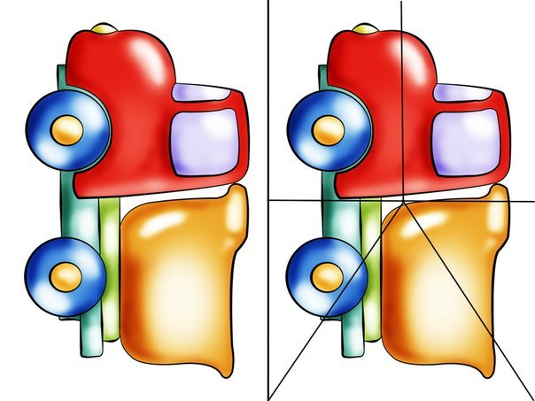](http://img0.liveinternet.ru/images/attach/c/9/107/983/107983356_large_sMOAWPMRIBE.jpg)

[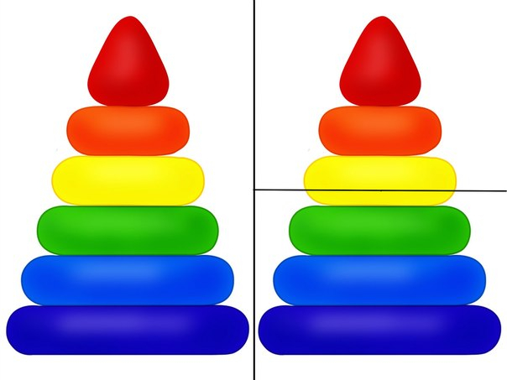](http://img0.liveinternet.ru/images/attach/c/9/107/983/107983358_large_TDlTdHBfeBY.jpg)   
.  
[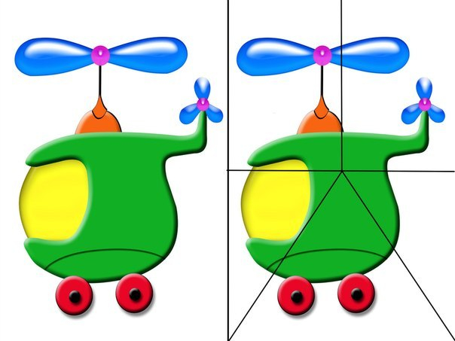](http://img0.liveinternet.ru/images/attach/c/9/107/983/107983360_large_tewQ0vV6AAk.jpg)   
9. [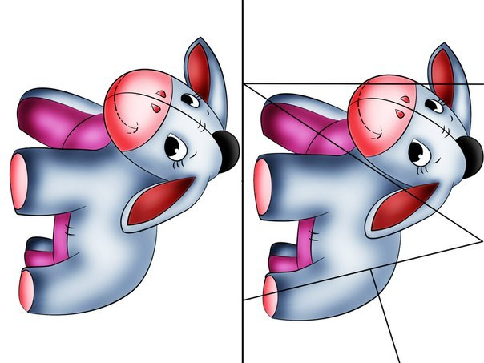](http://img1.liveinternet.ru/images/attach/c/9/107/983/107983365_large_7KAwXZVtXw.jpg)

[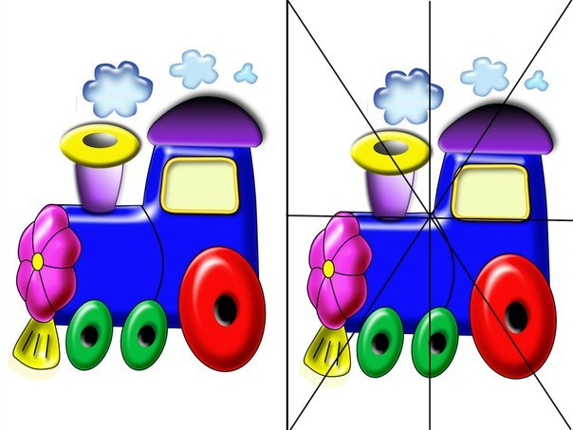](http://img0.liveinternet.ru/images/attach/c/9/107/983/107983362_large_UMcTzVikSpw.jpg)   
  
[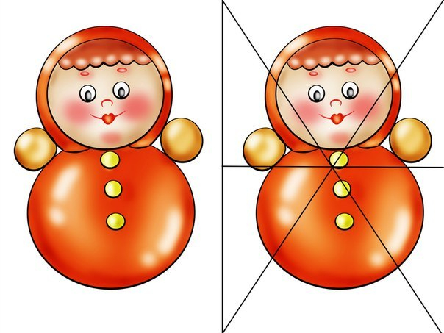](http://img0.liveinternet.ru/images/attach/c/9/107/983/107983364_large_2y5Ou1n8HzE.jpg) 

|  |
| --- |
|  |