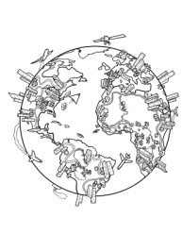  START | 1  What’s the capital of England? | 2  What are the colours of the Russian flag? | 3  In China people speak….. | 4  Miss a turn!!  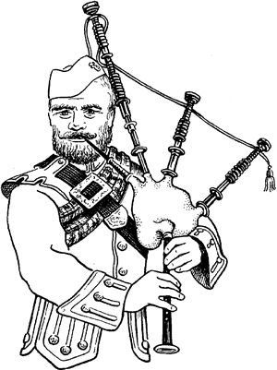
9  Do people speak Japanese in Japan? | 8  Move forward  two spaces !! | 7  What is the largest country? | 6  What is the capital of Northern Ireland? | 5  Do you speak French?
10  What country looks like a boot? | 11  What is the smallest country? | 12  What countries have you visited? | 13  Go back three  spaces!!  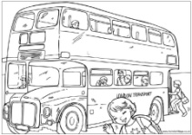 | 14  Do you want to visit Africa?
19  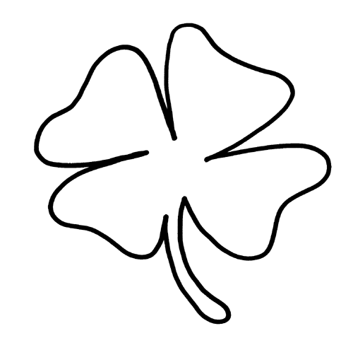  Miss a turn!! | 18  People speak German in…. | 17  You can see Big Ben in… | 16  What language do people speak in Australia?? | 15  What is the capital of Spain?
20  How many continents are there? | 21  What is the name of the Queen of England? | 22  Do Scottish men wear skirts?? | 23  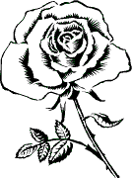  Move forward one space!! | 24  Where do women dance flamenco?
FINISH  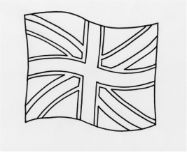 | 28  How many oceans do you know? | 27  What’s the name of the British flag? | 26  What is the symbol of England? | 25  Is there a Canadian language?

