6th form. Lesson 56-57.
1) Повторить новые слова.
2) р. 86, ex. 2. Read the dialogue. Answer the questions.
3) p. 86 learn the rule.
4)
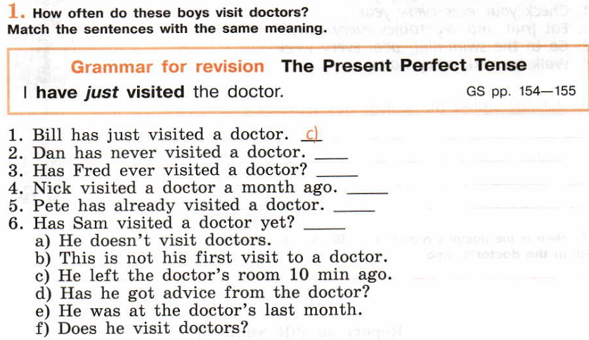
5) p.87 ex. 1 3) What did Bill answer?
6) 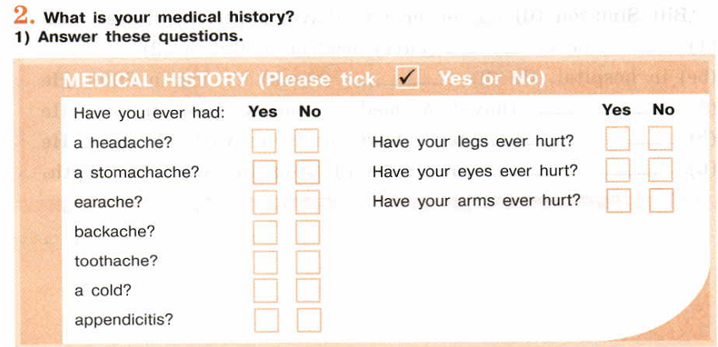
7) p. 88, ex. 3/ Find out what unusual things your classmates have done. Make a report.
8) 