Mount Gladenkaya - the largest modern ski resort in Khakassia 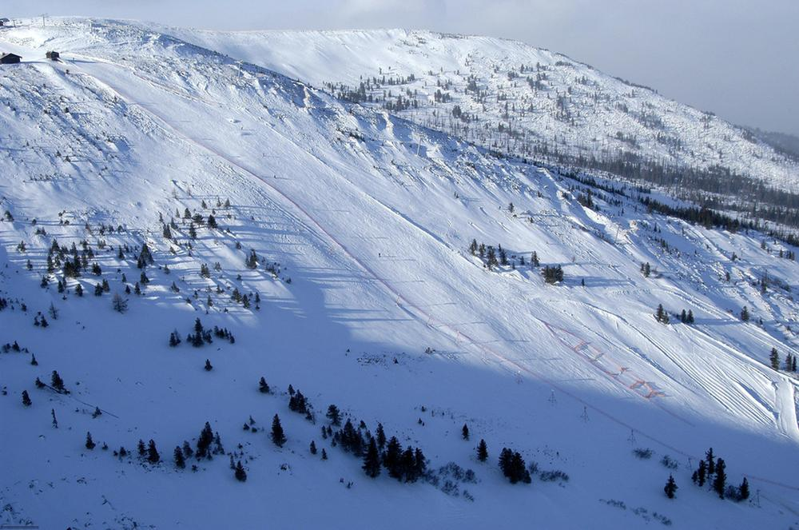
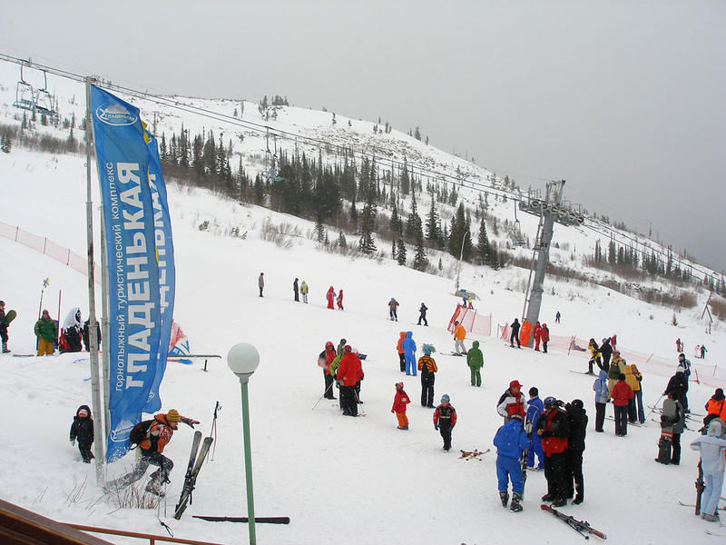
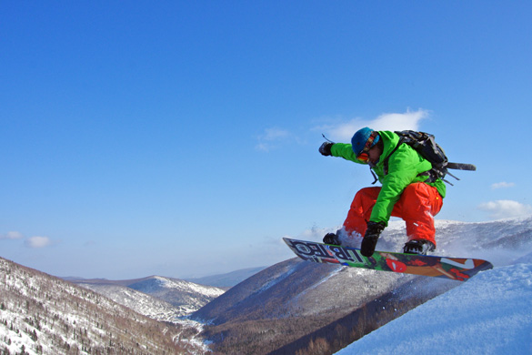

The Sayano-Shushenskaya HPP of Neporozhnij. It is located on the Yenisei river, on the border between the Krasnoyarsk territory and Khakassia, a Unique arch-gravity dam station with a height of 242 m — the highest dam in Russia and one of the highest dams in the world. The construction of the Sayano-Shushenskaya HPP, which began in 1963, was officially completed only in 2000.
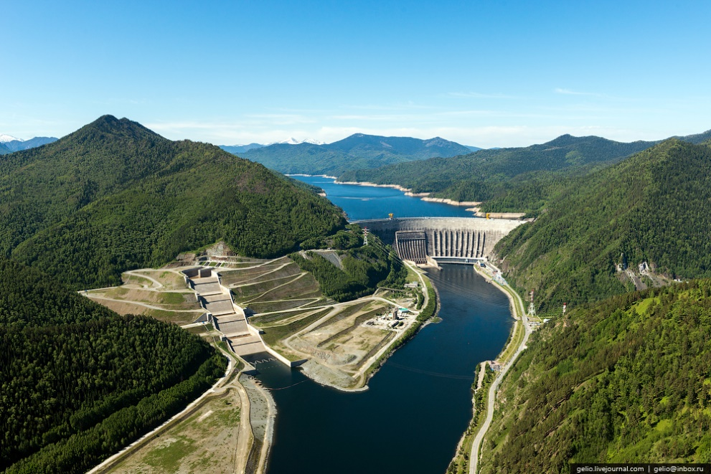
The great and mighty Yenisei River, 3487 km long, originates from the sandy landscapes of Tuva to the permafrost of Taimyr, flowing into the Arctic Ocean. The largest area of the basin, the Yenisei River ranks as the 2nd in Russia and the 7th in the world.
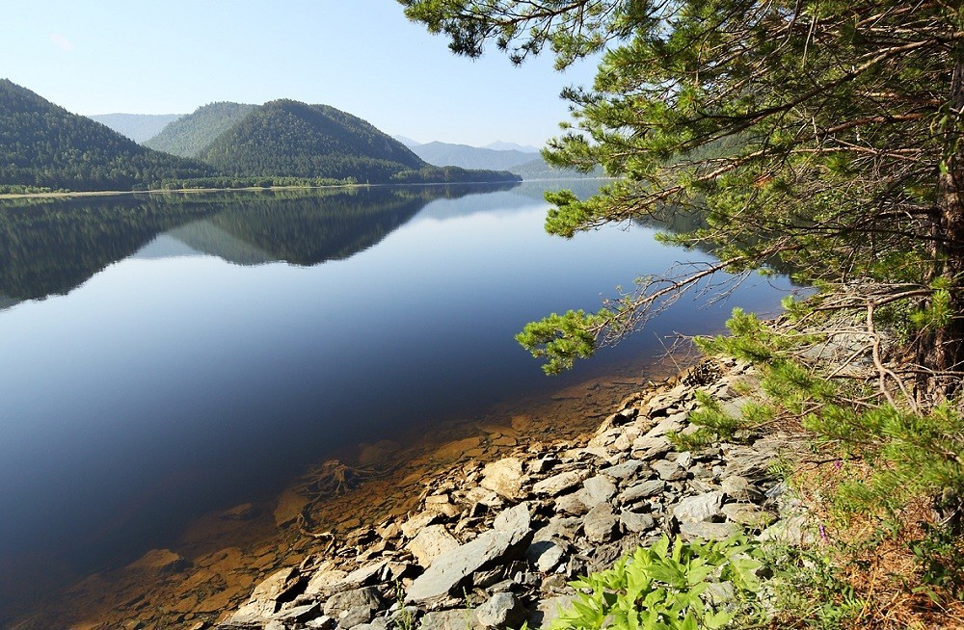

Cultural attractions of Khakassia

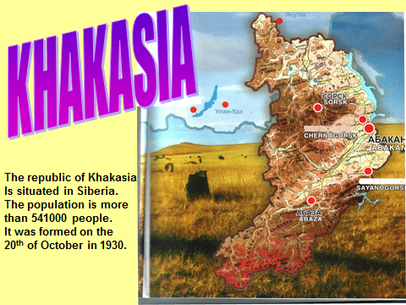

Ust-Sos is an open-air Museum, opened in 2010. It is the center of ethnographic and archaeological monuments.
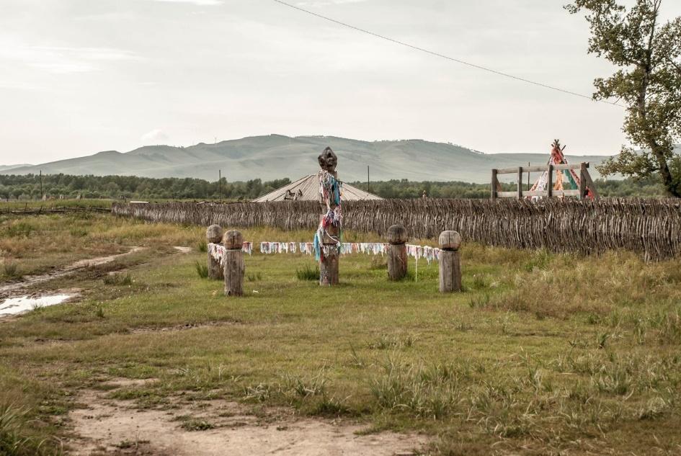
Rock paintings-ancient images on rocks, stones.
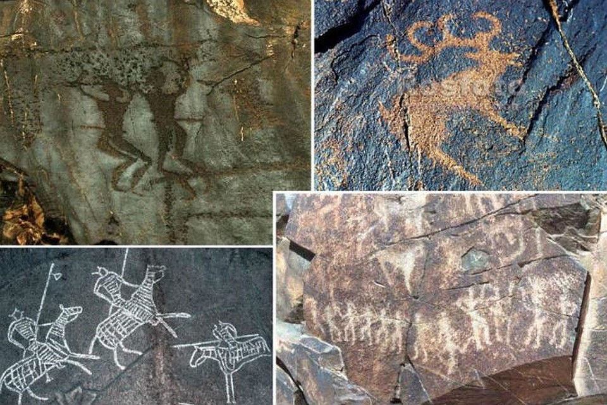
Chests - mountain ridge consisting of five massive mountain-remains is 200 meters high.
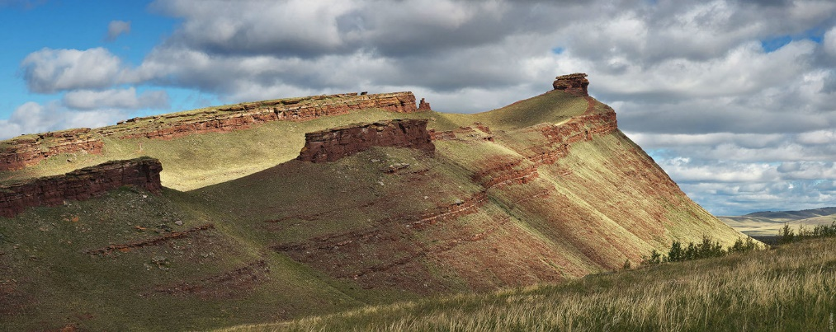
Salbyk mounds-an ancient monument-a fragment of Tagar culture, built in the 3rd century BC, the mound is a complex structure of stones weighing 60 tons. Mingars - so the Khakas people call these plates.
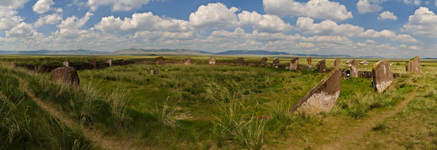
ПолнорThe Path of Forefathers On the banks of the river White Jus in a rocky massif Togyz-Az, which means Khakassky NINE MOUTHS, a few hundred meters stretched numerous grottoes and stone arches. According to local residents, the mountain massif is a cult place for shamans, so they called it the PATH of ANCESTORS.
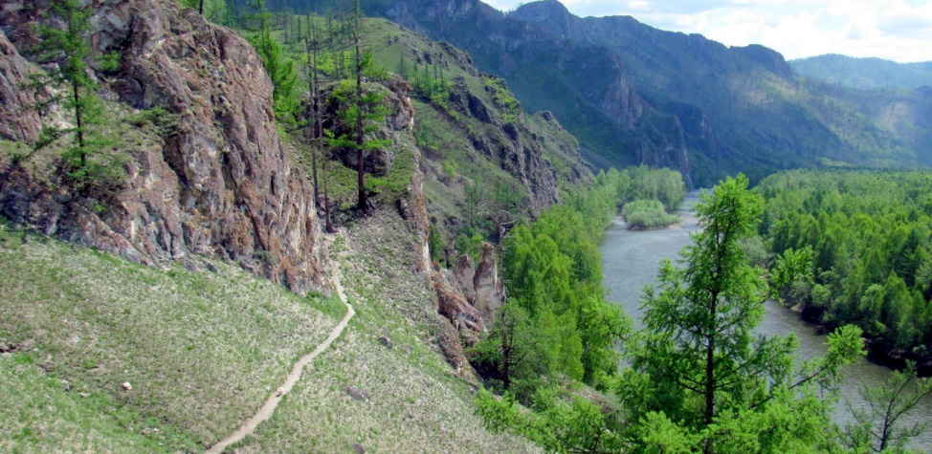
The Tuimsky failure was formed as a result of the collapse of rocks after the mining of various ores, which were conducted in the 19th century, the depth of 15 meters
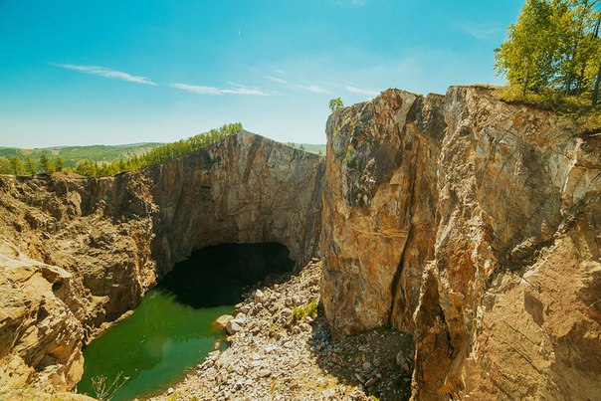
The village Kazanovka is Assescom area, completely preserved primeval life and the native language of the Khakas people. Yurts-houses are for one family, uses 3 types of material for construction: felt, birch bark and from the 19th century began to be built of wood
