Plan | Points | Mark
1. Look at the pictures. Find the odd one.
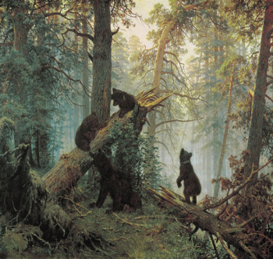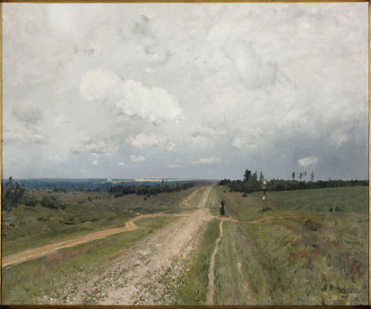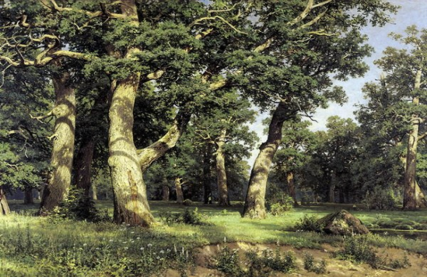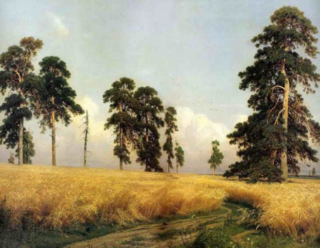

Why?

2. The topic of the lesson is ___________________________________

3. Look at the rest pictures. Who is the painter? ____________________

4. Use the phrases and make the story about one of the most prominent Russian painters.
(1832 - 1898), Outstanding landscape painter; Yelabuga; the Moscow Art School and the St Petersburg Academy of Fine Arts; 1870 – one of the founders of “Peredvizhniki”; show the power and beauty of Russian nature; fine teacher (help young artists to master professional skills)

Prepare good reading.
5. Match:
Landscape painting | Портрет (автопортрет)
Seascape paintings | Бытовой жанр
Portrait paintings (Self – portrait) | Пейзаж
Still – life paintings | Военная живопись
Genre paintings | Настенная живопись
Historical paintings | Морской пейзаж
Military art | Историческая живопись
Mural paintings | Натюрморт

6. What is your favourite genre? Why? ____________________________________________
____________________________________________________________________________
____________________________________________________________________________
7. Read and translate the phrases:
I’d like to attract your attention to (this painting, canvas,…)
It was painted by …(a famous, unknown, … painter) To begin with, this painting is a portrait which belongs to the brush of …
We can see … in the foreground (in the right, in the left, in the centre, in the middle, in the far distance, in the background)
The picture is executed mostly in (dark, light, bright, warm, cold, …) colours
The artist paints (depicts, represents)…
The picture conveys an idea of … (mother’s love, beautiful scenery)
- Impressions:
+ I’m impressed by the picture. It’s realistic and true to life. It’s an honest representation of… Isn’t it superb? This is what I should call … (art) it’s magnificent (fantastic, amazing, lovely)
It’s a work of a genius. Do look at it! This canvas gives so much food for thought.
- It’s ridiculous. It offends the eye. It’s completely meaningless. It’s unbelievable trash! I shouldn’t call it a painting at all. It’s too bad for

8. Describe the picture. Use the phrases.
________________________________________________________________________________________________________________________________________________________________________________________________________________________________________________________________________________________________________________________________________________________________________________________________________________________________________________________________________________________________________________________________________________________________________________________________________________________________________________________________________________________________________________________________________________________________________________________________________________________________________________________________________________________________________________________________________________________________________________________________________________________________________________________________________________________________________________________________________________________________________________________________________________________________________________________________________________________________

9. Homework. Get ready to describe the picture.
Total:

