____________________________________________
Тема | Слово | Перевод
География Архангельской области. Названия некоторых морей, рек и городов региона.  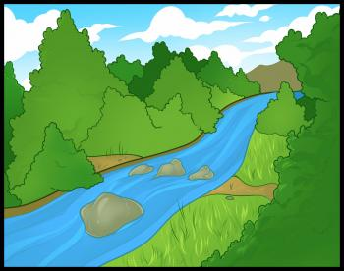 | ______________________________________________________  ___________________________  ___________________________  ___________________________  ___________________________  _____________________________________________________________________________________________________________________________________________________________________________________________ | _____________________________________________________________________________________________________________________________________________________________________________________________________________________________________________________________________________________________________________________________________
Погода в Архангельской области. Времена года.  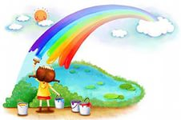 | ___________________________________________________________________________________________________________________________________________________________________________________________________________________________________________________ | _________________________________________________________________________________________________________________________________________________________________________________________________________________________________
Растения и животные региона  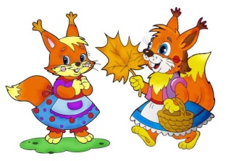 | _____________________________________________________________________________________________________________________________________________________________________________________________________________________________________________________________________________________________________________________________________________________________________________________________________________________ | _______________________________________________________________________________________________________________________________________________________________________________________________________________________________________________________________________________________________________________________________________________________________________________________
История и достопримечательности Архангельска | ______________________________________________________________________________________________________________________________________________________________________________________________________________________________________________________________________________ | __________________________________________________________________________________________________________________________________________________________________________________________________________________________________________________________
Литературный Архангельск.  С.Г. Писахов  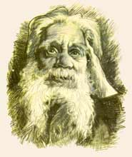 | _____________________________________________________________________________________________________________________________________________________________________________________________ | _______________________________________________________________________________________________________________________________________________________________________________
Я из д. Веркола Пинежского района.  Знакомство. | ____________________________________________________________________________________________________________________________________________________________________________________________________________________________________________________________________________________________________________________________________ | ____________________________________________________________________________________________________________________________________________________________________________________________________________________________________________________________________________________________________________
Веркола - моя малая родина.
Достопримечательности Верколы.

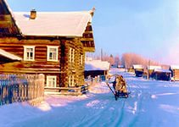
Известные люди Верколы.  Ф.А.Абрамов.  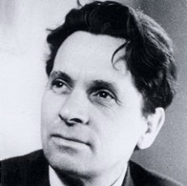 | _______________________________________________________________________________________________________________________________________ | _____________________________________________________________________________________________________________________________
Произведения Ф.А. Абрамова. | _______________________________________________________________________________________________________________________________________ | _____________________________________________________________________________________________________________________________
Инсценировка рассказов Ф.А.Абрамова | __________________________________________________________________________________________________________________________________________________________________ | ______________________________________________________________________________________________________________________________________________________
Я и моя семья. Семейное древо  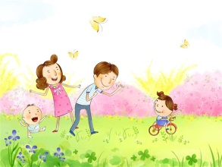 | ________________________________________________________________________________________________________________________________________________________________________________________________________________________ | ________________________________________________________________________________________________________________________________________________________________________________________________________
Моя школа  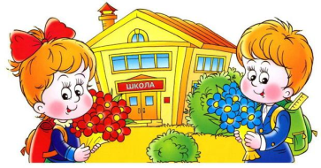 | __________________________________________________________________________________________________________________________________________________________________ | ______________________________________________________________________________________________________________________________________________________
Мои друзья  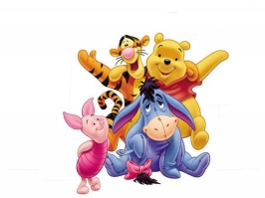 | __________________________________________________________________________________________________________________________________________________________________ | ______________________________________________________________________________________________________________________________________________________
Мой адрес | _____________________________________________________________________________________________________________________________________________________________________________________________ | _______________________________________________________________________________________________________________________________________________________________________________

