Примерные варианты ЕГЭ по разделу «Говорение»
Variant 1
C3. Imagine that you are preparing a project with your friend. You have found some interesting material for the presentation and you want to read this text to your friend. You have 1,5 minutes to read the text silently, then be ready to read it out aloud. You will not have more than 1,5 minutes to read it.
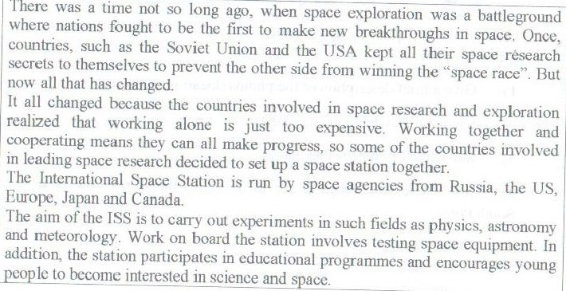
С4. Study the advertisement.
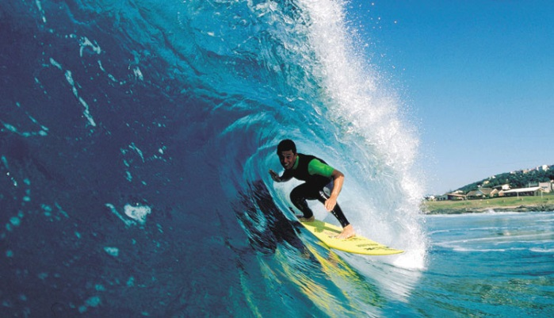
You are taking a language course in Australia. You want to try surfing. You have just found an advertisement to join a local surfing club. You are calling to the club to make some clarifications. In 1,5 minutes you are to ask 5 questions. You have 20 seconds to ask each question.
Find out:
- location of the club
- classes for beginners availability
- personal coach availability
- price for a week
- discounts for students

C5. Imagine that while travelling during your holidays you took some photos. Choose one photo to present to your friend. You will have to start speaking in 1,5 minutes and will speak for not more than 2 minutes.
In your talk remember to speak about:
- when you took the picture
- who/what is in the photo
- what is happening
- why you took this photo
- why you decided to show it to your friend
You have to talk continuously, starting with:
I’ve chosen photo number ….
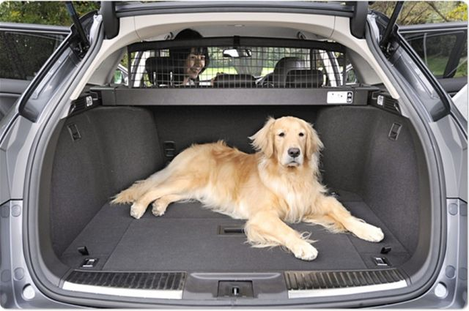 | 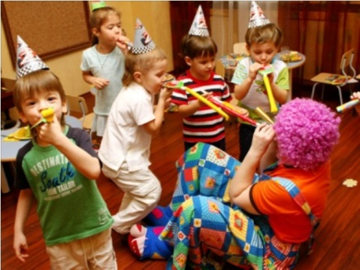

C6. Study the two photographs. In 1,5 minutes be ready to compare and contrast the photographs:
- give a brief description of the photos (action, location)
- say what the pictures have in common
- say what differences they have
- say what kind of ski you would prefer with your friend
- explain why
You will speak for not more than 2 minutes. You have to talk continuously.
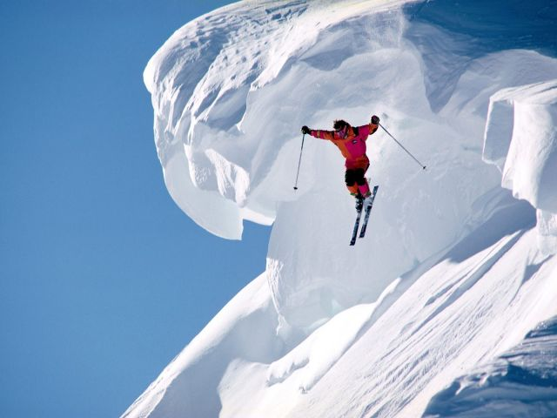 | 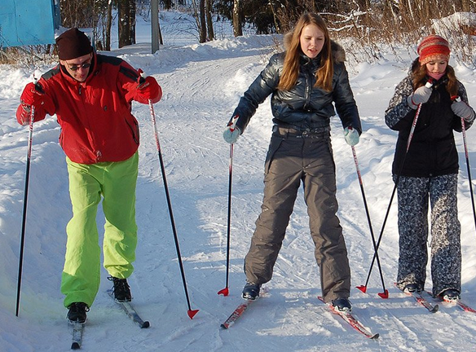

Variant 2
C3. Imagine that you are preparing a project with your friend. You have found some interesting material for the presentation and you want to read this text to your friend. You have 1,5 minutes to read the text silently, then be ready to read it out aloud. You will not have more than 1,5 minutes to read it.
С4. Study the advertisement.
You and your family are going to spend 2 weeks in Cypress. You have just found an advertisement about a nice hotel. You are making a phone call to the hotel to make some clarifications. In 1,5 minutes you are to ask 5 questions. You have 20 seconds to ask each question.
Find out:
- location of the hotel
- rooms for a family of 4 availability
- distance from the hotel to the sea
- price for 2 weeks
- discounts for small kids under 3

C5. Imagine that while travelling during your holidays you took some photos. Choose one photo to present to your friend. You will have to start speaking in 1,5 minutes and will speak for not more than 2 minutes.
In your talk remember to speak about:
- when you took the picture
- who/what is in the photo
- what is happening
- why you took this photo
- why you decided to show it to your friend
You have to talk continuously, starting with:
I’ve chosen photo number ….
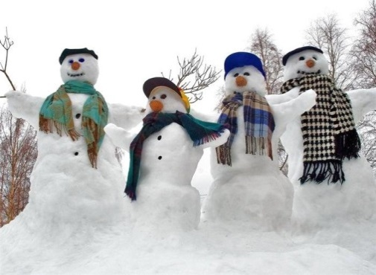

C6. Study the two photographs. In 1,5 minutes be ready to compare and contrast the photographs:
- give a brief description of the photos (action, location)
- say what the pictures have in common
- say what differences they have
- say what kind of shopping you would prefer
- explain why
You will speak for not more than 2 minutes. You have to talk continuously.
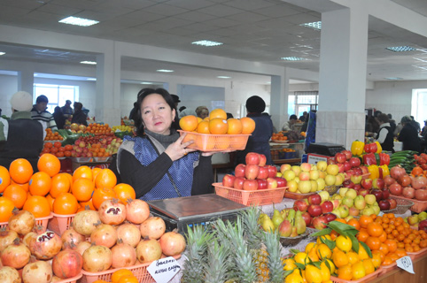

Variant 3
C3. Imagine that you are preparing a project with your friend. You have found some interesting material for the presentation and you want to read this text to your friend. You have 1,5 minutes to read the text silently, then be ready to read it out aloud. You will not have more than 1,5 minutes to read it.
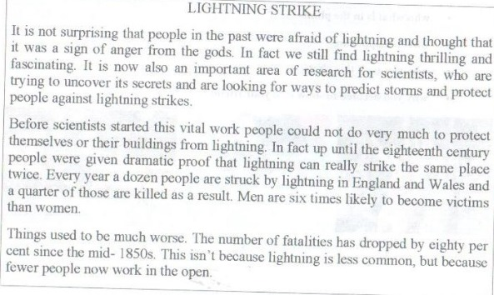
С4. Study the advertisement.
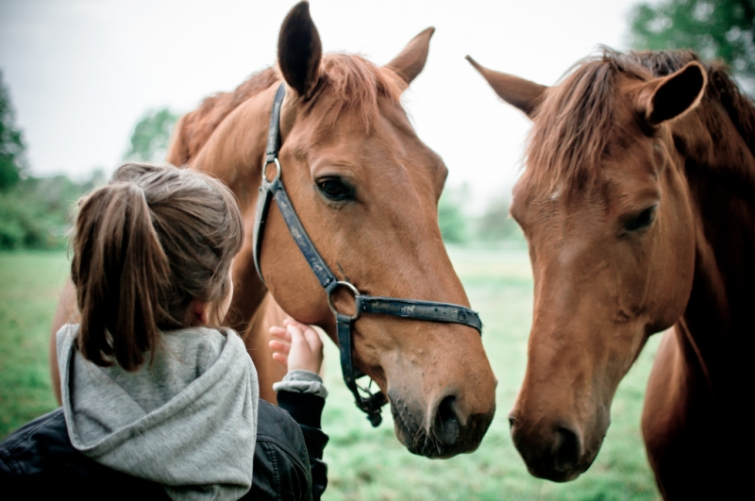
You are taking a language course in England. You want to try horse-riding. You have just found an advertisement to join a local horse-riding club. You are calling to the club to make some clarifications. In 1,5 minutes you are to ask 5 questions. You have 20 seconds to ask each question.
Find out:
- location of the club
- the timetable
- personal coach availability
- price for a 10 days course
- discounts for students
C5. Imagine that while travelling during your holidays you took some photos. Choose one photo to present to your friend. You will have to start speaking in 1,5 minutes and will speak for not more than 2 minutes.
In your talk remember to speak about:
- when you took the picture
- who/what is in the photo
- what is happening
- why you took this photo
- why you decided to show it to your friend
You have to talk continuously, starting with:
I’ve chosen photo number ….
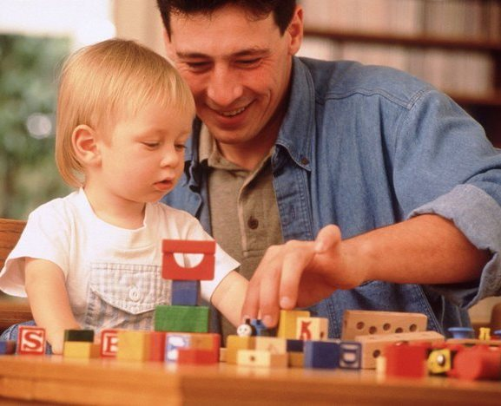

C6. Study the two photographs. In 1,5 minutes be ready to compare and contrast the photographs:
- give a brief description of the photos (action, location)
- say what the pictures have in common
- say what differences they have
- say what kind of telephone you would prefer to talk with your friend
- explain why
You will speak for not more than 2 minutes. You have to talk continuously.
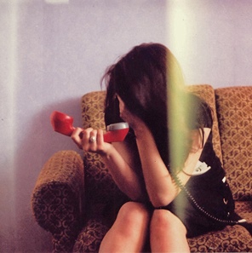

Variant 4
C3. Imagine that you are preparing a project with your friend. You have found some interesting material for the presentation and you want to read this text to your friend. You have 1,5 minutes to read the text silently, then be ready to read it out aloud. You will not have more than 1,5 minutes to read it.
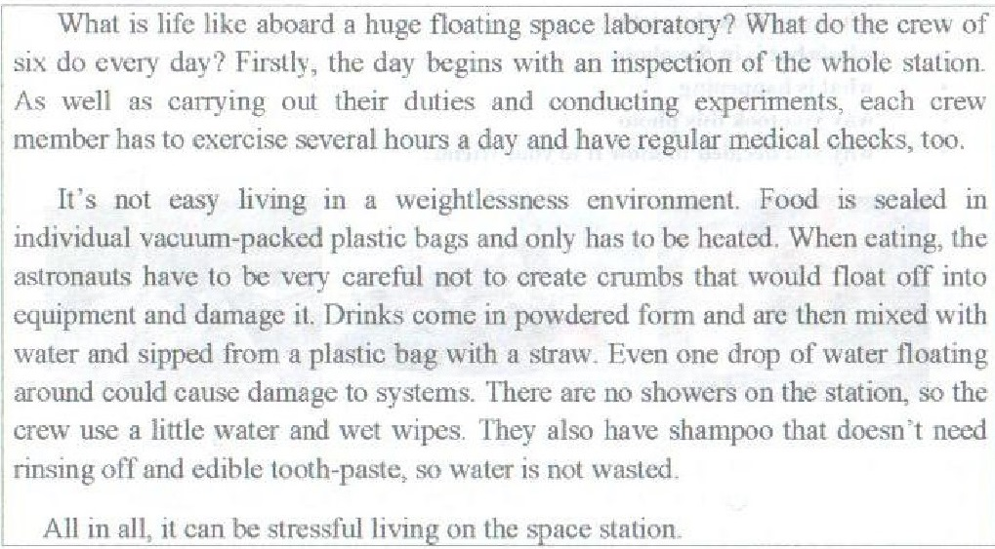
C4. Study the advertisement.
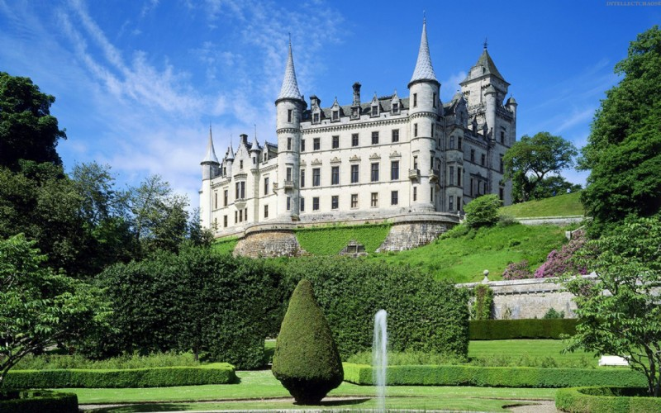
You are taking a language course in Scotland. You want to visit an ancient castle with a group of Russian friends. You have just found an advertisement to join a local horse-riding club. You are calling to the club to make some clarifications. In 1,5 minutes you are to ask 5 questions. You have 20 seconds to ask each question.
Find out:
- opening hours
- an excursion for today availability
- a Russian speaking guide availability
- ticket price
- discounts for a group
C5. Imagine that while travelling during your holidays you took some photos. Choose one photo to present to your friend. You will have to start speaking in 1,5 minutes and will speak for not more than 2 minutes.
In your talk remember to speak about:
- when you took the picture
- who/what is in the photo
- what is happening
- why you took this photo
- why you decided to show it to your friend
You have to talk continuously, starting with:
I’ve chosen photo number ….
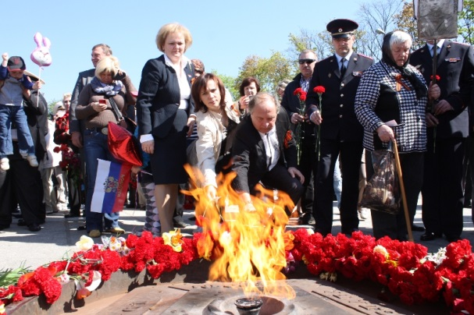

С6. Study the two photographs. In 1,5 minutes be ready to compare and contrast the photographs:
- give a brief description of the photos (action, location)
- say what the pictures have in common
- say what differences they have
- say what kind of music you would prefer to listen to: classical or rock
- explain why
You will speak for not more than 2 minutes. You have to talk continuously.
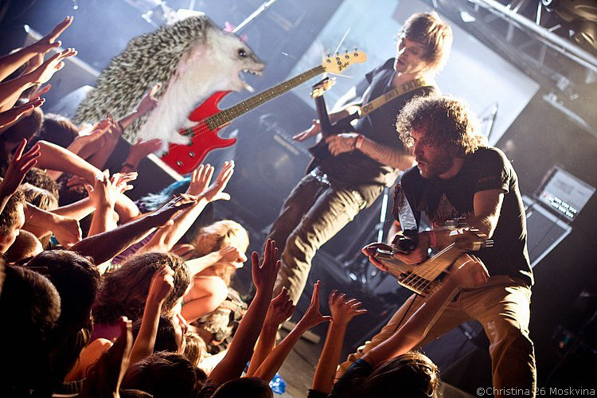 | 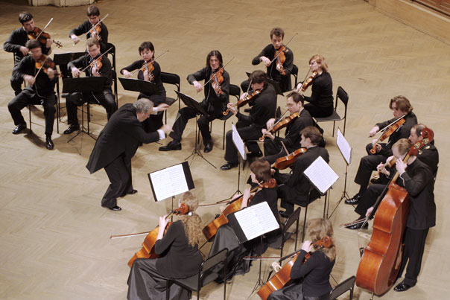

Variant 5
C3. Imagine that you are preparing a project with your friend. You have found some interesting material for the presentation and you want to read this text to your friend. You have 1,5 minutes to read the text silently, then be ready to read it out aloud. You will not have more than 1,5 minutes to read it.
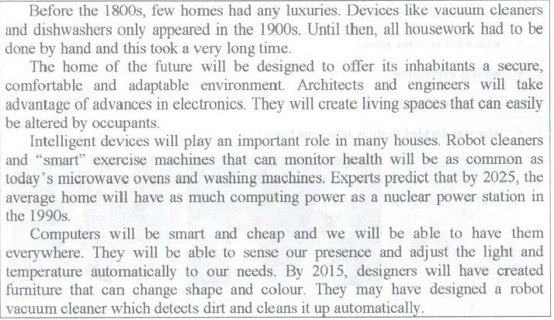
C4. Study the advertisement.
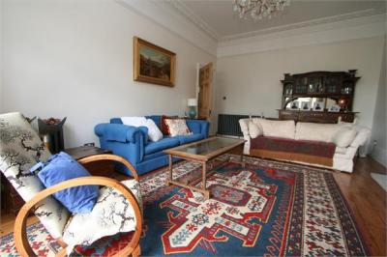
You are doing to stay in London with the group of students next month. You want to reserve some rooms. You are making a phone call to the reception to make some clarifications. In 1,5 minutes you are to ask 5 questions. You have 20 seconds to ask each question.
Find out:
- location of the hotel
- double rooms availability
- facilities offered
- price for a 5 nights double room
- discounts for the group of students
C5. Imagine that while travelling during your holidays you took some photos. Choose one photo to present to your friend. You will have to start speaking in 1,5 minutes and will speak for not more than 2 minutes.
In your talk remember to speak about:
- when you took the picture
- who/what is in the photo
- what is happening
- why you took this photo
- why you decided to show it to your friend
You have to talk continuously, starting with:
I’ve chosen photo number ….

C6. Study the two photographs. In 1,5 minutes be ready to compare and contrast the photographs:
- give a brief description of the photos (action, location)
- say what the pictures have in common
- say what differences they have
- say what kind of books: paper or electronic books you would prefer to read
- explain why
You will speak for not more than 2 minutes. You have to talk continuously.

Variant 6
C3. Imagine that you are preparing a project with your friend. You have found some interesting material for the presentation and you want to read this text to your friend. You have 1,5 minutes to read the text silently, then be ready to read it out aloud. You will not have more than 1,5 minutes to read it.
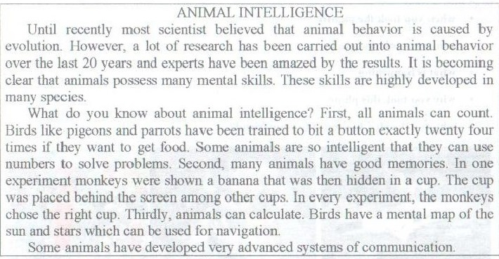
C4. Study the advertisement.
You are going to the cinema. You want to reserve a ticket. You are making a phone call to the booking office to make some clarifications. In 1,5 minutes you are to ask 5 questions. You have 20 seconds to ask each question.
Find out:
- the films on
- the session start time
- tickets availability
- the ticket price
- discounts for students
C5. Imagine that while travelling during your holidays you took some photos. Choose one photo to present to your friend. You will have to start speaking in 1,5 minutes and will speak for not more than 2 minutes.
In your talk remember to speak about:
- when you took the picture
- who/what is in the photo
- what is happening
- why you took this photo
- why you decided to show it to your friend
You have to talk continuously, starting with:
I’ve chosen photo number ….
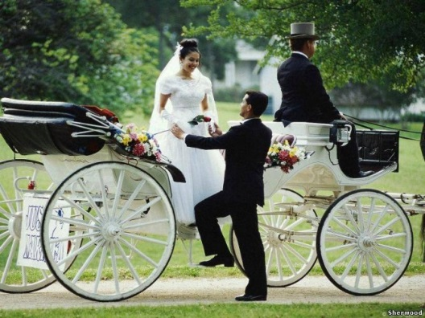

C6. Study the two photographs. In 1,5 minutes be ready to compare and contrast the photographs:
- give a brief description of the photos (action, location)
- say what the pictures have in common
- say what differences they have
- say how you celebrate holidays, what kind of festivals you prefer
- explain why
You will speak for not more than 2 minutes. You have to talk continuously.
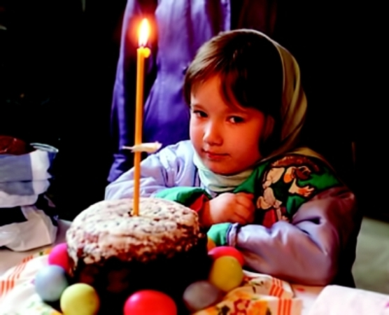

Variant 7
C3. Imagine that you are preparing a project with your friend. You have found some interesting material for the presentation and you want to read this text to your friend. You have 1,5 minutes to read the text silently, then be ready to read it out aloud. You will not have more than 1,5 minutes to read it.
C4. Study the advertisement.
You would like to buy a ticket for the Saturday performance. You need a seat in the stalls. You are making a call to the theatre box-office to make some clarifications. In 1,5 minutes you are to ask 5 questions. You have 20 seconds to ask each question.
Find out:
- Saturday performances
- tickets availability
- the time of performance
- the ticket price
- discounts for students
C5. Imagine that while travelling during your holidays you took some photos. Choose one photo to present to your friend. You will have to start speaking in 1,5 minutes and will speak for not more than 2 minutes.
In your talk remember to speak about:
- when you took the picture
- who/what is in the photo
- what is happening
- why you took this photo
- why you decided to show it to your friend
You have to talk continuously, starting with:
I’ve chosen photo number ….
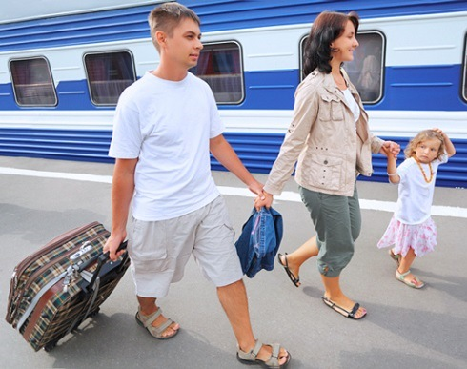 | 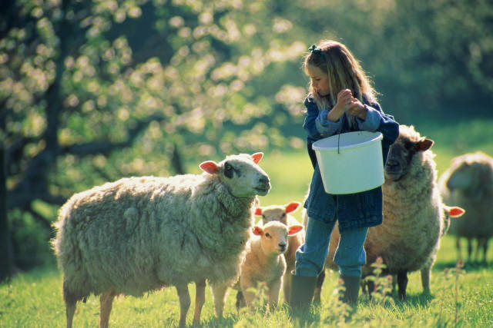 | 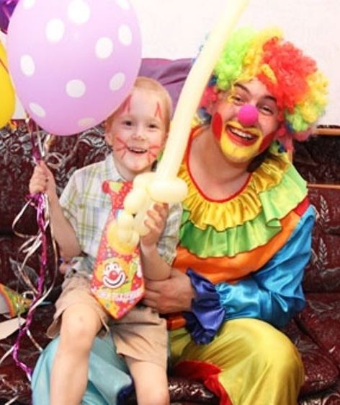

С6. Study the two photographs. In 1,5 minutes be ready to compare and contrast the photographs:
- give a brief description of the photos (action, location)
- say what the pictures have in common
- say what differences they have
- say what kind of restaurants you would prefer to eat out
- explain why
You will speak for not more than 2 minutes. You have to talk continuously.

Variant 8
C3. Imagine that you are preparing a project with your friend. You have found some interesting material for the presentation and you want to read this text to your friend. You have 1,5 minutes to read the text silently, then be ready to read it out aloud. You will not have more than 1,5 minutes to read it.
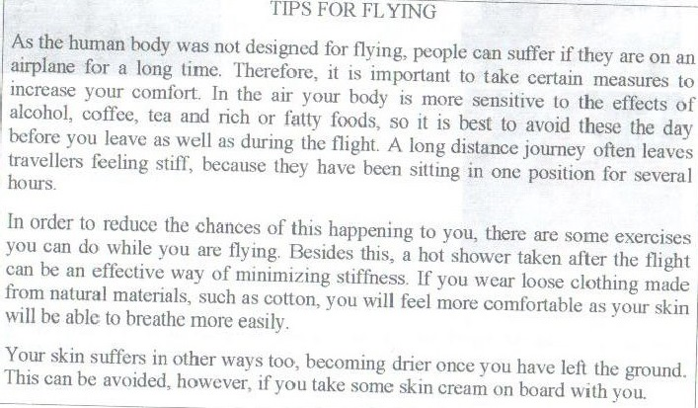
С4. Study the advertisement.
You would like to apply for a summer job. You are making a call to the job centre to make some clarifications. In 1,5 minutes you are to ask 5 questions. You have 20 seconds to ask each question.
Find out:
- available jobs
- job descriptions
- skills required
- working hours
- pay

C5. Imagine that while travelling during your holidays you took some photos. Choose one photo to present to your friend. You will have to start speaking in 1,5 minutes and will speak for not more than 2 minutes.
In your talk remember to speak about:
- when you took the picture
- who/what is in the photo
- what is happening
- why you took this photo
- why you decided to show it to your friend
You have to talk continuously, starting with:
I’ve chosen photo number ….
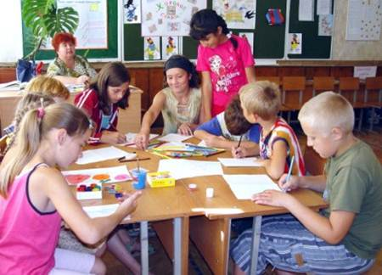 |  | 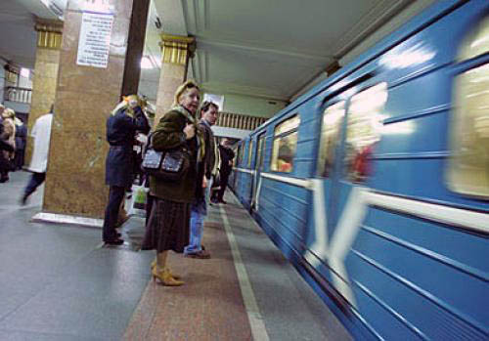

C6. Study the two photographs. In 1,5 minutes be ready to compare and contrast the photographs:
- give a brief description of the photos (action, location)
- say what the pictures have in common
- say what differences they have
- say what means of travelling you would prefer
- explain why
You will speak for not more than 2 minutes. You have to talk continuously.
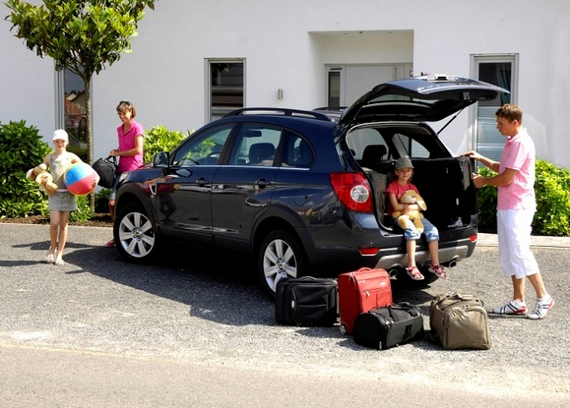

Variant 9
C3. Imagine that you are preparing a project with your friend. You have found some interesting material for the presentation and you want to read this text to your friend. You have 1,5 minutes to read the text silently, then be ready to read it out aloud. You will not have more than 1,5 minutes to read it.
С4. Study the advertisement.
You are having your birthday and you would like to reserve a table for the Saturday night. You are making a call to the restaurant to make some clarifications. In 1,5 minutes you are to ask 5 questions. You have 20 seconds to ask each question.
Find out:
- tables availability
- live music
- the types of cuisine available
- discounts for students
- special offer
C5. Imagine that while travelling during your holidays you took some photos. Choose one photo to present to your friend. You will have to start speaking in 1,5 minutes and will speak for not more than 2 minutes.
In your talk remember to speak about:
- when you took the picture
- who/what is in the photo
- what is happening
- why you took this photo
- why you decided to show it to your friend
You have to talk continuously, starting with:
I’ve chosen photo number ….

C6. Study the two photographs. In 1,5 minutes be ready to compare and contrast the photographs:
- give a brief description of the photos (action, location)
- say what the pictures have in common
- say what differences they have
- say what kind of travelling (travelling by plane of by train) you would prefer
- explain why
You will speak for not more than 2 minutes. You have to talk continuously.
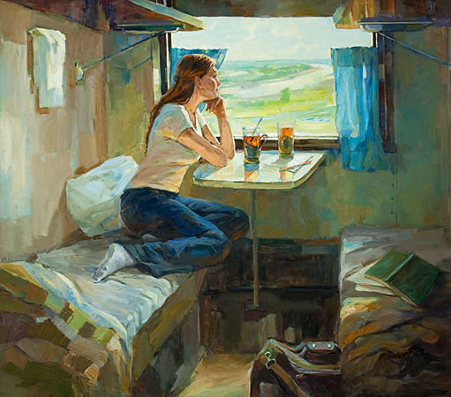

Variant 10
C3. Imagine that you are preparing a project with your friend. You have found some interesting material for the presentation and you want to read this text to your friend. You have 1,5 minutes to read the text silently, then be ready to read it out aloud. You will not have more than 1,5 minutes to read it.
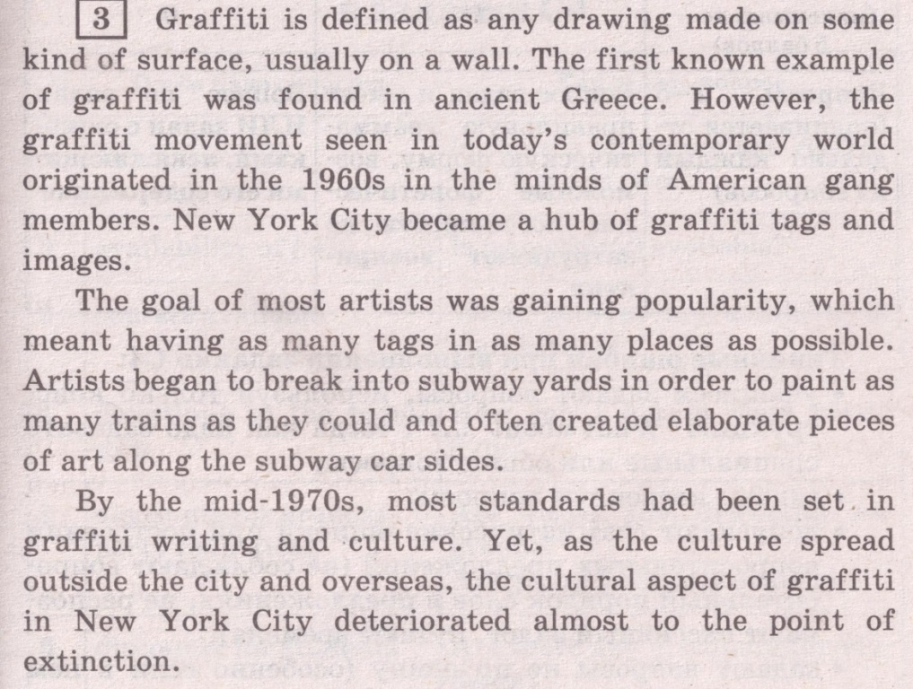
С4. Study the advertisement.
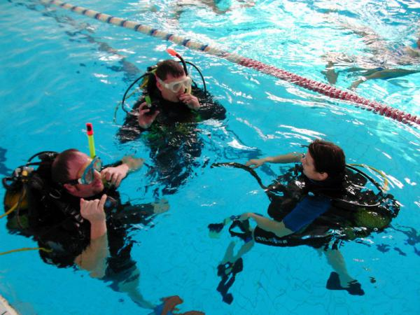
You are going to study abroad for three months and would like to go in for diving. You are calling to make some clarifications. In 1,5 minutes you are to ask 5 questions. You have 20 seconds to ask each question.
Find out:
- location of the swimming pool
- price for a beginner course
- duration of the course
- necessary gear
- discounts for students
C5. Imagine that while travelling during your holidays you took some photos. Choose one photo to present to your friend. You will have to start speaking in 1,5 minutes and will speak for not more than 2 minutes.
In your talk remember to speak about:
- when you took the picture
- who/what is in the photo
- what is happening
- why you took this photo
- why you decided to show it to your friend
You have to talk continuously, starting with:
I’ve chosen photo number ….
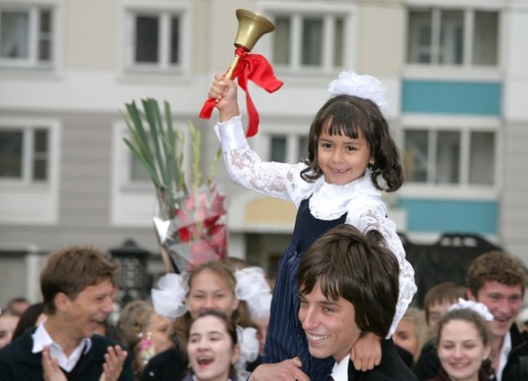 |  | 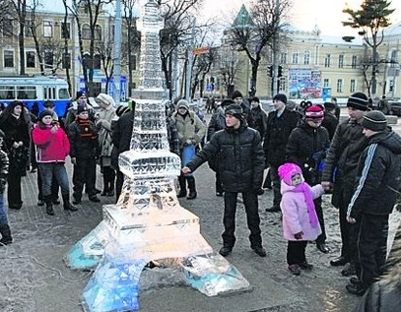

C6. . Study the two photographs. In 1,5 minutes be ready to compare and contrast the photographs:
- give a brief description of the photos (action, location)
- say what the pictures have in common
- say what differences they have
- say which of the pets presented in the pictures you’d prefer
- explain why
You will speak for not more than 2 minutes. You have to talk continuously.
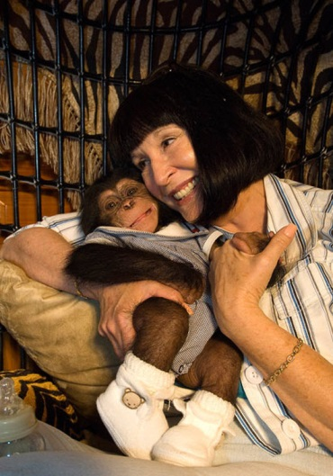 | 