The Lake Baikal

Tanya Panisheva 7-1

Baikal is the deepest lake. Baikal is locate in the center of Asia. It looks like a big moon!

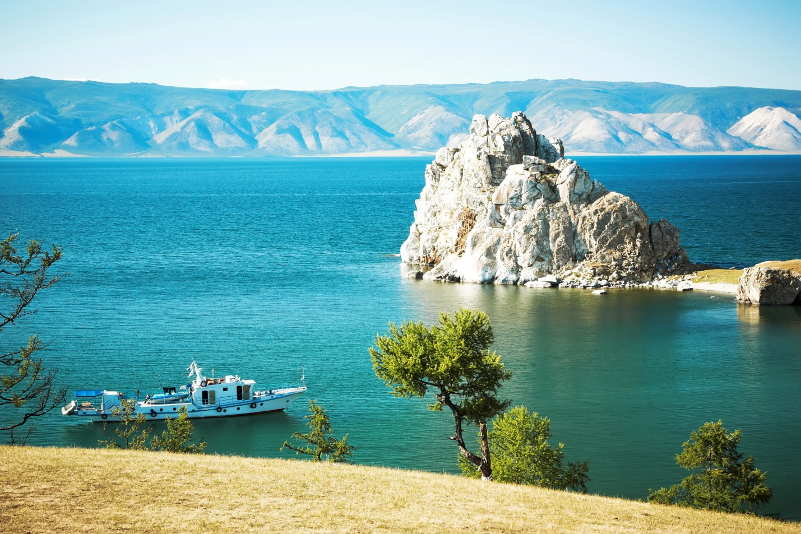

And now

5 facts about Baikal

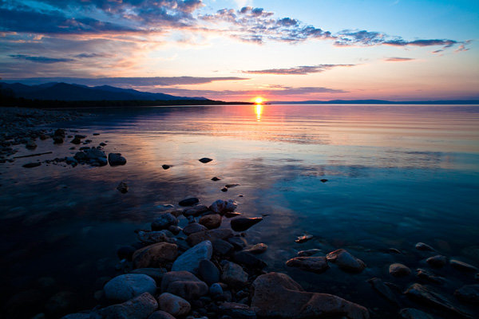

Baikal is 25 million

years old.

336 rivers fall into the late.

The water in lake Baikal is fresh

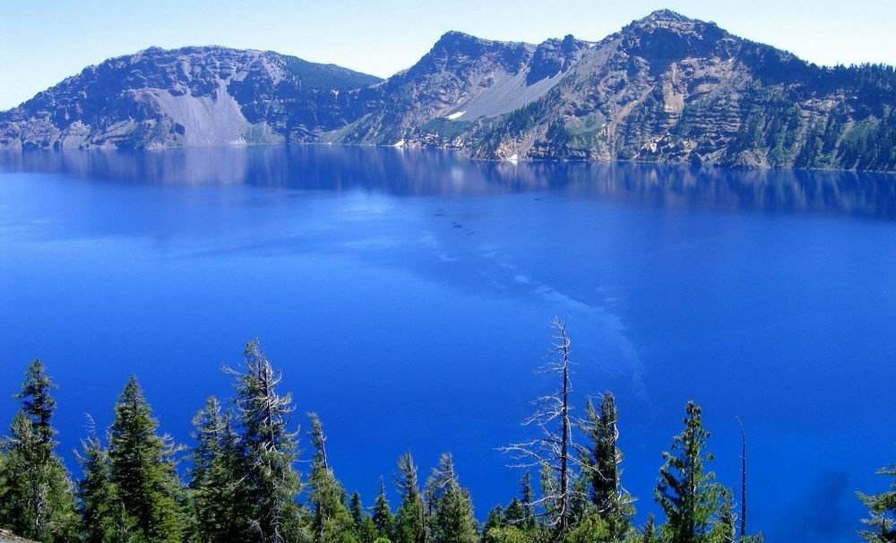

The water is not warm in Summer.

The water is transparent very much.

Thank you, Goodbye

