11th form. Lesson 54.

1) p. 224, ex.1. Read the information. What is advertised? Write down the phrases.
2) p. 225, ex. 2. Choose one of the inventions. Speak about it. Answer the questions.
3) p. 226, ex.2. Would you buy advertised things? Why? Why not?
4)
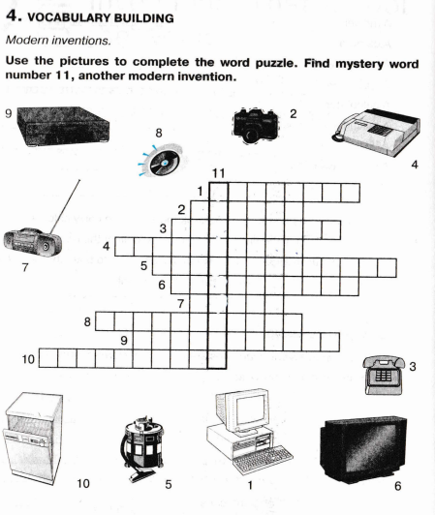
5)
