Муниципальное бюджетное общеобразовательное учреждение
«Средняя школа № 25» города Смоленска

ПРОЕКТ
« Fashion of the British royal family since the end of the 20th century – 21st century»

Выполнила:
ученица 9 класса «Б»
Никитина Вероника Юрьевна
Руководитель:
учитель английского языка
Семченкова А. К.

Смоленск
2019

Contents
1. Introduction | 3
2. Main part | 4-15
2.1 Relevance of the problem | 4
2.2 A short test about royal fashion | 5-7
2.3 The result of a social survey | 8
2.416 fashion rules the royal family lives by | 9-10
2.5 Fashion preferences of British royal family members | 11-14
3. Interesting facts | 15
- Some iconic moments connected with the members of the British royal family | 15-17
- Hidden meanings in royals’ outfits | 18-20
4. Conclusion | 21
5. Test answers and their explanations | 22
6. Information sources | 23
7. Attachments

Introduction
Fashion is something we deal with every day. Even people who say they don't care what they wear choose clothes every morning that say a lot about them and how they feel that day. One certain thing in the fashion world is a change. We are constantly being bombarded with new fashion ideas. Perhaps only few will be interested in the theme of my project, but I can confidently say that fashion of the British royal family is very peculiar and its history is not less interesting. I have chosen a time interval between the end of the twentieth and twenty first centuries.

Relevance of the problem
Theme of the project: fashion of the British royal family since the end of the 20th-21st century.
Objects of the study: England fashion in XX-XXI century. Fashion rules and preferences of the British royal family.
Subject of the study: style of the British royals.
Research methods: descriptive, questioning, comparative.
Problem: Students do not know about the English royal style’s features.
Project goal: to study fashion and style of the British royal family
Project tasks:
- to study theoretical materials, various sources connected with the British royal family’s style and fashion trends;
- to organize the information;
- to reveal classmates’ level of knowledge of the royal family style’s features;
- to develop the collection of paper dolls made for primary and secondary school students. In that way, they will be able to get acquainted with the topics of “Clothing”, “Style of the British royal family”

Short test about royal fashion
1. Which patron saint's day did Kate wear this green coat to celebrate in March 2013?
A St George's Day
B St Patrick's Day
C St Andrew's Day
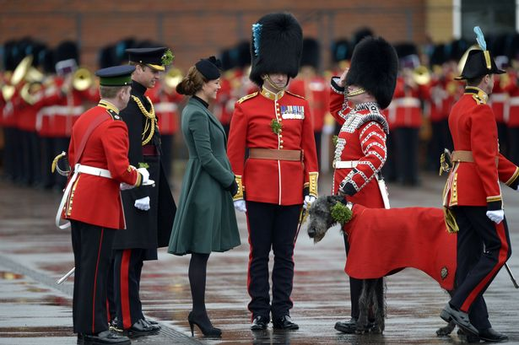

2. Which royal did these sapphire and diamond earrings used to belong to? Kate had them changed from studs to drop earrings and wears them often
A The Queen
B Camilla, Duchess of Cornwall
C Princess Diana
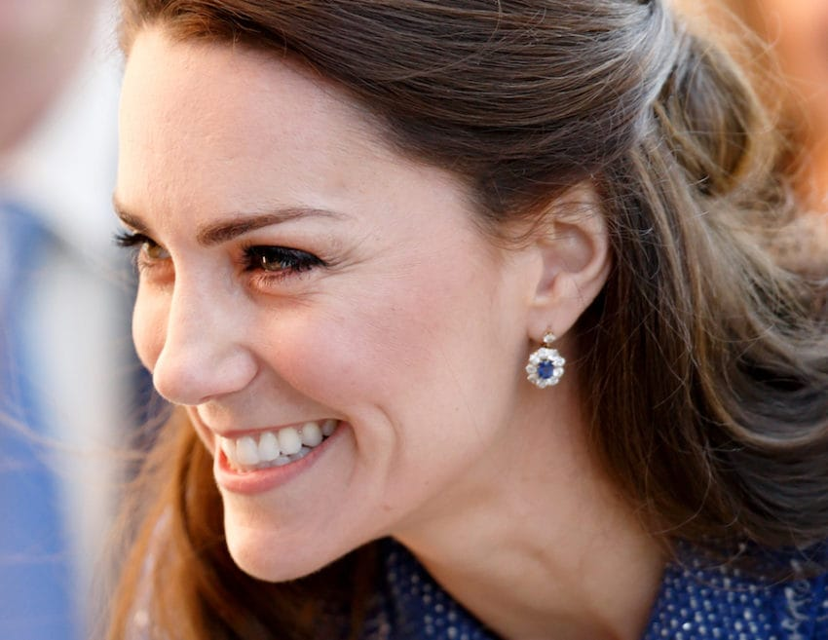
3. How much was this Erdem dress that Kate Middleton wore to visit an inner-city Manchester school in April 2013?
A £1, 0695
B £165
C £925
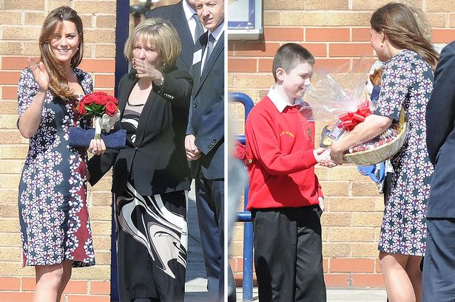
4. What colour shoes did Kate wear with this outfit for the Diamond Jubilee pageant? (Clue: they are said to be her favourite as she wears them so often)
A Black
B Brown
C Nude/Beige
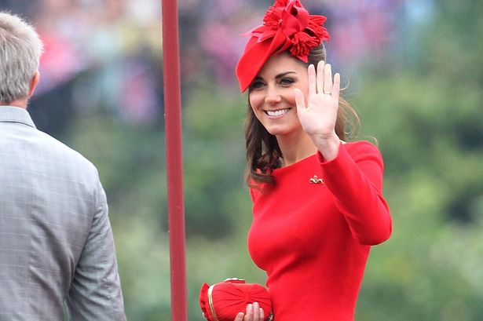
5. Flashy diamonds and tiaras are not allowed to be worn during the day. At what time do royal women get to ditch their hats and put their tiaras on?
A 5 p.m.
B 6 p.m.
C 7 p.m.
D 8 p.m.
6. Do British royal family women cover their nails with bright colours?
A Yes, always
B No, it is forbidden
C I don’t know the correct answer
7. Why are bright colours a necessity for the Queen?
A She likes them
B She wants to be seen in the crowd
C She just have to choose them instead of calm shades
8. Which type of clothes do royals take while they are travelling?
A Swimsuit
B Black ensemble
C Scotland skirt
D All variants
9. Why do royals wear gloves?
A They are fashionable
B Tradition
C Protection
D All variants
10. Are you interested anyway in British royal family?

The result of a social survey
One of the tasks in our project was to reveal classmates’ level of knowledge of the royal family style’s features. After the researching we understood that students from our school don’t know about the rules of royal fashion and royal etiquette. The material collected in our work could improve some linguistic and cultural knowledge in the sphere of fashion and etiquette. There was a social survey among students of our school that we conducted as a part of a project research. The main goal was to find out the percentage of people who are interested someway in the sphere of things connected with royalty. There were 16 people taken part in our survey. The results are quite expected. 100% respondents of this group know some information about the particular royal family. And only 19% of pupils answered the questions from the test absolutely right, other 81% were not able to give the right answers.
Conclusion: a large number of people don’t know about the foreign royal family traditions and maybe even the secrets linked with their own manners in fashion. We should try to get them acquainted with modern fashion, rules and preferences. That’s the main idea of our project!

16 fashion rules the royal family lives by
The British royal family abides by a very specific—and strict—style guide. And though it must be tough to appear prim and proper all the time, the queen's handful of sartorial rules have kept the family looking posh and avoiding potentially embarrassing faux pas for 60-plus years. When should one wear their military garb? What else might clutches be good for, beyond carrying breath mints and lipstick? It is all in the (figurative) handbook! There are 16 royal fashion do's and definite don'ts.

1. BRIGHT COLOURS ARE A NECESSITY FOR THE QUEEN.

After all, she wants to be noticed. Throughout her 66-year reign, Queen Elizabeth II has sported monochromatic fuchsia, lime green, and canary yellow outfits from her wardrobe, which boasts every colour of the rainbow. The uniform is quite sensible, though: She wants to guarantee the public can see her through the crowd.

2. HATS FOR WOMEN ARE A MUST.

3. TIARAS ARE LIKE WEDDING RINGS.
Only married women of the family get to don the jewels. That's because tiaras signify relationship status—and let curious bachelors know if a woman is off limits.

4. YOUNG PRINCES NEVER WEAR PANTS.

5. GLOVES ARE FOR PROTECTION.

6. ALWAYS HAVE A BLACK ENSEMBLE ON-HAND.
It is hard to see a royal wearing black, but while traveling outside the country, they are required to pack a full black outfit in case of emergency. This is so that, if a family member dies, they will arrive back in England dressed appropriately, since they will certainly be photographed when departing the plane.

7. COATS MUST STAY ON.
Etiquette bars female members of the family from removing their outermost layer in public, viewing it as an "unladylike action."
8. NAILS ARE TO BE KEPT SUBTLE.

9. WEDGE SHOES ARE LOOKED DOWN ON.

10. HANDBAGS AREN'T JUST FOR BELONGINGS.
For example, when she wants to leave a dinner, she sets the purse on top of the table, letting her aides know to wrap up in five minutes. Or, if she is in the middle of a dull conversation, she will place her bag on the floor, giving a cue to her lady-in-waiting that she'd like to be rescued.

11. CLUTCHES ARE GOOD IN A BIND.
To avoid an embarrassing slip up, Princess Diana relied on her custom clutches to shield her chest while stepping out of cars, thus keeping paparazzi from getting their money shot.

12. DON'T FORGET PANTYHOSE.
No bylaw explicitly states pantyhose are a must. But, it's an unspoken rule that the Queen expects—and enforces—female family members and their guests to wear tights to all public outings.

13. WEIGH DOWN HEMLINES.
Otherwise suffer a Marilyn moment. In her custom dresses, the Queen has small, lead curtain weights sewn inside her hemlines. Though they weigh less than an ounce each, they keep her skirts from flying up if there were to be a sudden gust of wind.

14. MILITARY UNIFORMS ARE TO BE WORN AT THE MOST FORMAL EVENTS.

15. USE FASHION TO COMPLIMENT HOSTS WHILE TRAVELING ABROAD.
While traveling, the family will pay tribute to a country they are visiting by sporting the national color or by incorporating a meaningful emblem into their outfits.

16. DENIM ISN'T FORBIDDEN, BUT IT'S NOT PREFERRED.

Fashion preferences of members of British royal family

Queen Elizabeth II

Queen Elizabeth’s wardrobe is made up almost entirely of matching suits and dresses, in fact, she is only been photographed wearing pants once and that was back in 1970. She also mostly sticks to loud, bright colours and there is a specific reason for that.

And if you are wondering if what the queen’s favorite colour to wear is that would be blue. She wears some shade of it 29% of the time. She also likes green which she breaks out 11% of the time, followed by pink and purple. Her least favorite colour to wear is beige which makes sense since it is not one that would grab the attention of a crowd gathered to see her.

Prince Philip Mountbatten, Duke of Edinburgh

For 65 years Prince Philip, Duke of Edinburgh, has had to navigate a harder corporate dress code than most men. As the Queen’s spouse, his clothes have had to be impeccable, but nearly invisible, is not attracting attention. In the seven decades that he has stood, literally and metaphorically, in his wife’s shadow, his wardrobe has always been beyond reproach, but very rarely eye-catching.

Look closely, however, and the Prince has a lot to teach us about dressing correctly and with restraint, and about the importance of looking comfortable. This is true of his classic suits, which are made by Savile Row tailor Mr John Kent and are as relevant now as they were in the 1950s, and of his more relaxed outfits.

Charles, Prince of Wales
Prince Charles, Prince of Wales and heir to the British throne must have an irreproachable appearance. It must be said that the heir to the throne looked after his appearance from an early age. After all, the Prince of Wales has a duty to represent his country and the image of the nation.
Prince Charles for more than 30 years has remained true to the classic patterns that his trusty tailors Anderson & Sheppard, and Gieves & Hawkes have advised him and that he has always dressed in the absolute British style.

Prince of Wales has always used excessive colors in his outfits. His mono color or diplomatic costumes are his most frequent choice. Something similar happens with his shirts. These are usually also monochrome or in some cases, blended with fine lines. It will be difficult to see him in plaid shirts or striking stripes. His favorite color for these is the light blue. This color facilitates the correct combination of handkerchiefs and also allows him to choose a handkerchief for a more cheerful print.

Prince of Wales is the ultimate sample of British elegance in its maximum. If you have the opportunity to go to an English bookstore and look at the many biographies that exist on Prince of Wales, you can see in the photos of the interior that his dress has hardly undergone remarkable changes in all these years.

Camilla, the Duchess of Cornwall
From royal weddings and black tie events to international tours of the Commonwealth, Camilla Parker Bowles carries out a number of official duties and she has to look the part of the wife of the future King of England. Unlike the Queen and her step-daughter-in-law Kate the Duchess of Cornwall usually steers clear of bright colours, favoring neutrals, pastels, and navy with the occasional pop of bright blue. But when it comes to hats, she is not afraid to make a bold statement.

Diana, Princess of Wales
As a royal and a humanitarian, the late Princess Diana’s legacy extends far beyond her wardrobe. Diana made bold statements with her sartorial choices, from the bright suits and dramatic gowns to her famous wedding dress.
Nonetheless, 22 years after her death on 31 August 1997, the world remains fascinated with the royal's sense of style.
From the polka dot smock dress she wore on the steps of the Lindo Wing with newborn Prince Harry to the so-called "revenge dress" she wore the same evening Prince Charles confessed to his adultery with Camilla, Princess Diana’s looks were among the most scrutinized of her time.
Fashion label Off-White’s spring/summer 2018 collection directly referenced a number of Princess Diana’s most famous ensembles, with models wearing everything from cycling shorts with blazers to pastel suits and power shoulders.
The Duchess of Sussex and Duchess of Cambridge often pay tribute to their late mother-in-law’s wardrobe in subtle ways.
She not only became a fashion icon of her time, but she used her famous looks to inspire charitable donations through clothing auctions. She will live on as the stylish royal who never lost sight of her larger purpose and never let the glaring attention change her (besides maybe making her even more fashionable each passing year, if that’s possible).

William, Duke of Cambridge
From the red carpet to royal tours and personal appearances, Prince William rarely puts a foot wrong with his wardrobe, trusting in a tried-and-tested series of suits and looks for every occasion.

Henry, Duke of Sussex
Since Prince Harry had getting engaged to Meghan Markle in November 2017, it's been noted that his style has become noticeably more sophisticated and nuanced. A number of people link it with influence of Meghan Markle, who used to star on a television show called Suits. After meeting his wife in 2016, Prince Harry has toned down his louder outfits of the past, opting for more earthy and neutral coloured ensembles and well-tailored suits and also he has ditched bright ties and baggy suits.

Catherine, Duchess of Cambridge
From state banquets to official engagements, the Duchess of Cambridge is never anything less than flawless. Kate is how she's mastered the art of high-low dressing, fusing the best of the British high street with high-end designs fresh from the catwalk. While Meghan Markle uses fashion to cause a stir within Buckingham Palace, her sister-in-law is pretty good at doing the exact opposite. Between Kate Middleton’s ubiquitous A-line dresses and designer coats, seldom do we see her take risks. Of course, with a closet full of Alexander McQueen dresses and Gianvito Rossi pumps, why would she?

Meghan, Duchess of Sussex
As editor-in-chief of The Tig, Markle became known for her fashion sense. Markle has cited Emmanuelle Alt as her style inspiration. In an interview with Glamour, the Duchess said that she favored "that French way of styling, where if your outfit is pulled together, then something's got to be disheveled—your hair, your make-up". In her youth, Markle's "sensibility had always been relaxed California girl style" consisting of jeans, cut-offs and flip-flops. She usually prefers "streamlined dresses" with "neutral colors" and bateau necklines, and likes "monochromatic and tonal dressing". She has worn outfits and ensembles by a wide variety of fashion designers.
In December 2017, Markle caused a surge in interest in Scottish retailer Strathberry after carrying one of their handbags to a public event shortly after her engagement. This was reported as an indication that her fashion choices would produce her own version of the Kate effect. After Markle and Prince Harry's first appearance as a couple, brands Mackage, Birks, R&R Jewelers, Crown Jewelers and Everlane noted an upswing in their website hits and sales. It has been speculated that Markle's effect would be greater, as she has a strong appeal in America. She caused a boost in the sales of yellow gold in the first quarter of 2018 in the United States.
In 2018, Tatler named the Duchess on its list of Britain's best dressed people, praising her for redefining "modern royal style with every subsequent appearance". Following the announcement of her pregnancy, the Duchess appeared in a Karen Gee dress that resulted in the breakdown of the designer's website. She was ranked one of the best dressed women in 2018 by fashion website Net-a-Porter, and was nominated for the 2018 Teen Choice Awards in the category Choice Style Icon. In 2019, British brand Reiss reported a growth in profits, after the Duchess was seen wearing a mini-dress by them on International Women's Day.

Some iconic fashion moments connected with
the members of the British royal family

Princess Diana’s wedding dress

It might surprise you to hear that when Princess Diana first got engaged, she had no interest in fashion. But overnight, she went from a shy young aristocrat to a soon-to-be princess in the limelight, and had to dress accordingly. At first, her style was very twee. As Diana’s former stylist, Anna Harvey, reveals, ‘Diana started off being really safe with her style. It was all very ‘Laura Ashley’.’ Cue bows, frills and, in other words, every little girl’s interpretation of a fairytale princess.
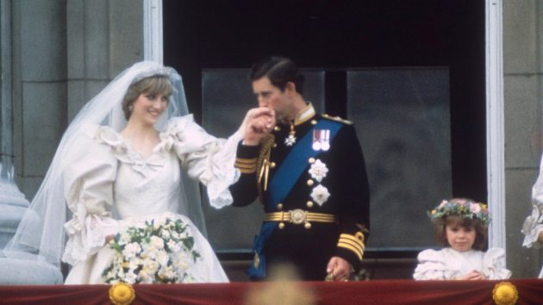

Princess Diana’s “revenge dress”
Princess Diana always knew how to make a black dress look classy. Soon after Prince Charles confessed he had been unfaithful to her in a 1994 interview, Princess Diana attended a Vanity Fair party in an off-the-shoulder little black dress, paired with black tights and a statement necklace. She looked so strikingly sexy that the outfit has gone down in history as her “revenge dress”.
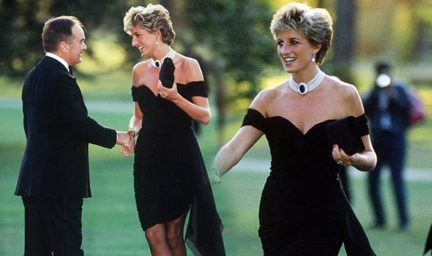

«Markle’s add»

The Line coat from Meghan Markle's engagement photos in 2017 became so popular that the company ended up naming it after her.
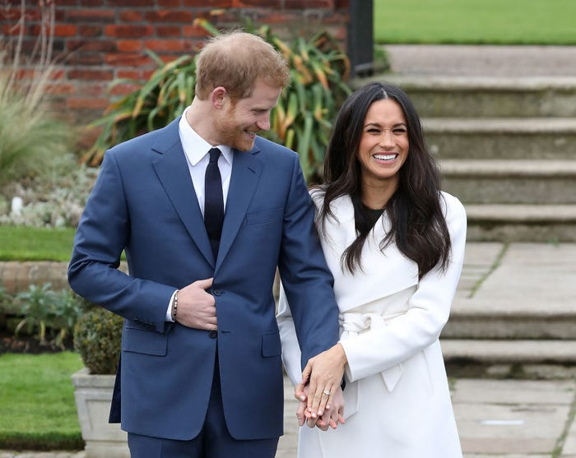

Dancing with John Travolta in 1985
Another iconic moment during which Princess Diana captured the hearts of the world; showing off her fun side by dancing with a young John Travolta at a White House dinner held by President Reagan. The gown, an off shoulder number by Victor Edelstein, was sold at auction for £240,000 after her death. 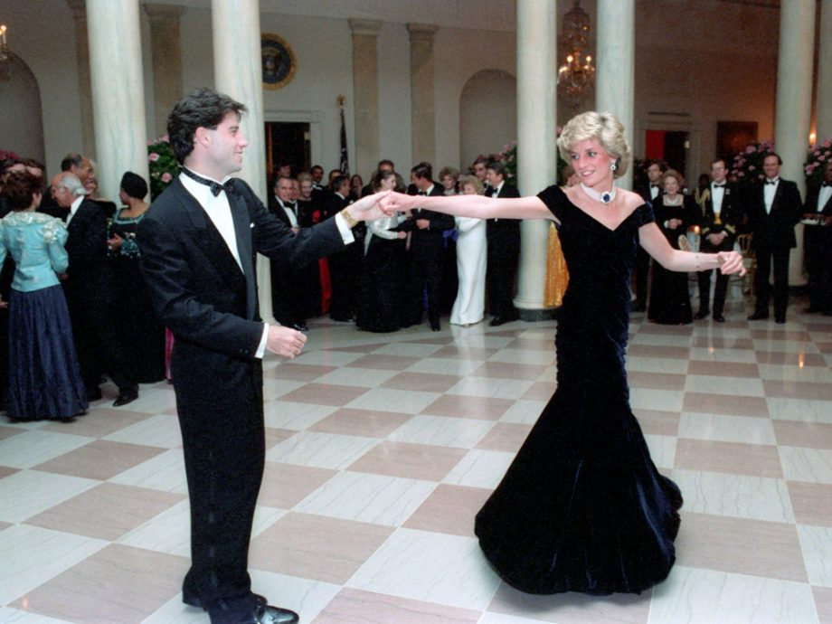

Hidden meanings in royals’ outfits
- At the wedding of Harry and Megan Elizabeth II was dressed in a green suit. And her majesty’s advisor tells that it is not just so! Violet would mean the Queen’s endorsement, and green is the color that demonstrates respect and hope for the best future.
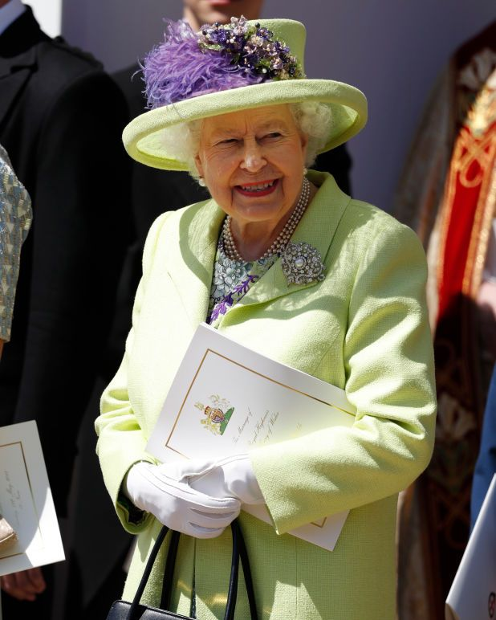
- When Middleton became a mother for the first time when she gave birth to Prince George in July 2013, Kate paid homage to her late mother-in-law Princess Diana with a bespoke short sleeved blue polka dotted dress with an empire waist by Jenny Packham — a nod to the dotted dress that Diana wore when leaving the hospital with Prince William three decades earlier.

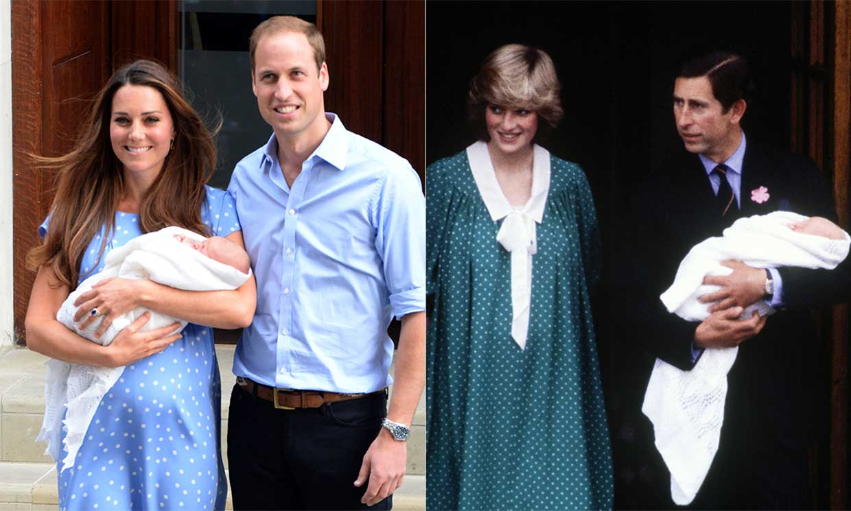

- When Diana and Charles debuted Prince Harry after his birth in 1984, Diana wore a red coat with a white top that had a red bow and white collar. She wore the same red kitten heels as a few years earlier when she debuted Prince William. Prince Charles had on a navy blue pinstripe suit.
Kate and Williams' outfit choices 34 years later were clear tributes to the prince's parents. The 37-year-old wore a red Jenny Packham shift dress that had a white lace collar. Prince William wasn't as formal as his father that day, but he also wore a blue sport coat and navy pants. That seems to be his look when introducing the royal babies to the world.
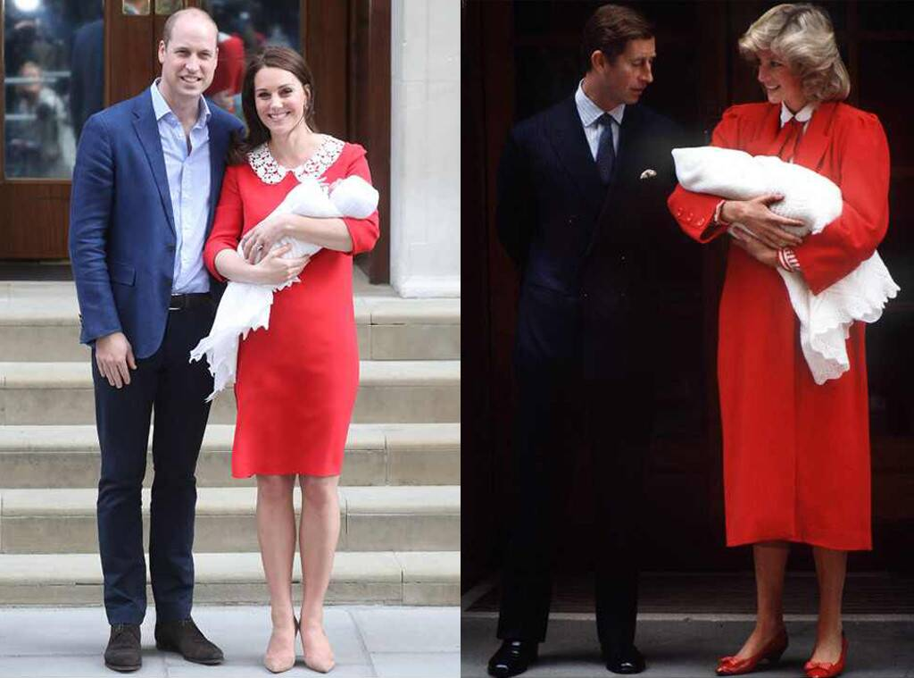
- Meghan’s wedding bouquet consisted of scorpion grasses. Those flowers are Princess Diana’s favourite ones.
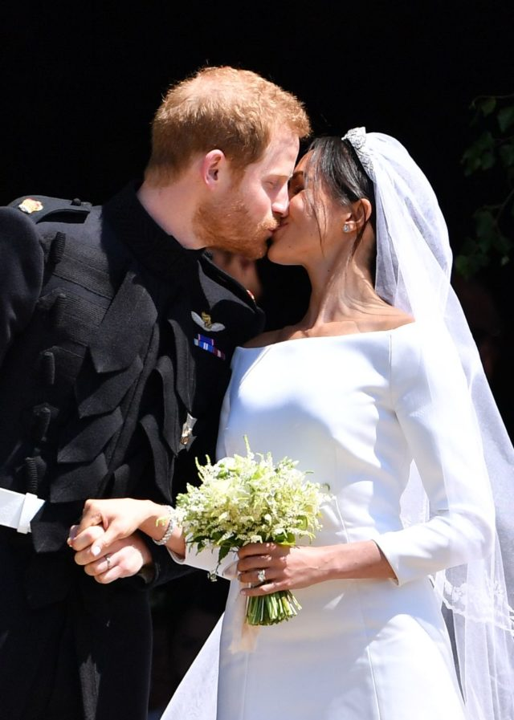
- While Kate and William were visiting Germany in 2017, she wore a dress with eagle print on it. Eagle is the national bird of this country.

Conclusion
Lots of people believe that it's important to look nice. However, some people say that we place too much importance on appearance and fashion.
From my point of view, when people speak to you, they always pay attention to your appearance and your clothes. If you look untidy, they will try to avoid communication with you. There is a saying that "good clothes open all doors" and I firmly believe in it.
On the other hand some people place too much importance on their appearance. They spend much money on expensive clothes and sometimes they look absurd and unfashionable at all. There are some styles that can surprise and even shock people
Without a doubt, I'd like to say that nowadays fashion becomes even more influential than it was in the past. It effects and establishes public taste. I strongly believe that people should follow fashion and pay attention to their appearance. What’s more, we should try to follow some rules as royal family does. And on the contrary fashion should never become a kind of obsession

Test answers and their explanations
- B
- C
- A
- C
- B In addition to only being suitable for formal events after 6 p.m. , tiaras are also off-limits to unmarried women (which is why Meghan Markle didn't get to wear one until her wedding day).
- B
- B
- B
- C or D

Information sources
16 Fashion Rules the Royal Family Lives By | Mental Floss
https://peopletalk.ru/article/1651012/
https://peopletalk.ru/article/megan-markl-samaya-stilnaya-sobrali-vse-ee-vyhody-v-statuse-gertsogini/
https://www.mirror.co.uk/news/uk-news/kate-middleton-fashion-quiz-you-2042493
http://www.livingly.com/trivia/2K5-fQu-ISN/How+Well+Know+Kate+Middleton+Style
https://home.bt.com/lifestyle/health/beauty-advice/kate-middleton-fashion-11364196818353
https://peopletalk.ru/article/ne-prosto-naryady-skrytye-znacheniya-korolevskih-obrazov-kejt-middlton-megan-markl-i-printsessy-diany/
https://www.harpersbazaar.com/fashion/street-style/g10330122/princess-diana-fashion-style/
https://www.independent.co.uk/life-style/fashion/princess-diana-fashion-best-iconic-anniversary-revenge-dress-cycling-shorts-death-a9086341.html
https://www.marieclaire.com.au/princess-diana-style-file
https://www.southernliving.com/fashion-beauty/princess-diana-style

