11 класс. Урок 96.
Задание для самостоятельной работы. Работа с материалами ЕГЭ. Лексика. Грамматика.
Задачи:
- Рассмотрите внимательно задание и запишите алгоритмы работы с данным видом задания.
- _____________________________________________________________
- _____________________________________________________________
- _____________________________________________________________
- _____________________________________________________________
- _____________________________________________________________
- Выполните задания
Tourism in Britain
Every year more than eleven million tourists visit Britain. In fact, tourism is an _________________ (importance) industry, employing thousands of people. Most _________________ (visit) come in the summer months when they can expect good weather. Tourists ____________ (usual) spend a few days in London, then go on to other well-known cities. Perhaps the least visited places in England are old _________________ (industry) towns. But many people think that the 19th century cities show the _____________ (real) f Britain. The _____________ (great) of the past is to be still seen in their old streets. The cheap, concrete buildings of the 1960s look old and dirty, but for the _____________ (adventure) tourists these cities are full of life and colour.

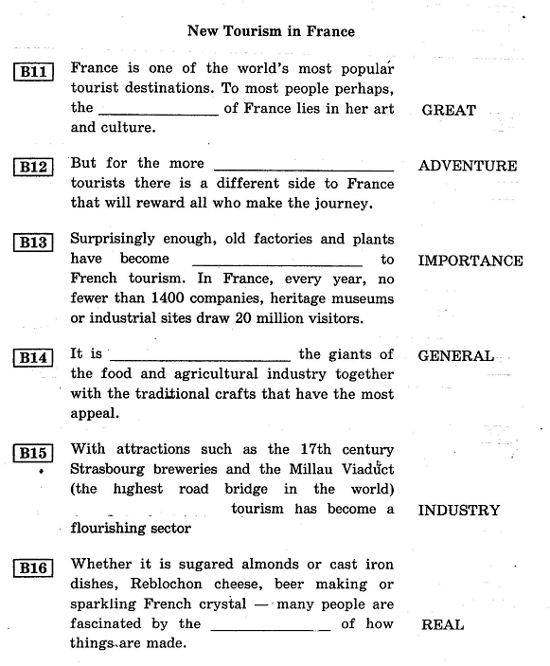
B11
B12
B13
B14
B15
B16

